Broadband Costs (Web Researcher #1)
Search the Internet to find specific companies selling the various types of Internet access in the chart below. Find speeds and price data.

When you are done, type the resuilts into a Word document and save it on a floppy for the Results Presenter.
Type Company Speed Cost
Dial-up
DSL
Cable
T1
T3
OC1
OC3

Internet Backbone (Web Researcher #2)
- Open a browser and go to caida.org
- At the top of the page, click Tools.
- In the Visualization section, click Mapnet.
- In the center-right portion of the page, click run mapnet.
- A map of the world opens as shown below. This is showing the Internet backbone – the main data links that carry the world’s Internet traffic.
- In the top row, select View USA. On the right in the second row, select Commercial Backbones.
- In the list on the lower left, click a commercial service provider to see that provider’s backbone. Then use the mouse to point to a specific line, and the speed and location of that line appears in the lower right. For example, in the figure below I have highlighted an AT&T WorldNet link from San Francisco to Los Angeles. This link has two “pipes” (probably fiber optic cables) – one running at 45 Mbps and the other at 155 Mbps.
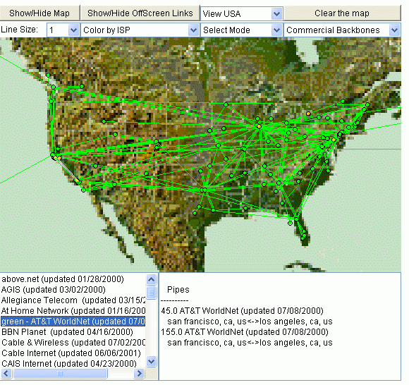

- Find examples of links with the speeds below. Hint – for the slower speeds, switch to View World, or to Color by Bandwidth.
Speed Company From city To city
2.0 Mbps
15 Mbps
45 Mbps
155 Mbps
2488 Mbps

Using Ping to Measure the Latency of Special Locations
- Try PINGing the special locations below. Get the latency values, if you can.
- The Web Researcher #1 should try to find out where these locations are.
Site Location Latency

PING www.cia.gov

PING 127.0.0.1

PING 147.144.1.2
Preparing the Results
- Type your results into a Word document so the presenter can project them and explain them to the class.

