Starting Your Computer
- Start your computer with the appropriate L removable hard drive in it. Log in with the account information your instructor provided to you. In Fall 2005, the User name is CNIT235 with a password of windowsxp

Starting VMWare Workstation
- Double-click the VMWare Workstation icon on the desktop.
- When the VMWare Workstation window opens, click the CNIT 100 tab and then click Start this virtual machine.
- When the virtual machine starts, click the Waldo icon. This is an Administrator account, and it should have no password. If it asks for a password, try P@ssw0rd

Creating a New Partition
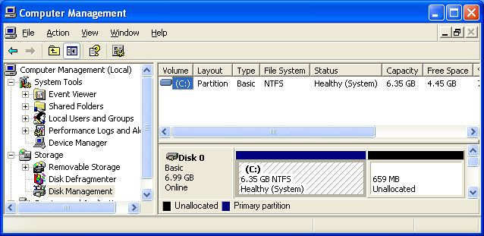
- Click Start and point to My Computer. Right-click My Computer and click Manage. Computer Management opens, as shown below. In the left pane, click Disk Management.
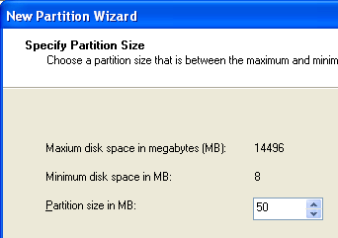
- In the lower right portion of Disk Management, right-click the Unallocated section and select New Partition.
- The New Partition Wizard opens. Click Next.
- In the Select Partition Type screen, accept the default selection of Primary Partition and click Next.
- In the Select Partition Size screen, enter a value of 50 MB, as shown to the right on this page. Click Next.
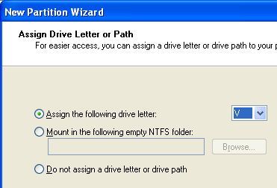
- In the Assign Drive Letter or Path screen, select a drive letter of V, as shown to the right on this page. Click Next.
- In the Format Partition screen, accept the default selections and click Next.
- In the Completing the New Partition Wizard screen, click Finish.
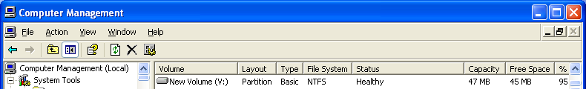
- You should see the formatting process in the Computer Management window. Some of the unallocated space will vanish and a new V: partition will appear. When the formatting is complete, the partition should show a status of Healthy in the upper right pane, as shown below on this page.

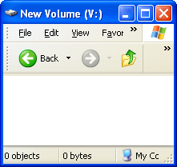
- Close Computer Management.

Examining the V: Partition
- Click Start, My Computer. Double-click New Volume (V:). A New Volume (V:) window opens, as shown to the right on this page. This volume is empty because we have not saved any files here yet.

Copying a Test Files onto V:
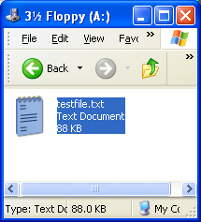
- Get a floppy disk with testfile from your instructor and insert it into the drive. Click Start, My Computer. Double-click 3 ½ Floppy (A:). The file should be visible, as shown to the right on this page.
- Resize the windows so you can see both the 3 ½ Floppy (A:) window and the New Volume (V:) window. Drag the test file from the floppy to V: and drop it there.
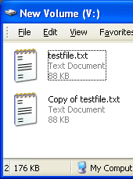

Filling the V: Partition with Files
- In the New Volume (V:) window, hold down the Ctrl key and press A once to select the test file.
- Then hold down the Ctrl key and press C to copy the file to the clipboard.
- Then hold down the Ctrl key and press V. That will make a copy of the file, as shown to the right on this page.
- Repeat those three keystrokes again: Ctrl+A, Ctrl+C, Ctrl+V. Now the folder has four files in it.
- Repeat those three keystrokes again: Ctrl+A, Ctrl+C, Ctrl+V. Now the folder has eight files in it.
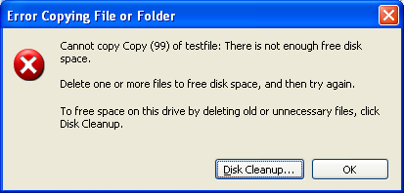
- Repeat the three keystrokes again: Ctrl+A, Ctrl+C, Ctrl+V, a total of seven or eight more times. You will have to wait for the copies to finish after the first few sets of copies. Each time you do this, you double the number of files in the folder.
- Eventually the folder will be full, and you will see an error message as shown to the right on this page. Click OK.

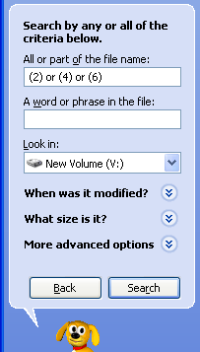
Deleting Some of the Files
- In the New Volume (V:) window, click the Search button. Rover, the search dog, appears in the left pane. Click All files and folders.
- In the All or part of the file name: box, enter (2) or (4) or (6) as shown to the right on this page. Click the Search button.
- The Search Results window shows 21 files. Press Ctrl+A to select them all.
- Hold down the Shift key and press the Delete key to delete them without putting them into the Recycle bin. In the Confirm Multiple File Delete box, click Yes. This will leave 21 scattered open spaces on the hard disk. Close the Search Results window.
- Click Start, My Computer. Double-click New Volume (V:).
- Resize the windows so you can see both the 3 ½ Floppy (A:) window and the New Volume (V:) window. Drag the Really big file from the floppy to V: and drop it there. If the file cannot be copied, try emptying the Recycle bin.
- Now there is a fragmented file on V:, stored in those scattered open spaces.
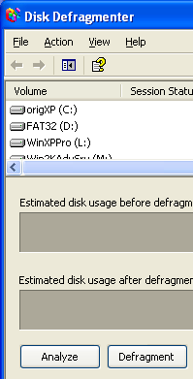

Running a Fragmentation Analysis
- Click Start, My Computer. Right-click New Volume (V:) and click and click Properties. In the New Volume (V:) Properties window, click the Tools tab. Click the Defragment Now… button.
- A Disk Defragmenter box opens, as shown to the right on this page. Click Analyze.
- A Disk Defragmenter box opens saying “You do not need to defragment this volume.” Click View Report.
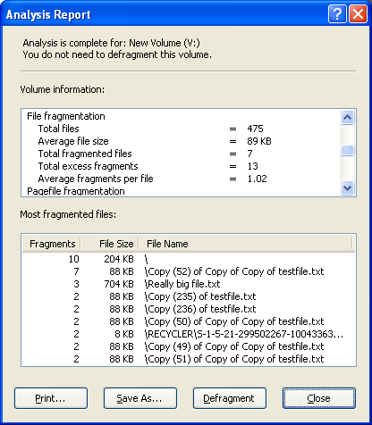
- Scroll down in the Analysis Report to the File fragmentation section, as shown below on this page. You should see that one or more files were fragmented – when I did it, I found 7 fragmented files.
- Click the Defragment button. If you get an error message complaining that there is not 15% free space, click Yes.
- When the defragmentation is complete, click View Report. Now there should be zero Fragmented files.

