
Free Domain Names at TK.com
- Open Internet Explorer and go to www.dot.tk
- In the REGISTER A DOMAIN NAME box, enter your desired domain name and click the OK button. If that domain is already registered, click the Back button and try a different domain name.
- If the domain is available, you will a Domain name registration (Step 1 of 4) page. Scroll down and accept the default selection of FREE DOMAIN NAME. Enter a working email address and click Continue. You can use a mailinator.com address if you like, to avoid spam. To do that, just make up any name and add it in there, such as cnit100@mailinator.com
- In the Domain name registration (Step 2 of 4) page, enter your Web Site. Scroll down and fill in the rest of the form. Click Continue.
- In the next page (also labeled Domain name registration (Step 2 of 4)), scroll down and fill in the form. Click Continue.
- In the Domain name registration (Step 3 of 4) page, enter a fake name, address, and phone number. Use the same email you used before. Click Continue.
- Now you need to read that email. Open another browser window and look for a message from vmailerd@dot.tk. If you used a mailinator address, read it at mailinator.com.
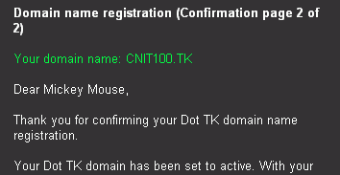
- Find the CONFIRMATION CODE in that email message, and copy it to the clipboard. Click the link in step 1 in that email message. Paste in your CONFIRMATION NUMBER and click Confirm Registration.
- You should see a message like the one shown to the right on this page saying Your Dot TK domain has been set to active.
- Open Internet Explorer and type in your domain name. it has to start with www and end with .tk, like www.cnit100.tk
- It took a long time (ten minutes or even longer) for them to activate my domain, so if yours is not working yet, take a look at the two I made to see how they work:
www.samsclass.tk
www.cnit100.tk

