Viewing a Web Page and Deleting Temporary Internet Files
- Open Internet Explorer and go to samsclass.info
- In the Internet Explorer window, click Tools, Internet Options. On the General tab, in the Temporary Internet Files section, click the Delete Files button. In the Delete Files box, check the Delete all offline content box and click OK. In the Internet Options box, click OK.
- Now all local copies of Web pages have been deleted, so when you refresh this page later, we will be able to see the whole thing load from the Web server.
- Resize the Internet Explorer window so it’s visible, but out of the way on the screen.
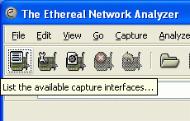
Capturing Packets with Ethereal
- Click Start, All Programs, Ethereal, Ethereal.
- In the The Ethereal Network Analyzer window, point to the upper-left button. A yellow ScreenTip appears, saying List the available capture interfaces… as shown to the right on this page. Click that button.
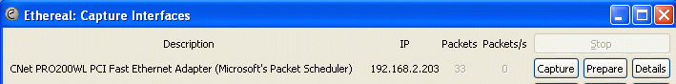
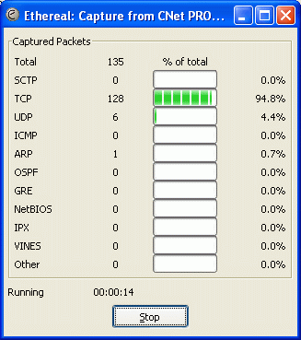
- An Ethereal: Capture Interfaces window opens, as shown below. If more than one interface is shown, find the interface with an IP address starting with 192.168 – that’s the interface that goes to the Internet. Click that Capture button.

- In the Internet Explorer window, click View, Refresh. This requests a fresh copy of the Web page from the server.
- The Ethereal: Capture window should show some packets captured, as shown to the right on this page. When I did it, I captured 135 packets, but you may see a somewhat different number because of random additional network traffic. Click the Stop button.

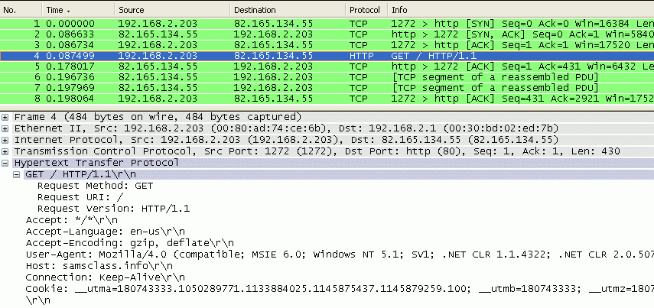
- The (Untitled) – Ethereal window now shows the details of the captured packets, as shown below on this page. Look in the Protocol column for HTTP packets. Find the HTTP packet that says GET / HTTP/1.1 in the Info column. It’s packet number 4 in the capture shown below.

- In the upper pane of the Ethereal window, click GET / HTTP/1.1 to highlight it. The middle pane now shows details of this packet, as shown above. (The bottom pane shows the raw packet byte-by-byte, which is confusing, so ignore it.)
- In the middle pane, click the + sign to the left of the label Hypertext Transfer Protocol to expand it, as shown above. Note that the Host: is samsclass.info – the URL of the page you are viewing. This packet is requesting a copy of my Web page from my Web server.
- After the request, the Web server sends an acknowledgement packet with protocol TCP and Info of http > 1272 [ACK] as shown in packet 5 in the figure above on this page. The 1272 is a local port number and will be different on your machine. Find the acknowledgement packet in your (Untitled) – Ethereal window.
- After the acknowledgement frame, there are several TCP packets with Info of [TCP segment of a reassembled PDU]. These packets contain the HTML that makes up the Web page. Find the corresponding packets in your (Untitled) – Ethereal window.

Last modified 4-24-06

