Viewing a Web Page and Deleting Temporary Internet Files
- Open Internet Explorer and go to samsclass.info
- In the Internet Explorer window, click Tools, Internet Options. On the General tab, in the Temporary Internet Files section, click the Delete Files button. In the Delete Files box, check the Delete all offline content box and click OK. In the Internet Options box, click OK.
- Now all local copies of Web pages have been deleted, so when you refresh this page later, we will be able to see the whole thing load from the Web server.
- Resize the Internet Explorer window so it’s visible, but out of the way on the screen.
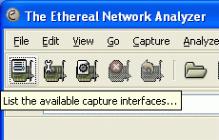
Capturing Packets with Ethereal
- Click Start, All Programs, Ethereal, Ethereal.
- In the The Ethereal Network Analyzer window, point to the upper-left button. A yellow ScreenTip appears, saying List the available capture interfaces… as shown to the right on this page. Click that button.
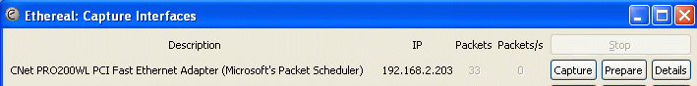
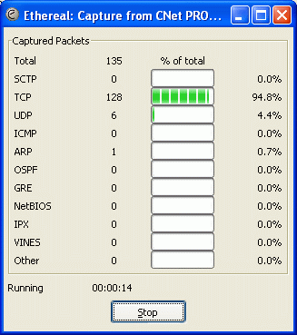
- An Ethereal: Capture Interfaces window opens, as shown below. If more than one interface is shown, find the interface with an IP address starting with 192.168 – that’s the interface that goes to the Internet. Click that Capture button.

- In the Internet Explorer window, click View, Refresh. This requests a fresh copy of the Web page from the server.
- The Ethereal: Capture window should show some packets captured, as shown to the right on this page. When I did it, I captured 135 packets, but you may see a somewhat different number because of random additional network traffic. Click the Stop button.

Finding HTTP Status Packets
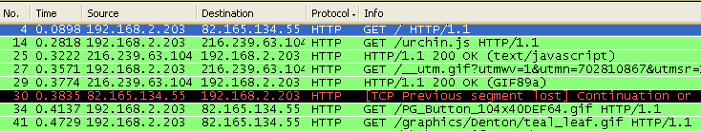
- The (Untitled) – Ethereal window now shows the details of the captured packets, as shown below on this page. Click the gray Protocol column label to sort the packets by Protocol. That puts all the HTTP packets together, as shown below.

- Look at packets number 14 and 25 in the figure above on this page (packet number is in the leftmost column). Packet 14 is a GET request for a file named urchin.js, a JavaScript file. That file was received correctly, so after it arrives, packet 25 shows HTTP/1.1 200 OK. This is an HTTP Status Code packet, indicating status 200 – OK.
- Find as many different status codes as you can in this series of packets. There is a list of status codes on page 293 in your textbook which may help guide you.
- Repeat the process for one or two more Web sites, such as yahoo.com or msn.com.

Last modified 4-24-06

