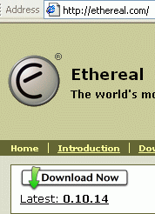
- Start your computer with the appropriate L hard drive. Start the CNIT 100 virtual PC and log in as Waldo.
- Open a browser and go to ethereal.com
- At the Ethereal main page, click the Download Now link, as shown to the right on this page.
- In the Windows section, click SourceForge.
- On the SourceForge page, find the Ethereal package and click the green Download link.
- In the chart, find the item for an Architecture of i386 -- that means a PC. In that line, click the blue link, as shown below on this page.
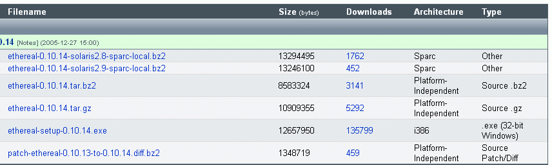
- In the next page, find a link in America, as close to California as you can, and click its Download link. When I did this, I found one named EasyNews in Phoenix, Arizona.
- In the File Download – Security Warning box, click Run.
- In the Internet Explorer – Security Warning box, click Run.
- In the Ethereal Setup Wizard box, click Next. Click through the installer screens accepting all the default selections.
- When a WinPCap Setup box appears, click Next. In the next screen, click I Agree. At the Completing screen, click Finish. WinPCap is a program that captures packets so Ethereal can analyze them, so you need to install it. Click through the installer screens accepting all the default selections.
- When the Ethereal Setup screen says Installation Complete, click Next. At the Completing screen, click Finish.

Last modified 4-24-06

