I. Using the Microscope to Observe Fiber
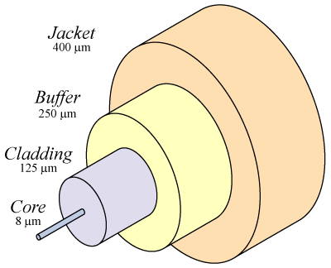
Required Equipment
Singlemode Fiber Optic Cable

Microscope

Connector cleaning equipment:

Kimwipes

Alcohol bottle

Two cables: one Singlemode and one Multimode
Core and Cladding
- A fiber optic cable has several layers, as shown to the right on this page.
- The light travels through the Core. The layer surrounding the core is the Cladding.
- The Core and Cladding are both made of glass, and are permanently fused together. All the other layers just serve to protect the Core and Cladding.
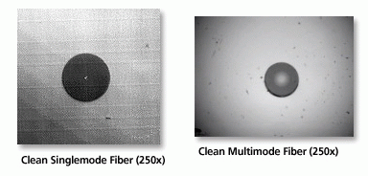
Examining the Singlemode Fiber
- Connect one end of the Singlemode cable to the microscope. Turn the microscope light on. Adjust the focus until you see the end of the fiber, which should look like the image to the right on this page. You should see the Core as a tiny dot and the Cladding as a larger circle. Dust and oil on the connector end will show up as specks or streaks on the fiber end.
- Clean the connector with a Kimwipe and a drop or two of alcohol. Wipe it on the wet part of the Kimwipe, and then on a dry part of it to dry it. Then put it back in the microscope and see what difference cleaning it made, if any.
- Turn the microscope light off. Point the other end of the cable at the room’s fluorescent light in the ceiling and see how the image changes. The Core carries the light through the cable, but the Cladding does not.

Examining the Multimode Fiber
- Connect one end of the Multimode cable to the microscope. Turn the microscope light on. Adjust the focus until you see the end of the fiber, which should look like the image to the right on this page. You should see the Core as a much larger dot, about half as wide as the Cladding.
- Turn the microscope light off. Point the other end of the cable at the room’s fluorescent light in the ceiling and see how the image changes. The Core carries the light through the cable, but the Cladding does not.

II. Using a Light Source and Power Meter
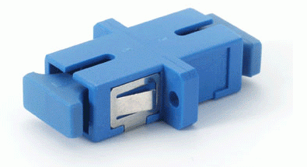
Required Equipment

Infrared Source, multimode

Power meter

Connector cleaning equipment:

Kimwipes

Alcohol bottle

Two cables: one Singlemode and one Multimode

An SC-to-SC adapter as shown in the photo above
Using the Light Source and Power Meter

Light Source

Power Meter

Multimode
- Clean a connector on the Multimode cable and insert it into the Light Source. Clean the other connector and insert it into the Power Meter, as shown to the right on this page.
- Turn on the Light Source. Set the wavelength to 850 nm. This is near-infrared light, just a bit longer than the reddest light you can see.
- Fiber optic transmissions usually use invisible infrared light, because it travels more efficiently through glass than visible light does.
- Turn on the Power Meter and set the wavelength to 850 nm. You should see a reading of approximately -10 dBm. If it’s more than 2 dB away from that number, something is wrong – probably a loose connection or the wrong wavelength setting.
- Record the Power Meter reading below

MM Cable Alone: Power: ________________________________

- Add the Singlemode cable between the Multimode cable and the Power Meter as shown to the right on this page, using the SC-to-SC Adapter to connect the two cables. Remember to clean both ends of the Singlemode cable.

Light Source

Power Meter

Multimode

Singlemode

- Record the Power Meter reading below. It should be a lot lower, around -30 dBm, indicating that a lot of light was lost.

MM Cable Alone: Power: ________________________________
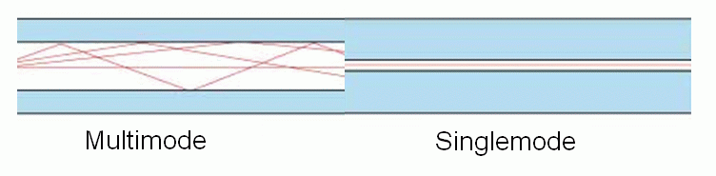
- Can you understand why so much light was lost? The diagram to the right shows why – the Multimode fiber has a lot of light going through all of its wide core, but only a tiny part of that light enters the much smaller Singlemode core.

