Starting Your Computer
- Start your computer with the appropriate L removable hard drive in it. Log in with the account information your instructor provided to you. In Spring 2006, the User name is CNIT235 with a password of windowsxp

Starting VMWare Workstation
- Double-click the VMWare Workstation icon on the desktop. In the VMWare Workstation window, click the CNIT 100 tab and then click Start this virtual machine.
- When the virtual machine starts, click the Waldo icon. This is an Administrator account, and it should have no password. If it asks for a password, try P@ssw0rd

Ensuring that File Extensions are not Hidden
- Open My Computer. Click Tools, Folder Options. In the Folder Options box, click the View tab. Scroll down to find the Hide extensions for known file types box and make sure it is not checked. Click OK to close the Folder Options box. Close My Computer.

Creating a New File Type: .xyz
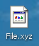
- Right-click the desktop and select New, Text Document. A new document appears with the name New Text Document.txt highlighted so you can change it. Type in the new name File.xyz and press Enter. A Rename box pops up warning you If you change a file name extension, the file may become unusable. Click Yes.
- Notice that the File.xyz icon is the generic icon, as shown to the right on this page. That's because Windows does not know what application should be used to open this file – the extension .xyz has no association with any installed program.

Associating the .xyz Extension with Notepad
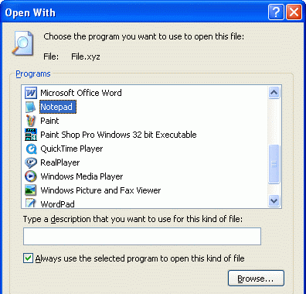
- Right-click File.xyz and select Open.
- A Windows box opens saying Windows cannot open this file. Click Select the program from a list and click OK.
- In the Open With box, scroll down to Notepad and click it. Verify that the Always use the selected program to open this kind of file box is checked, as shown to the right on this page. Click the OK button.
- The file opens in Notepad. Type in some text, and click File, Save to save the file. Close Notepad.


- Notice that the File.xyz icon now has a little Notepad on it, as shown to the right on this page. That's because the extension .xyz is now associated with Notepad.
- Double-click File.xyz. It opens in Notepad immediately. Close Notepad.

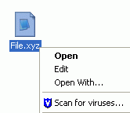
Using the Context Menu
- Right-click File.xyz. A list of choices appears, as shown to the right on this page. This is the Context menu.
- In the context menu, left-click Open. The file opens in Notepad. Close Notepad.
- Right-click File.xyz. In the context menu, left-click Edit. The file opens in Notepad. Close Notepad.

Changing the Edit Action for .xyz Files
- Edit and Open both do the same thing for this file type. But we will change that.
- In the My Computer window, click Tools, Folder Options.
- In the Folder Options box, click the File Types tab.
- When the file extensions appear, scroll down to the XYZ extension and click it.
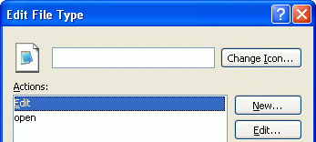
- In the Details for 'XYZ' extension section, click the Advanced button. (You may see a Restore button instead of an Advanced button. If you do, click it to make the Advanced button appear.)
- In the Edit File Type box, click the Edit action and click the Edit button, as shown to the right on this page.
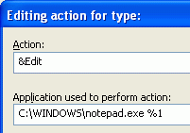

- An Editing action for type: box opens. The Application used to perform action: box shows the following command-line:
C:\WINDOWS\notepad.exe %1
Change the command line to
"C:\Program Files\Windows NT\Accessories\wordpad.exe" "%1"
Don't forget the quotation marks.
- Click OK to close the Editing action for type: box.
- Click OK to close the Edit File Type box.
- Click Close to close the Folder Options box.
- Right-click File.xyz and select Edit. The file opens in WordPad. To verify that this is really WordPad, click the Format menu item and note that Bullet style is one of the options. Close WordPad.
- Right-click File.xyz and select Open. The file opens in Notepad. To verify that this is really Notepad, click the Format menu item and note that the Bullet style is not available. Close Notepad.

Adding a New Action for .xyz Files
- In the My Computer window, click Tools, Folder Options.
- In the Folder Options box, click the File Types tab.
- When the file extensions appear, scroll down to the XYZ extension and select it.
- In the Details for 'XYZ' extension section, click the Advanced button.
- In the Edit File Type box, click the New button.
- In the New Action box, enter an Action of Calculate and an Application used to perform action: of
C:\WINDOWS\system32\calc.exe
As shown in the figure below on this page.
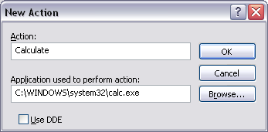

- Click OK to close the New Action box.
- Click OK to close the Edit File Type box.
- Click Close to close the Folder Options box.
- Right-click File.xyz and observe that there is now a Calculate option. Click Calculate option. Calculator opens. Close Calculator.

