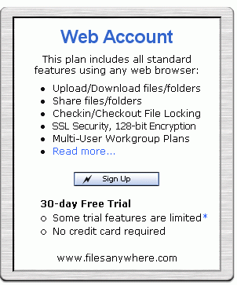
Creating a File to Back Up
- Open Microsoft Word. Type in your name, or any other text. Save the document in the My Documents folder with the name Important Info.
Signing Up for a FreeTrial of Files Anywhere
- Open Internet Explorer and go to filesanywhere.com
- In the upper left, click on Free Trial – Sign Up Here
- In the Web Account section, as shown to the right on this page, click the Sign Up button.
- Fill in the form. Make up any User name and use an e-mail address that works. At the bottom, check both of the boxes, as shown below. Click Continue.
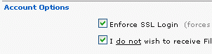

- In the next screen, click Start Now.
- Check your email. Open the message with the subject “Your New FilesAnywhere Account” to get your Temporary Password.
- Copy the Tempory Password into the Password box at the top of the FilesAnywhere web page and click the Enter button.
- In the next screen, click Continue.
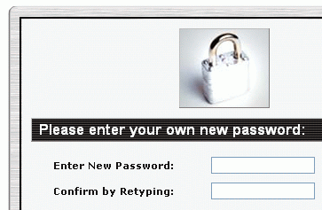
- If one or more Security Alert boxes opens saying You are about to view pages over a secure connection, click OK.
- Copy the Tempory Password into the Password box at the top of the FilesAnywhere web page and click the Enter button.
- The next screen asks you to Please enter your own new password, as shown to the right on this page. Type in a password you can remember into both boxes and click Continue.
Uploading a File
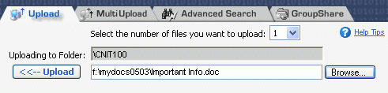
- In the next screen, change the Select the number of files you want to upload: value to 1, as shown to the right on this page.
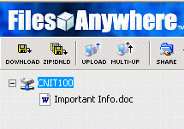
- Click the Browse button.
- In the Choose File box, click the My Documents button and double-click Important Info.
- Click the Upload button. When a box pops up saying Upload successful, click OK.
- The Important Info file appears on the left of the window, as shown to the right on this page.
Making a Big File
- One problem with some online file storage services is that the upload and download speeds are slow. To test that, let’s make a big file.
- Press the PrtScn button on the upper right of the keyboard. This copies the contents of the video memory to the clipboard – nothing visible happens on the screen.
- Click Start, All Programs, Accessories, Paint. Click Edit, Paste. A copy of the desktop is pasted into the Paint window.
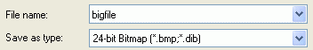
- Click File, Save As…. Save the file in the My Documents folder with the name bigfile. Make sure it is saved with a Save as type: of 24-bit Bitmap as shown to the right on this page.
- Click Start, My Documents. Right-click bigfile and click Properties. Check the size of the file—its exact size depends on the resolution of your monitor, but it should be at least 1 megabyte.
Uploading a Big File
- In the Files Anywhere page, change the Select the number of files you want to upload: value to 1
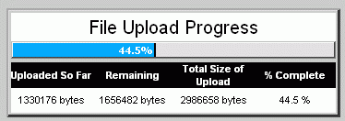
- Click the Browse button.
- In the Choose File box, click the My Documents button and double-click bigfile.
- Click the Upload button. A File Upload Progress message appears, as shown to the right on this page. Wait until the upload finishes. It took about 30 seconds when I did it.
- When a box pops up saying Upload successful, click OK.

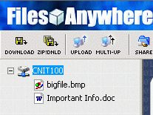
- Bigfile file appears on the left of the window, as shown to the right on this page.

