Downloading and Installing Flash 8 (30-day demo)
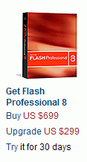
- Use your virtual PC. Start a browser and go to adobe.com.
- In the Products section, click on Flash.
- A page opens with the header Flash Professional 8. Find the section with the photo of a red box and the words Get Flash Professional 8, as shown to the right on this page. Click the word Try in the sentence Try it for 30 days.
- At the Macromedia Trial Downloads page, enter your e-mail address, click the No, I will create one now radio button, and click the Continue button.
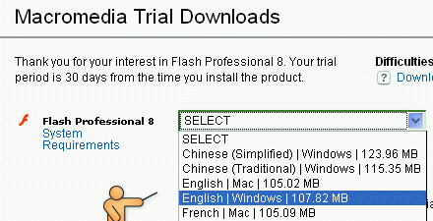
- At the Macromedia Trial Downloads page, fill out the long form and click the Continue button at the bottom of the page.
- A Macromedia Trial Downloads page opens. Next to Flash Professional 8, select English | Windows, as shown to the right on this page. Click the Download button.
- Save the Flash8-en.exe file on your desktop.
- Double-click the Flash8-en.exe file. Click through the installation accepting all the default choices.
Saving Two Images
- You will make a simple Flash movie, with a background image and a moving image. In your movie, the moving image will be animated to move on top of the background image. Use Google Images or any other source of images and find the two images. Save them in the My Pictures folder.
Starting Flash and Creating a New Flash Document
- Click Start, All Programs, Macromedia, Macromedia Flash 8.
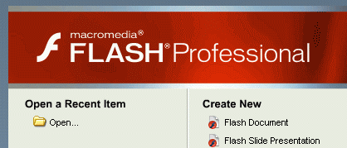
- In the Welcome to Macromedia Flash box, select I want to try Macromedia Flash and click the Continue button.
- In the Select Flash 8 Trial Edition box, click Flash Professional 8 and click the OK button.
- The Macromedia Flash Professional 8 window opens as shown to the right on this page. Under the Create New header, click Flash Document.
The Flash Window
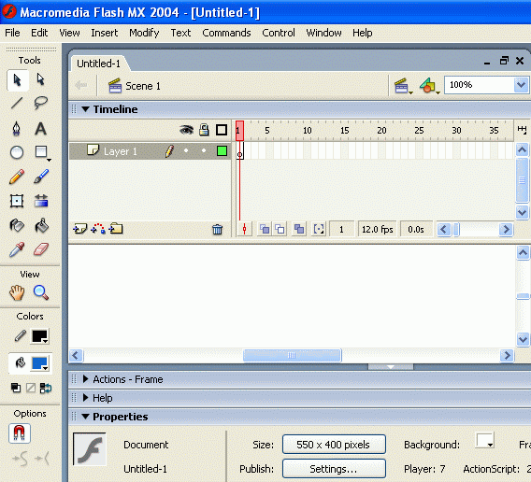
- Notice the main features of the Flash window as shown in the figure below:
Menu bar
Selection tool
Text Tool
Timeline Pane
Stage
Properties Pane

- The Stage area in the center is where you place images and build your movie. Each movie is a series of frames, and you control the animation with the Timeline pane. Right now there is only one layer in the movie, named Layer 1, and although there is room for 65 frames or more on the window, only the first frame has any content so far. The basic idea is that you add objects to the Stage, and then control the motion using the Timeline.
- The tools on the left are used to place objects on the Stage, and to manipulate them. You can draw directly on the stage with the tools in the toolbar shown to the left, or add text with the Text Tool.
Importing Your Images
- Before you can use images in Flash, you have to import them. From the menu bar, select File, Import, Import to Library. Open My Documents and then open My Pictures. Select your background image, select it, and click the Open button. Repeat the process to import your moving image.
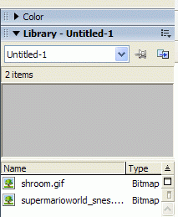
- On the right side of the screen, you should see the Library with your images in it, as shown to the right on this page.
Making the Background Layer
- Drag your background image icon from the Library into the blank white Stage area in the center of the Macromedia Flash Professional 8 – Untitled window.
- This completes the static background of the movie. We will put the moving image on a different layer, so the layer named Layer 1 in the Timeline section should be renamed.
- In the Timeline section, double-click the Layer 1 label and type in Background. Press the Enter key.
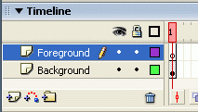
Inserting the Foreground Layer
- In the Timeline section, right-click the Background label and select Insert Layer. A new layer named Layer 2 appears above the Background layer.
- In the Timeline section, double-click the Layer 2 label and type in Foreground. Press the Enter key. You should now have two layers in the Timeline section as shown to the right on this page.
Inserting the Foreground Image into the Foreground Layer
- In the Timeline section, in the Foreground layer, click the white cell in column 1. That cell turns black to indicate that it is selected.
- Drag your foreground image from the Library window onto the stage. Position it at the starting point for its motion.
Animating the Foreground Image
- In the Timeline section, in the Foreground layer, click the cell in column 10. At the top of your keyboard, press the F6 key. This makes frame 10 a Key Frame, and cell 10 shows a black background with a white dot. As you will see below, motion happens by filling in frames between Key Frames.
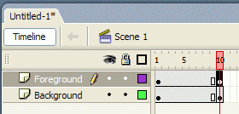
- In the Timeline section, in the Background layer, click the cell in column 10. At the top of your keyboard, press the F6 key. This copies the background into the first ten frames.
- In the Timeline section, in the Foreground layer, click the cell in column 10. In the Stage area, drag your foreground image to the ending point for its motion. Your timeline should now look like the example to the right on this page.
Setting the Tween Motion
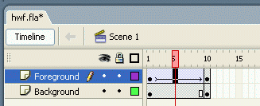
- In the Timeline section, in the Foreground layer, click the cell in column 5. In the Properties area at the bottom of the screen, set the Tween value to Motion. This will fill in the frames between the Key Frames (Frame 1 and Frame 10) to create smooth motion. Your foreground image moves to a point between the starting and ending position, and an arrow appears in the Foreground layer in the Timeline section, as shown to the right on this page.
Saving Your Movie
- From the menu bar, click File, Save. Save your Flash presentation with any name, on a floppy disk. This saves your movie as a .fla file, which can be opened and edited by Flash, but which cannot be played in a browser.
Previewing Your Movie
- From the menu bar, click Control, Test Movie. This converts your movie to a shockwave file (.swf) that can be seen in a browser, and plays it in the browser. Look at it and see if it looks the way you want it to.
- When you are done viewing the preview, close the preview window by clicking the small X on the gray background in the upper right-hand corner.
- Adjust your movie as desired. When you are happy with it, save it again.
Exporting Your Movie
- From the menu bar, click File, Export, Export Movie. Save your Flash presentation with any name, on a floppy disk. Flash will add the extension .swf creating a Shockwave file that can be viewed in a browser.
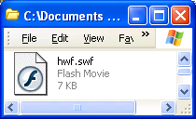
- An Export Flash Player box opens, giving you a chance to adjust the quality settings for your movie. Accept the default settings and click OK.
- Click Start, My Computer and open your floppy disk. You should see your swf file, as shown to the right on this page.
- Right-click this file, point to Open With…, and select Internet Explorer.
- In the Information Bar box, click Close. Click the yellow Information Bar at the top of the Internet Explorer window and select Allow Blocked Content. In the Security Warning box, click Yes. You should see your movie playing.

Revised 5-8-06

