Starting Your Computer
- Start your computer with the appropriate L removable hard drive in it. Log in with the account information your instructor provided to you. In Spring 2006, the User name is CNIT235 with a password of windowsxp

Starting VMWare Workstation
- Double-click the VMWare Workstation icon on the desktop. In the VMWare Workstation window, click the CNIT 100 tab and then click Start this virtual machine.
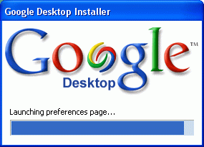
- When the virtual machine starts, click the Waldo icon. This is an Administrator account, and it should have no password. If it asks for a password, try P@ssw0rd
Downloading and Installing Google Desktop
- Start a Web browser such as Internet Explorer. Go to desktop.google.com
- Click the Agree and Download button.
- A File Download – Security Warning box opens. Click Run.
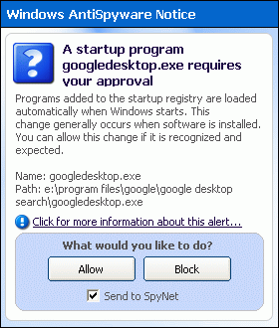
- An Internet Explorer – Security Warning box, click Run. The Google Desktop Installer appears, as shown to the right on this page.
- If a box pops up saying Google Desktop needs to close some programs, allow that.
- If a Windows AntiSpyware Notice appears, as shown to the right on this page, click Allow.
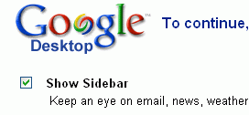
- In the Google Desktop screen, as shown to the right on this page, do these things:
  - Show Sidebar: Leave this checked, you’ll see what it does
  - Set Google as my default search engine …: leave this checked.
  - Search Gmail and my other computers…: leave this unchecked
  - Update the Links Toolbar with my favorite sites leave this unchecked
  - Click Set preferences and continue
- If Windows AntiSpyware Notice windows appear, click Allow.
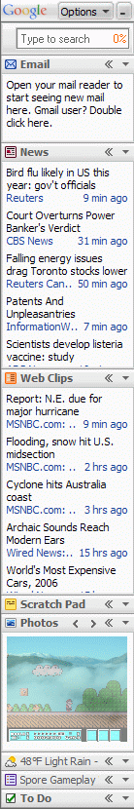
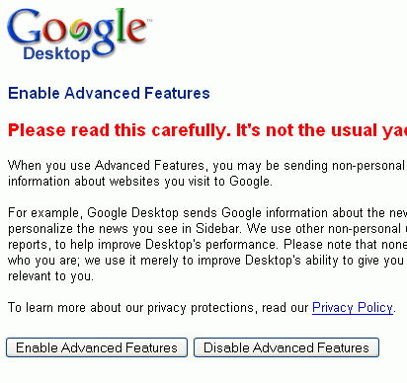
- In the Google Desktop window shown immediately to the right on this page, click Disable Advanced Features.
- In the next screen, click Go to the Desktop homepage.
Google Sidebar
- The Google Sidebar appears, as shown to the right on this page. Go through the sections and find these things:
  - Where is the What’s Hot section? Look through it and find an interesting item to show the class.
  - Where are the Photos coming from?
  - What’s the weather forecast? What city is this forecast for?
- It would be nice to try out the Google search of your computer and compare it to the Microsoft search, but we need to give Google Desktop a few hours to index the hard drive. Hopefully it will be ready by the next class.

