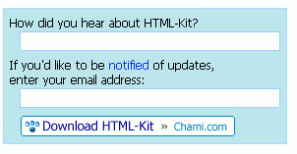
Downloading and Installing HTML-KIT
- Use your virtual PC.
- Open Internet Explorer and go to chami.com
- Click the large blue HTML-Kit link.
- In the next screen, at the top, click the white DOWNLOAD link.
- In the next screen, find and click the Download HTML-Kit link, as shown above and to the right on this page.
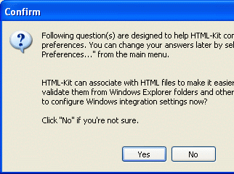
- In the File Download – Security Warning box, click Run.
- In the Internet Explorer – Security Warning box, click Run.
- An installer box opens. Click through the installer, accepting all the default selections.
- HTML-KIT should open. If it does not, click Start, All Programs, HTML-KIT, HTML-KIT to start it.
- The first time you start HTML-KIT, it asks a lot of long, confusing questions, like the one shown to the right on this page. Just click No to every question.
- When the Open file wizard appears, accept the default selection of Create a new file and click OK.
Making a Web Page with HTML-KIT
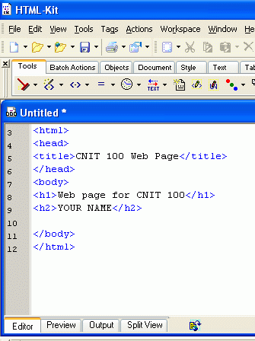
- Type in the text you see to the right on this page. Notice that HTML-KIT has already filled in a lot of the text for you, and that it color-codes the HTML tags blue as you type them in.
- Click File, Save and save the file with the name hkpage.html in My Documents.

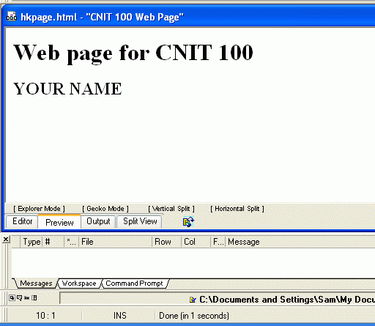

- Click the Preview tab at the bottom of the window to see how your page will look in a browser. You should see your Web page, with two lines of big letters, as shown in the right on this page.
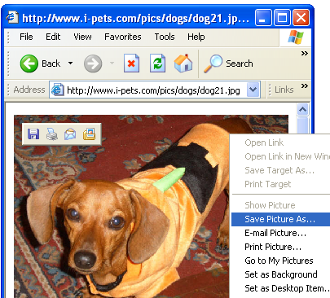
Saving an Image File
- Open a new browser window and go to Google.com. Do a search for anything you like, such as dogs, and find a picture you like.
- You need to save this picture on your hard disk, and you need to make sure you know its exact file name, including the file extension.
- Right-click on the picture you like best and select Save Picture As…, as shown to the right on this page.

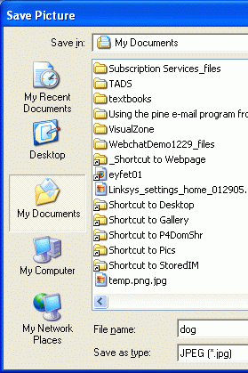
- The Save Picture dialog box opens, as shown to the right on this page. In the left section of the Save Picture dialog box, click the My Documents folder. Click Save to save your image.

Adding the Image to the Web Page
- In the HTML-KIT window, click the Editor tab at the bottom to return to the HTML source code.
- In the Files pane at the right of the HTML-KIT window, click the + sign next to My Documents. You should see the dog.jpg file. Drag the dog.jpg file and drop it into the HTML code below the line with YOUR NAME in it. The diagram below shows the process.
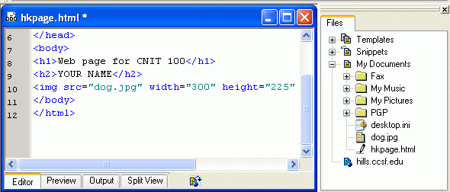

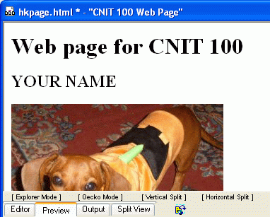
- An <img src> tag appears in your HTML file. This is the tag that puts the image in your page.
- Click the Preview tab. Your Web page should now have the image on it, as shown in the right on this page.
- Click File, Save to save your page.

Publishing the Web Page on the CCSF Server
- This Web page consists of two files in your my Documents folder: hkpage.html and dog.jpg. But no one can see the files on your computer – to make them available to other people, you have to move the files up to a Web server.
Adding a FTP Server to the HTML-KIT Workspace
- In the HTML-KIT window, from the top menu bar, click Workspace, Add Folder / FTP Server, Add FTP Server…
- In the Add FTP Server box, as shown below, enter these things:

Server address: hills.ccsf.edu

Login user name: Your HP-UNIX ID, as shown in the list on the bulletin board

Password: Your birthday in the format aug0178

Initial directory: public_html
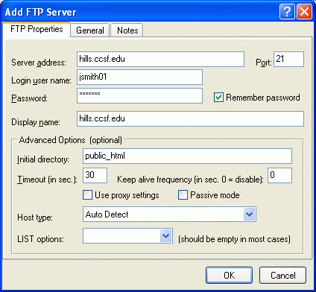

- After entering those four things, click OK.
Connecting to the FTP Server in HTML-KIT
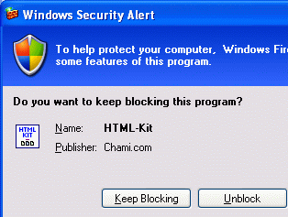
- In the HTML-KIT window, in the Files pane on the right, click the + sign to the left of hills.ccsf.edu.
- If a Windows Security Alert appears, as shown to the right on this page, click Unblock.
Uploading Files to the Server
- In the HTML-KIT window, in the Files pane on the right, right-click hills.ccsf.edu and select Upload.
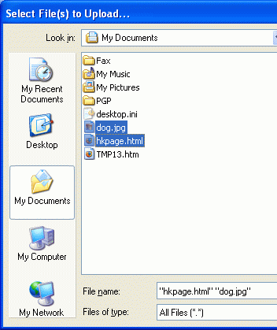
- In the Select File(s) to Upload… box, at the bottom, set the Files of type: to All Files.
- Click the dog.jpg file to select it. Hold down the Ctrl key on the keyboard and click the hkpage.html file to select it also, as shown to the right on this page. Then click the Open button.
Fixing Permissions
- In the HTML-KIT window, in the Files pane on the right, right-click hkpage.htm and select Set Permissions….
- In the Set Permissions box, make sure all three Read boxes are checked, as shown on the bottom right on this page. Click OK.
- Repeat the same process to set permissions for the dog.jpg file.
Viewing Your Page
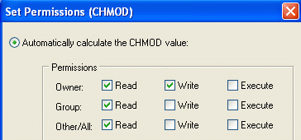
- Open a browser and type in this URL to see your page:
hills.ccsf.edu/~gsmith01/hkpage.html
Replace gsmith01 with your HP-UNIX ID.

Last modified 4-26-06 3 pm

