Getting an Image to Work With
- You do not need to use the virtual PC. Open Internet Explorer. Go to google.com. Click the images tab. Enter a topic and press the Enter key to find images. Pick an image that is large – at least 400x400 pixels. When you find an image you like, right-click on it and select Save Picture As…. Save the image in the My Pictures folder. Note the file extension – it should be either GIF or JPG.
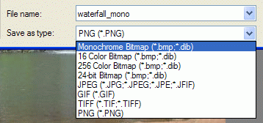
Using Paint to Make a Monochome Bitmap
- Click Start, All Programs, Accessories, Paint.
- When Paint opens, click File, Open. Open the image you are working with.
- Click File, Save As…. In the Save As box, give the file a name ending in mono and select a Save as type: of Monochrome Bitmap as shown to the right on this page. Save the file. When a box pops up warning you that you may lose some color information, click Yes.
Using Paint to Make a 16 Color Bitmap
- Click File, Open. Open the original image you are working with. Be careful not to open the monochrome bitmap
- Click File, Save As…. In the Save As box, give the file a name ending in 16 and select a Save as type: of 16 Color Bitmap.
Using Paint to Make a 256 Color Bitmap, a 24-bit Bitmap, a JPEG, and a GIF
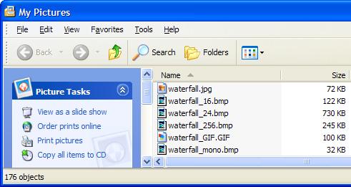
- Use the same procedure to make these four types of files. Make sure you open the original file first each time. When you are done, click Start, My Pictures.
- In the My Pictures window, click View, Details. You should see all the files you made, with their file sizes, as shown to the right on this page.

Finding the Dimensions of Your Image
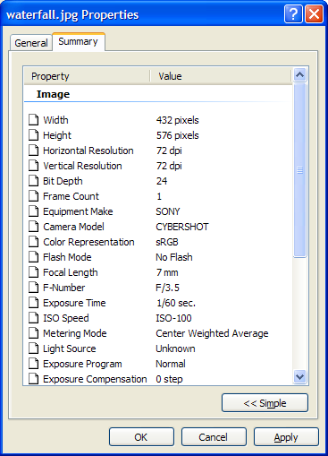
- In the My Pictures window, right-click your original image and select Properties. Click the Summary tab, and click the Advanced button. You should see a Properties window, as shown to the right on this page. This should tell you the Width and Height of your image, in pixels. Write those numbers down.
Calculating Bitmap Sizes
- First you need to know the number of pixels in your image. To get that, multiply the Width by the Height. If you want a calculator, click Start, All Programs, Accessories, Calculator. For example, the number of pixels in the image shown to the right is 432 x 576 = 248832.
- A monochrome bitmap uses one bit per pixel. So to get the number of bytes in the monochrome bitmap, divide the number of pixels by eight. In the example above, the number of bytes in the monochrome bitmap is 248832 / 8 = 31,104.
- Use this method to fill in the table on the next page with the calculated and actual sizes of your images.
Image Width:
Image Height:
Image Pixels:

File Type # bits/pixel Calculated size Actual size
Monochrome Bitmap: 1
16-Color Bitmap: 4
256-Color Bitmap: 8
24-bit Bitmap: 24
JPEG:
GIF:

