Downloading and Installing Flash 8 (30-day demo)
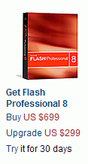
- Use your virtual PC. Start a browser and go to adobe.com.
- In the Products section, click on Flash.
- A page opens with the header Flash Professional 8. Find the section with the photo of a red box and the words Get Flash Professional 8, as shown to the right on this page. Click the word Try in the sentence Try it for 30 days.
- At the Macromedia Trial Downloads page, enter your e-mail address, click the No, I will create one now radio button, and click the Continue button.
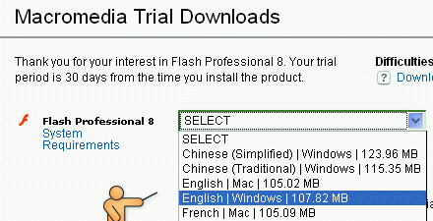
- At the Macromedia Trial Downloads page, fill out the long form and click the Continue button at the bottom of the page.
- A Macromedia Trial Downloads page opens. Next to Flash Professional 8, select English | Windows, as shown to the right on this page. Click the Download button.
- Save the Flash8-en.exe file on your desktop.
- Double-click the Flash8-en.exe file. Click through the installation accepting all the default choices.
Starting Flash and Creating a New Flash Document
- Click Start, All Programs, Macromedia, Macromedia Flash 8.
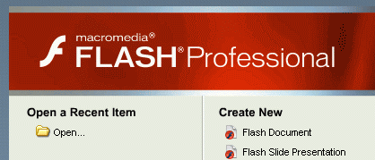
- In the Welcome to Macromedia Flash box, select I want to try Macromedia Flash and click the Continue button.
- In the Select Flash 8 Trial Edition box, click Flash Professional 8 and click the OK button.
- The Macromedia Flash Professional 8 window opens as shown to the right on this page. Under the Create New header, click Flash Document.
The Flash Window
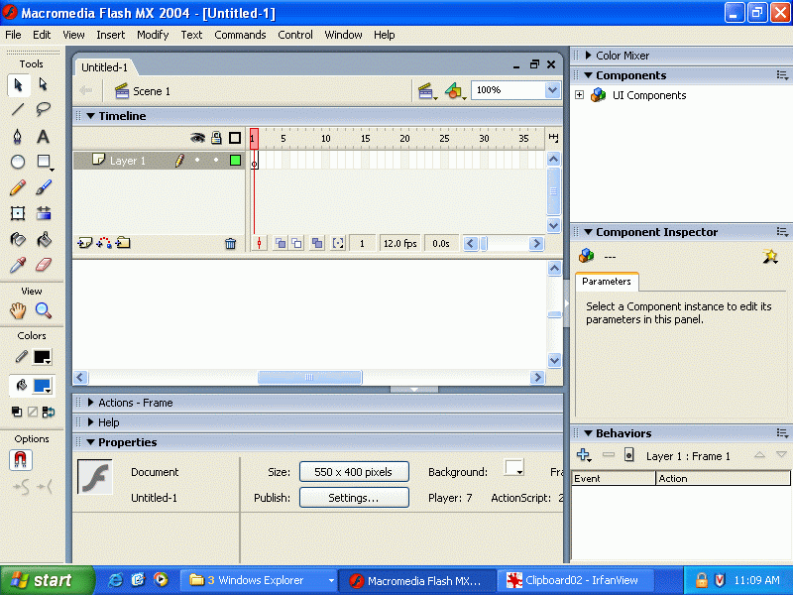
- Notice the main features of the Flash window as shown in the figure to the right.
Menu bar
Selection tool
Brush Tool
Stage

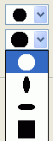
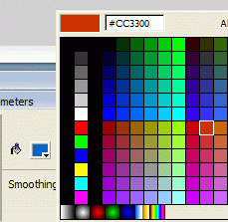
Drawing a Simple Image in Flash
- Click the Brush Tool and try drawing with it. On the bottom of the left pane there are two drop-down list boxes that you can use to change the shape and size of the brush, as shown to the left on this page. Experiment with a few brushes.
- At the bottom of the screen there is a small colored square with a tiny black down-arrow on it, as shown to the right on this page. Click that tiny arrow to change the brush color.

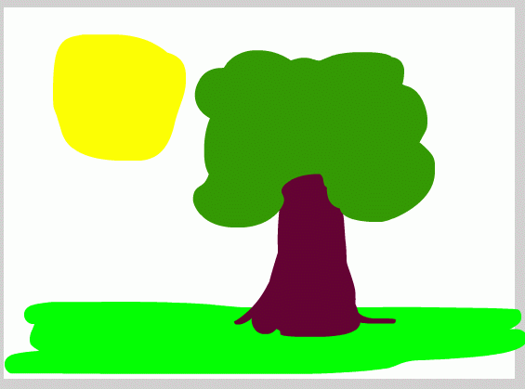
- Draw a simple image, like the one shown to the right on this page. It doesn’t matter what you draw, or whether it looks good. If you want to undo a portion of your drawing, click Edit, Undo.

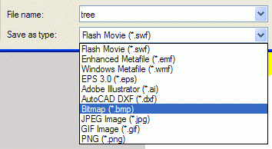
Saving the Image as a Bitmap
- From the menu bar, click File, Export, Export Image. Give your image any name you like, such as tree, and save it on a floppy disk. In the Save as type: drop-down list box, select Bitmap as shown to the right on this page. Click the Save button.

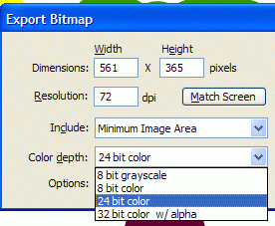

- In the Export Bitmap box, notice the Color depth choices, as shown to the right on this page. Accept the default of 24 bit color and click OK.

Saving the Image as a GIF
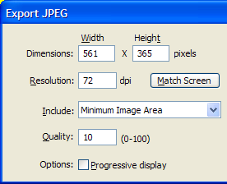
- From the menu bar, click File, Export, Export Image. Use the same filename you used before. In the Save as type: drop-down list box, select GIF Image. Click the Save button.
- In the Export GIF box, notice the Colors choices. Accept the default of Standard colors and click OK.
Saving the Image as a JPEG (Quality 10)
- From the menu bar, click File, Export, Export Image. Use the same filename you used before. In the Save as type: drop-down list box, select JPEG Image. Click the Save button.
- In the Export JPEG box, notice the Quality box, as shown to the right on this page. Accept the default of 10 and click OK.
Saving the Image as a JPEG (Quality 100)
- From the menu bar, click File, Export, Export Image. Use the same filename you used before, with a 100 at the end, such as tree100. In the Save as type: drop-down list box, select JPEG Image. Click the Save button.
- In the Export JPEG box, set the Quality to 3 and click OK.
Saving the Image as a JPEG (Quality 1)
- From the menu bar, click File, Export, Export Image. Use the same filename you used before, with a 1 at the end, such as tree1. In the Save as type: drop-down list box, select JPEG Image. Click the Save button.
- In the Export JPEG box, set the Quality to 1 and click OK.
Saving the Image as a SWF Vector Graphic
- From the menu bar, click File, Export, Export Image. Use the same filename you used before, such as tree. In the Save as type: drop-down list box, select Flash Movie. Click the Save button.
- In the Export Flash Player box, accept the default settings and click OK.
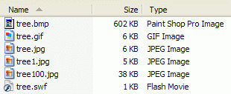
Comparing the Images
- Click Start, My Computer. Open the Floppy Disk. Click View, Details. You should see the image files, as shown to the right on this page.
- Double-click the Bitmap image (it is the one with the largest file size). The image opens in the default viewer, which is probably Windows Picture and Fax Viewer.
- Look for a little magnifying glass icon with a + in it, as shown to the left on this page. Click it to zoom in on a detail of the image. The image does have some blur in it, which is the way Flash drew it—none of the distortion comes from the bitmap format.
- Use the same procedure to examine each file in turn. Fill in the table on the next page with the quality of the image, and the file sizes.

File Type Quality File Size (KB)
Bitmap:
GIF:
JPEG1:
JPEG10:
JPEG100:
SWF:

