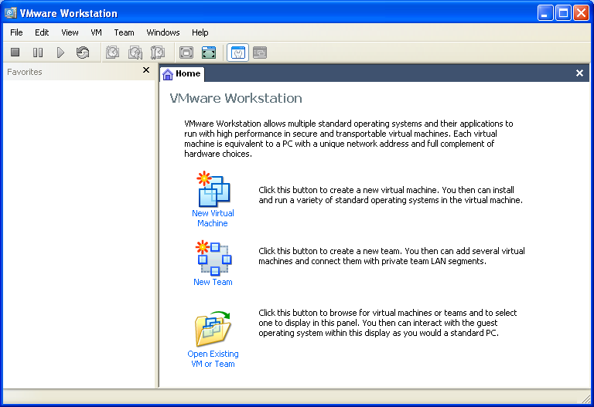
Starting Your Computer
- Start your computer with the appropriate L removable hard drive in it. Log in with the account information your instructor provided to you. In Fall 2005, the User name is CNIT235 with a password of windowsxp

Starting VMWare Workstation
- We will use a program called VMWare Workstation, which simulates a computer on top of the existing Windows XP operating system. That way you can practice installation and other activities without changing (and possibly damaging) the existing operating system.
- Double-click the VMWare Workstation icon on the desktop.
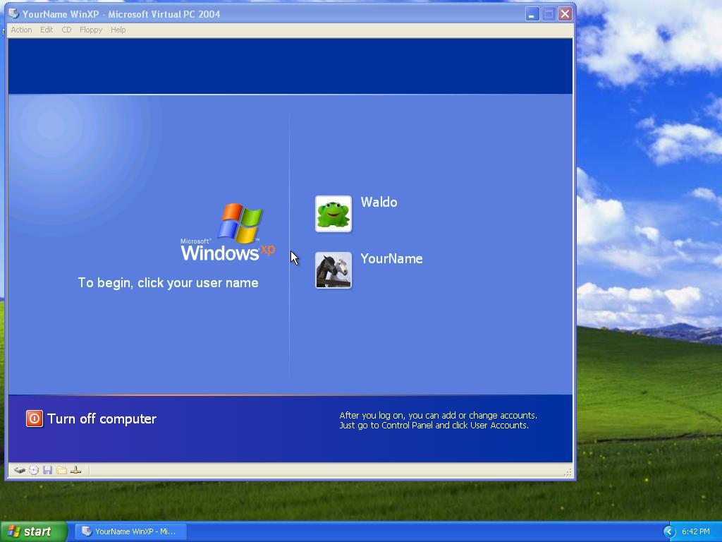
- A VMWare Workstation window opens as shown to the right on this page. Click the CNIT 100 tab and then click Start this virtual machine.
- When the virtual machine starts, you will see a login screen as shown to the right on this page (the names may be different). Click the Waldo icon. This is an Administrator account, and it should have no password. If it asks for a password, try P@ssw0rd
Downloading and Installing IRFANVIEW
- Open Internet Explorer. Go to irfanview.com. Click the download link.
- In the next screen, click the Tucows Worldwide Network - Download IrfanView link.
- A new window opens with a tucows banner. Click the DOWNLOAD NOW link.
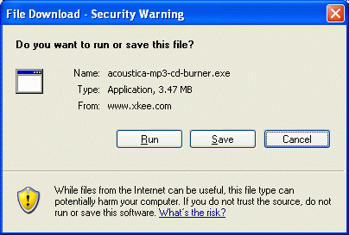
- The next page asks you to choose a download location. Scroll down to find USA and click on it. Click on any location in the list that appears – use one in California if possible. When downloading files, it’s faster, more reliable, and cheaper for the server operators if you use a nearby location.
- A File Download – Security Warning box opens, as shown to the right on this page. Click Run.
- In the Internet Explorer – Security Warning box, click Run.

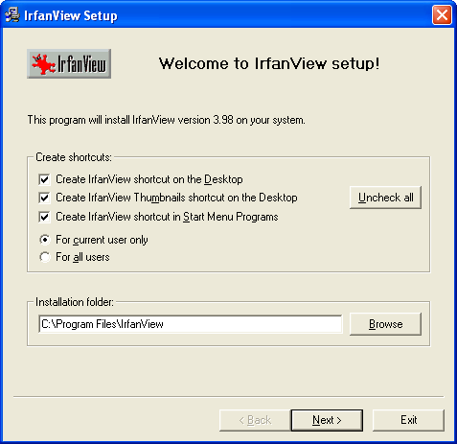
- .An Irfanview Setup box opens, as shown to the right on this page. Notice the Destination folder:

C:\Program Files\IrfanView

- Click Next.
- Click Next through the next two windows.
- When you see a window titled Free! Google Desktop Search, click the Don’t install Google Desktop Search radio button and click Next.
- In the Ready to Install box, click Next.
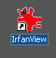
- In the Installation Successful box, click Done.
- Your virtual PC desktop should now have an IrfanView shortcut, as shown to the right on this page.
Examining the Installed Software
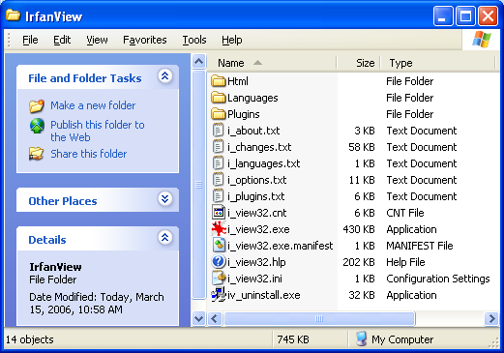
- Click Start, My Computer. Double-click drive C:. Click Show the contents of this folder.
- Double-click Program Files. Click Show the contents of this folder.
- Double-click Irfanview. In the Irfanview window, click View, Details. Several files and folders are visible, as shown below on this page.
- Find all the filename extensions in this window, and in the three folders. Make a list of how many files of each type you find.
- Take your list to the other members of your group, and make sure they have a complete list of file types.
Observing the Uninstall Option
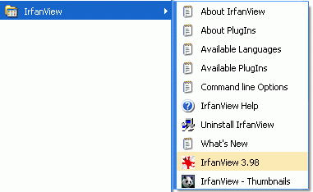
- Click Start, All Programs, IrfanView. Observe that there are several choices here, including an Uninstall Irfanview item. That was a nice thing the programmer provided for us. But not all programs are this kind – what would we do if there were no Uninstall option?
Using Add or Remove Programs
- Click Start, Control Panel. Click Add or Remove Programs.
- Add or Remove Programs opens. Wait until the list of programs appears. Then find IrfanView as shown below on this page.

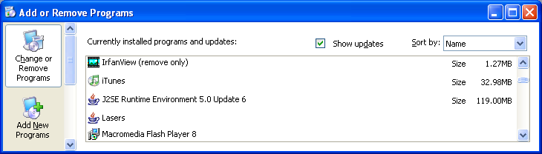

- Click on IrfanView (remove only). A blue bar appears, including a Change/Remove button. Click the Change/Remove button.
- An IrfanView Uninstall box opens, with the message Do you really want to uninstall IrfanView? Click Yes.
- An IrfanView Uninstall box opens, with the message IrfanView uninstalled. Click OK.
- Click Start, My Computer. Double-click drive C:. Double-click Program Files. Look for the IrfanView folder – it should be gone.
- Look for the IrfanView icon on the desktop – it should also be gone.
- Click Start, All Programs, and look for IrfanView – it should be gone. When an uninstallation proceeds correctly, it should remove all traces of the software from your machine.

