This project requires a hub and some Ethernet cables.

Choosing Machines for your LAN
- Select two adjacent machines in the room. Do NOT use any of these machines: L3, L6, L9, L12, L15, L18, L21. Those machines have special network settings that interfere with this project.

Starting Your Computers
- Start your computers with the appropriate L removable hard drive in it. Log in with the account information your instructor provided to you. In Spring 2006, the User name is CNIT235 with a password of windowsxp

Starting VMWare Workstation
- Double-click the VMWare Workstation icon on the desktop.
- When the VMWare Workstation window opens, click the CNIT 100 tab and then click Start this virtual machine.
- When the virtual machine starts, click the Waldo icon. This is an Administrator account, and it should have no password. If it asks for a password, try P@ssw0rd

Testing the Machines
- On both virtual machines, open Internet Explorer and make sure you can get to the Internet.

Wiring the LAN (Local Area Network)
- Put a hub on the table in the middle of your machines. Plug the power into the hub and make sure its front panel lights light up.
- Look at the back panel of one of your machines. There will be a blue cable plugged in – that’s the Internet connection. There may also be a red cable – if there is, unplug it and replace it when this project is over.
- Remove the blue Ethernet cable from the back of your machine. Replace the blue cable on each machine with a short patch cord that goes to a numbered port on the hub. It does not matter which port on the hub you use – they are all the same, except the Uplink port. If there is an Uplink port, don’t use it – just leave it empty. Your final network should look like the diagram to the right on this page. Each box marked W is a computer (Workstation).
Hub
4 3 2 1
W
W

Using the Network Setup Wizard to Make a Workgroup
- On both of your machines, click Start, My Computer. In the My Computer window, in the left pane, click My Network Places.
- In the left pane of the My Network Places window, in the Network Tasks section, click the Set up a home or small office network link.
- At the Welcome to the Network Setup Wizard screen, click Next.
- At the Before you continue… screen, click Next.
- If a screen opens titled The wizard found disconnected network hardware, and the disconnected hardware is the NetGear adapter, check the Ignore disconnected network hardware box and click Next. If the Intel adapter is disconnected, that’s wrong: plug it in and click Back.
- At the Select a connection method screen, select Other and click Next.
- At the Other Internet connection methods screen, select This computer belongs to a network that does not have an Internet connection and click Next.
- If a screen opens titled Your computer has multiple connections, accept the default choice Determine the acceptable connections for me (Recommended) and click Next.
- At the Give this computer a description and a name screen, leave the description unchanged and verify that the Computer name is the same as the label on the front of your system unit (for example, S214-01), and click Next.
- At the Name your network screen, enter a name of WORKGROUP and click Next.
- If a File and printer sharing screen appears, select Turn on file and printer sharing and click Next.
- At the Ready to apply network settings screen, read the settings, and if they look correct, click Next.
- At the Please wait screen, wait for the animation to end. It might take a minute or longer.
- At the You’re almost done screen, click Just finish the wizard. I don’t need to run the wizard on other computers and click Next.
- At the Completing the Network Setup Wizard screen, click Finish.
- If you are prompted to, restart your machine.

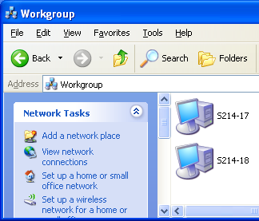
Viewing Your Workgroup in My Network Places
- On any one of your machines, click Start, My Computer. In the My Computer window, in the left pane, click My Network Places.
- In the left pane, in the Network Tasks section, click View workgroup computers. Both the computers in your workgroup should appear, as shown to the right on this page. If they don’t, try pressing the F5 key to refresh the Workgroup window, and then try restarting all the machines.

Choose a Internet Gateway
- Choose one of your machines to be an Internet Gateway. The other machine will be the Client.

Sharing a Folder on the File Server
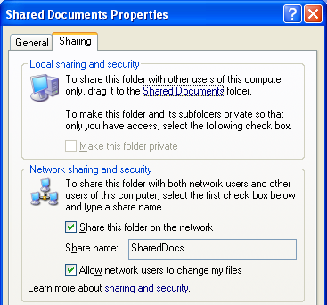
- Open Notepad and type in some text. Save the file in the Shared Documents folder as Shared File.
- On the Server machine, click Start, My Computer. Right-click the Shared Documents folder and select Sharing and Security.
- The Shared Documents Properties box opens, as shown to the right on this page. On the Sharing tab, select Share this folder on the network, and check the Allow network users to change my files box, as shown to the right on this page. Click OK.

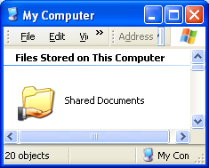
- In the My Computer window, a hand should now appear under the folder icon indicating that it is shared, as shown to the right on this page.

Viewing the Shared File from the Client
- Go to the Client machine. Click Start, My Computer. In the My Computer window, in the left pane, click My Network Places.
- In the left pane, in the Network Tasks section, click View workgroup computers. Both of the computers in your workgroup should appear. Find the Server machine and double-click it. You may see a Connect to computername window, asking you for a name and password, if the account you are using is not recognized on the other machine. If that happens, enter a name of Administrator and a password of P@ssw0rd.
- A window opens named \\computername, where computername is the name of your Server machine. Double-click the Shared Docs folder to open it. Double-click Shared File. You should see the shared file’s text.

Using the Internet
- On both your Client and Server machines, open Internet Explorer. You should not be able to get to the Internet, because the blue cables are disconnected. These machines can network with each other, but not with any other machines or the Internet.

Returning the Computers to Normal
- Remove the short patch cords and the hub from the machines. Give them back to your instructor. Plug the blue cables back into the machines. After a minute or so, the machines should be back on the Internet. If they cannot connect, restart the virtual machines.

Last modified 4-2-06

