This project requires a hub and some Ethernet cables.

Choosing Machines for your LAN
- Select two adjacent machines in the room. One of the machines will be the Internet Gateway¸ and it must be one of these machines: L3, L6, L9, L12, L15, L18, L21. The other machine will be your Client.

Changing Network Adapters Settings for the Internet Gateway (Drives L3, L6, L9, L12, L15, & L18)
- Each virtual machine on the stations listed above has new networking settings, which permits it to act as an Internet gateway. However, the changed settings mean some adjustment is required on your Internet Gateway so it can access the room’s network.
- Start VMware Workstation
- Select your virtual machine, but do not start it.
- Click the blue Edit Virtual Machine Settings link on the left side.
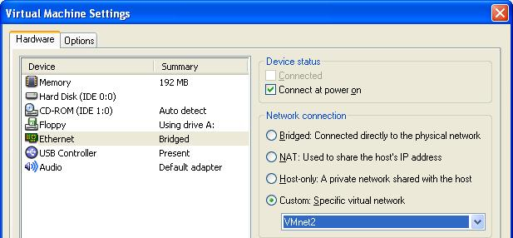
- Select Ethernet in the left pane and in the right pane click the Custom radio button, and select VMnet2 from the drop-down list, as shown below on this page. Click OK.
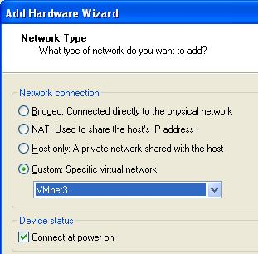
- In the Virtual Machine Settings box, click the Add button.
- The Hardware Wizard starts. Click Next.
- On the next screen select Ethernet Adapter and click Next.
- On the Network Type screen select Custom and select VMnet3 from the drop-down list as shown to the right on this page. Click Finish.
- In the Virtual Machine Settings window, click OK. This machine now has two virtual Ethernet adapters which map to its two physical NICs.

Testing the Internet Gateway
- Start the Internet Gateway, and log in as Waldo. Open Internet Explorer and verify that you can connect to the Internet. If you cannot, call the instructor over to fix the problem before proceeding any further.

Testing the Client
- Start the Client, and log in as Waldo. Open Internet Explorer and verify that you can connect to the Internet. If you cannot, call the instructor over to fix the problem before proceeding any further.

Wiring the LAN (Local Area Network)
- Put a hub on the table in the middle of your machines. Plug the power into the hub and make sure its front panel lights light up.
Hub
To the Internet
Client
Internet
Gateway
- Look at the back panel of one of your machines. There will be a blue cable plugged in – that’s the Internet connection. There may also be a red cable – if there is, unplug it and replace it when this project is over.
- Remove the blue Ethernet cable from the back of the Client machine, and replace it with a short patch cord that goes to a numbered port on the hub. It does not matter which port on the hub you use – they are all the same, except the Uplink port. If there is an Uplink port, don’t use it – just leave it empty.
- Leave the blue cable connected on the Internet Gateway machine. Connect a patch cord from the second Ethernet port (on an expansion card) to a numbered port on the hub. Your final network should look like the diagram to the right on this page.

Using the Network Setup Wizard to Create an Internet Gateway
- On your Internet Gateway click Start, My Computer. In the My Computer window, in the left pane, click My Network Places.
- In the left pane of the My Network Places window, in the Network Tasks section, click the Set up a home or small office network link.
- At the Welcome to the Network Setup Wizard screen, click Next.
- At the Before you continue… screen, click Next.
- At the Select a connection method screen, select This computer connects directly to the Internet. The other computers on my network connect to the Internet through this computer and click Next.
- At the Select your Internet connection screen, accept the default selection and click Next.
- At the Give this computer a description and a name screen, leave the description unchanged and verify that the Computer name is the same as the label on the front of your system unit with a V at the end (for example, S214-01V), and click Next.
- At the Name your network screen, enter a name of WORKGROUP and click Next.
- If a File and printer sharing screen appears, select Turn on file and printer sharing and click Next.
- At the Ready to apply network settings screen, read the settings, and if they look correct, click Next.
- At the Please wait screen, wait for the animation to end. It might take a minute or longer.
- At the You’re almost done screen, click Just finish the wizard. I don’t need to run the wizard on other computers and click Next.
- At the Completing the Network Setup Wizard screen, click Finish.

Testing the Internet Gateway’s Internet Connection
- Open Internet Explorer on the Internet Gateway machine. You should be able to access the Internet.

Using the Network Setup Wizard to Connect the Client Machine to the Internet Gateway
- Click Start, My Computer. In the My Computer window, in the left pane, click My Network Places.
- In the left pane of the My Network Places window, in the Network Tasks section, click the Set up a home or small office network link.
- At the Welcome to the Network Setup Wizard screen, click Next.
- At the Before you continue… screen, click Next.
- There are two possibilities for the next screen:
  - If you see a Select a connection method screen, select This computer connects to the Internet through a residential gateway or through another computer on my network and click Next.
  - If you see a Do you want to use the shared connection? screen, select Yes, use the existing shared connection… and click Next.
- At the Give this computer a description and a name screen, leave the description unchanged and verify that the Computer name is the same as the label on the front of your system unit with a V at the end (for example, S214-01V), and click Next.
- At the Name your network screen, enter a name of WORKGROUP and click Next.
- If a File and printer sharing screen appears, select Turn on file and printer sharing and click Next.
- At the Ready to apply network settings screen, read the settings, and if they look correct, click Next.
- At the Please wait screen, wait for the animation to end. It might take a minute or longer.
- At the You’re almost done screen, click Just finish the wizard. I don’t need to run the wizard on other computers and click Next.
- At the Completing the Network Setup Wizard screen, click Finish.

Testing the Client’s Internet Connection
- Open Internet Explorer on the Client machine. You should be able to access the Internet.

Shutting Down the Gateway Machine
- Shut down the gateway machine. Then try to use the Internet from the client machine. You can’t, of course, because their only path to the Internet goes through the gateway machine.

Restarting the Gateway Machine
- Start the gateway machine. Then try to run a Google search on the other machines in the workgroup. They are again connected to the Internet.

Returning the Computers to Normal
- Remove the short patch cords and the hub from the machines. Give them back to your instructor. Plug the blue cables back into the machines. After a minute or so, the machines should be back on the Internet. If they cannot connect, restart the virtual machines.

Last modified 4-2-06

