Finding Your CCSF Email Address
- The first part of your CCSF email address is your HP-UNIX ID. Your HP-UNIX ID is made by taking the first letter of your first name, the first 5 letters of your last name, and then adding a 2-digit number, usually 01
- For example, a student named Wilhelm Reichert would have an HP-UNIX ID of wreich01 (note that all letters are lowercase).
- To complete the email address, add @ccsf.edu to the HP-UNIX ID. So Wilhelm Reichert’s email address would be wreich01@ccsf.edu
- Not all the HP-UNIX IDs end in 01. To find your HP-UNIX ID, ask your instructor, or look at the list posted on the bulletin board in S214.
CCSF Email Address:
MSDNAA Password:
- When you have your CCSF Email Address, write it in the box to the right on this page.
Requesting Your MSDNAA Password
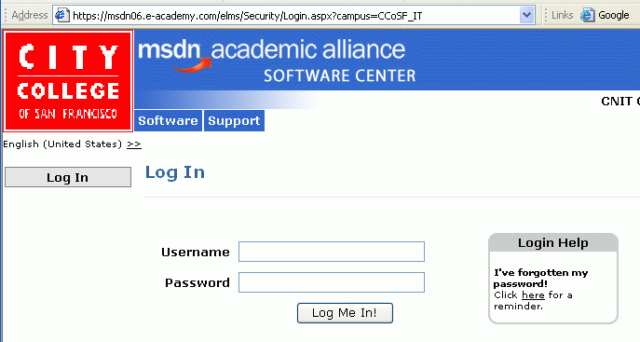
- Open Internet Explorer and go to www.ccsf.edu/cnit
- Look in the list on the left side of the page, around the sixth item down. Click the MSDN Academic Alliance link. The msdn academic alliance page opens, as shown to the right on this page.
- Click the gray Log In link on the left side of the page.
- Look at the right of the page to find the Login Help section. Click the word here.
- In the Password Reminder screen, in the Username box, enter your CCSF Email Address as you wrote it in the box on the previous page. Click the Submit button.
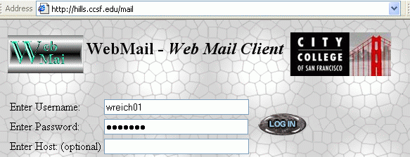
Getting Your CCSF Email
- Start Internet Explorer and go to hills.ccsf.edu/mail
- The WebMail page opens, as shown to the right on this page. In the Enter Username box, enter your HP-UNIX ID (do not include the @ccsf.edu). In the Enter Password box, enter your birthday in the format aug0378
- Click the LOG IN button.
- The first time you use it you will see a configuration page – just accept the defaults and go on to the main MAIL page.
Getting Your MSDNAA Password
- You should see a message with the subject Login Reminder – City College … from msdnaa_softwarecenter, as shown below.
- Click the blue Login Reminder link to open the message. Your MSDNAA Password should be in that message. Write that password in the box on the previous page.
Logging in to MSDNAA
- Open Internet Explorer and go to www.ccsf.edu/cnit
- Click the MSDN Academic Alliance link.
- In the msdn academic alliance page, click Log In. In the Username box, enter your CCSF email address from the box on the previous page. In the Password box, enter the MSDNAA Password from the box on the previous page. Click the Log Me In! button.
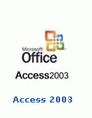
Ordering a Copy of Microsoft Access
- Click the blue Software box at the top of the page. If a Security Alert box opens, click Yes. If you see a message that the page has moved, click the click here link.
- Click on the of Access 2003 logo, as shown to the right on this page.
- Click Download only and click ADD TO CART.
- The Student Use Guidelines appear. Scroll down and click I Agree at the bottom.
- A View Shopping Cart screen appears. Click CHECK OUT.
- On the Customer Information screen, fill in your name and click Next.
Getting your Serial Number
- On the Order Details screen, click on the blue Access 2003 link.
- Your Serial Number appears. Save this number – I recommend copying it into an e-mail message or NotePad file immediately. You will need it to install the software at home.
Downloading Access
- Scroll down and click one of the gray Download Software buttons.
- Download the file to your desktop. It is a small file named Simon.exe.
- Close all windows and double-click the Simon.exe file. A License Authorization and Software Installation window opens.
- Accept the default download location of C:\Temp and click the gray button to proceed.
- Wait for the red progress indicator at the bottom of the License Authorization and Software Installation window to reach 100%. Wait until it has downloaded the file and unzipped it.
- When the red progress indicator vanishes, you will see a gray Launch Install button. DO NOT CLICK IT!
- Click Start, My Computer. Double-click drive C:. Double-click the Temp folder. You should see a folder named EN_Access2003. This folder contains the Access installation files. We want to burn this folder to a CD so you can take it home and install it there.
- Make the Temp window smaller, so that it uses about 1/3 of the screen.
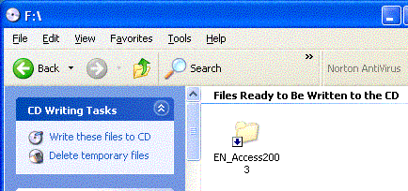
Recording a CD
- Insert a blank CD-R.
- Click Start, My Computer. Double-click the CD drive. Make the CD’s window small, so it is next to the Temp window without overlapping.
- Drag the EN_Access2003 folder from the Temp window and drop it into the CD’s window.
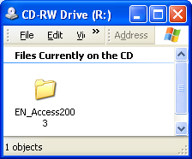
- In the left pane of the CD’s window, click Write these files to the CD, as shown to the upper right on this page.
- The CD Writing Wizard opens. In the first screen, Enter a CD name of Access 2003 and click Next. Wait while the CD burns.
- When the CD pops out, label it “Access 2003” with a felt-tipped pen.
Checking the CD
- Insert the labeled CD-R into the drive on a different computer. Click Start, My Computer. Double-click the CD drive. You should see the EN-Access2003 folder on the CD, as shown to the right on this page.
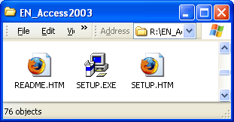
- Double-click the EN-Access2003 folder. There should be 76 objects in the folder, including a SETUP.EXE item, as shown to the right on this page. When you install the software at home, double-click this SETUP.EXE

Recording More CDs
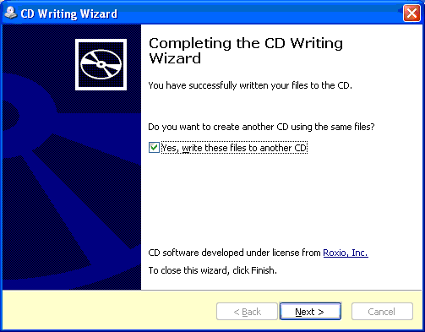
- In the Completing the CD Writing Wizard window, check the Yes, write these files to another CD box, as shown to the right on this page. Insert another blank CD and click the Next button. Repeat until you have made as many CDs as needed.

Revised 4-17-06

