Materials Needed
Note: Copying music is only legal from CDs you own, to make copies for your personal use. If you make copies of copyrighted music and distribute them, you may be committing a crime.
- A music CD-ROM
- Speakers or headphones.
- Administrative access to a computer so you can install software
Files on Music CDs
- Insert a music CD, probably the one your instructor provided. Open My Computer, and open the CD to see what’s on it.
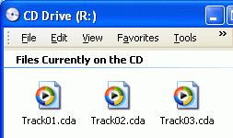
- The CD window opens, as shown to the right on this page. It contains several files with a .cda filename extension. If you cannot see the filename extensions, do this process to make them visible:
  - Click Tools, Folder Options
  - In the Folder Options window, click the View tab
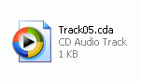
  - Clear the Hide extensions for known file types box. Click OK.
- Let’s try to copy the music from the CD onto the computer. In the CD window, point to one of the files, right-click, and click Copy. Then minimize all windows, point to an empty portion of the desktop, right-click, and select Paste. The file appears on your desktop, as shown to the right on this page.
Playing Music with Windows Media Player
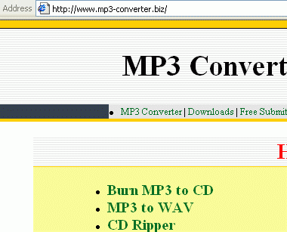
- Right-click the file on your desktop and select Play. Windows Media Player opens, but you do not hear any music. Perhaps something is wrong with the copied file – let’s try to play the original music instead.
- In the CD window, right-click a .cda file and select Play. Windows Media Player opens, and the music should start playing. So the music is really on the CD, but it can’t be copied using Windows Explorer. To copy music CDs, you need a CD Ripper.
Installing Acoustica
- Open Internet Explorer and go to
www.mp3-converter.biz
- At the next screen, as shown to the right on this page, click on CD Ripper,.

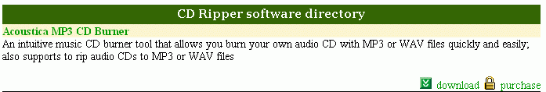
- In the CD Ripper Software directory section, find Acoustica MP3 CD Burner, as shown below on this page. Click the download link.

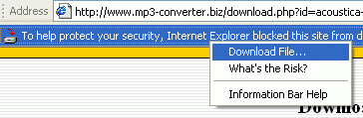
- If an Information Bar box opens, click OK.
- If a Security Alert box opens, click OK.
- Click the Information Bar below the address and click Download File… as shown to the right on this page.
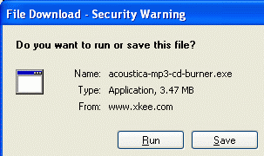
- If a Security Alert box opens, click OK.
- Find the File Download – Security Warning box, as shown to the right on this page. You may have to minimize the Internet Explorer window to make it visible. Click Run.
- In the Internet Explorer – Security Warning box, click Run.
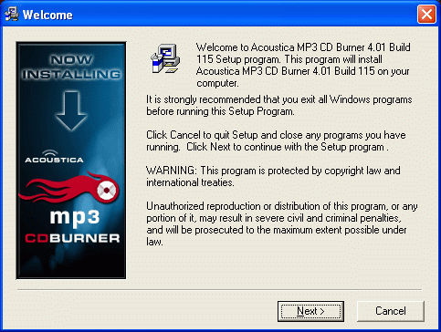
- .A Welcome box opens, as shown to the lower right on this page. Click Next.
- In the Choose Destination Location box, click Next. Click Next through the next three windows.
- In the Installation Complete box, click Finish.
- In the Acoustica MP3 CD Burner License Agreement & Disclaimer box, check the check box and click Continue.
- In the Acoustica MP3 CD Burner Free Trial box, click Close.
Ripping a CD with Acoustica
- Acoustica opens, as shown below. Click the RIP CD button.
RIP CD
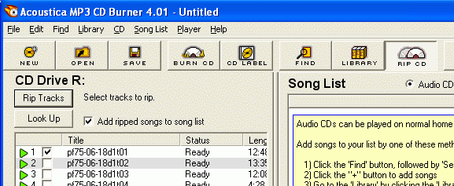
Rip Tracks

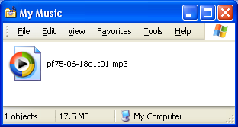
- In the left pane, clear all but one of the check boxes, so we will only rip one track. That will make the process faster.
- Click the Rip Tracks button. Wait while the process completes – it will take a couple of minutes to reach 100%.
- Click Start, My Music. The ripped track should be there, with an .mp3 file extension, as shown to the right on this page.
- Double-click the MP3 file to play it. The music should play now. The music from the CD has been converted into an MP3 file, which can be played on a computer, iPod, cell phone, or any MP3 player.

