Starting Your Computer
- Start your computer with the appropriate L removable hard drive in it. Log in with the account information your instructor provided to you. In Fall 2005, the User name is CNIT235 with a password of windowsxp

Starting VMWare Workstation
- Double-click the VMWare Workstation icon on the desktop.
- When the VMWare Workstation window opens, click the CNIT 100 tab and then click Start this virtual machine.
- When the virtual machine starts, click the Waldo icon. This is an Administrator account, and it should have no password. If it asks for a password, try P@ssw0rd

Creating a Test File
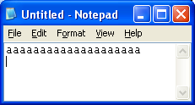
- Right-click an empty area of the desktop and select New, Folder. Name the folder NTFS.
- Click Start, All Programs, Accessories, Notepad. In the Notepad window, hold down the letter a for a while so you get a line of as. It doesn’t matter exactly how many as you end up with. Then press the Enter key, so your screen looks like the example to the right on this page.
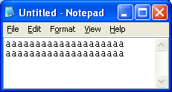
- Hold down the Ctrl key and press A once to select all the text.
- Then hold down the Ctrl key and press C to copy all the text to the clipboard.
- Then hold down the Ctrl key and press V twice. That will copy the line twice – once on top of the existing line, and once after it, so you end up with two lines as shown to the right on this page.
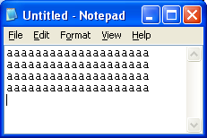
- Repeat those four keystrokes again: Ctrl+A, Ctrl+C, Ctrl+V, Ctrl+V. Now the file should have four lines in it, as shown to the right on this page.
- Now repeat the whole cycle of keystrokes ten times: Ctrl+A, Ctrl+C, Ctrl+V, Ctrl+V. That makes a big Notepad file to use.
- In the Untitled – Notepad window, click File, Save. Save the file in your NTFS folder on the desktop with the filename testfile.
- Close Notepad.

Copying the Test File
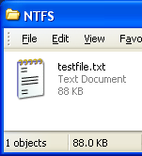
- Double-click the NTFS folder on the desktop. You should see the testfile in the folder, as shown to the right on this page.
- Press Ctrl+A to select the file.
- Press Ctrl+C to copy the file to the clipboard.
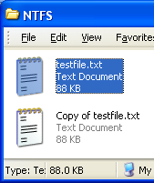

- Press Ctrl+V to paste a copy of the file into this folder. Now the folder should have two files, as shown to the right on this page. Notice that both files are 88 KB in size (your size may be different, but both files should be the same size). If you cannot see the file size, click View, Tiles.

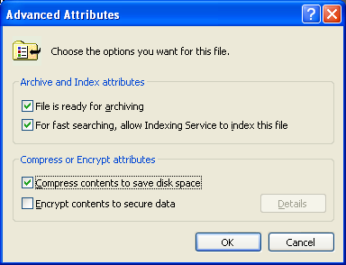

Using NTFS Compression
- Right-click testfile.txt and click Properties. In the testfile.txt Properties box, click the Advanced button.
- In the Advanced Attributes box, check the Compress contents to save disk space box, as shown to the right on this page. Click OK.
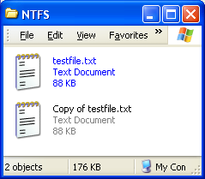
- In the testfile.txt Properties box, click the OK button.

- Click an empty portion of the NTFS window to deselect the testfile.txt file. You should see testfile.txt labeled in blue letters—this is how Windows XP tells you the file is compressed. But the file size is still the same! Why is that?

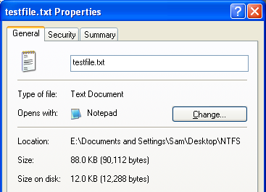
- Right-click testfile.txt and click Properties. In the testfile.txt Properties box, look at the Size and Size on disk values. The file has its original Size, but it occupies much less room on the disk. That’s what NTFS Compression does – it makes the file smaller. Click OK to close the testfile.txt Properties box.

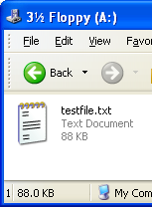

Copying the Compressed File to the Floppy Disk
- Insert a floppy disk. Right-click testfile.txt, point to Send to, and click 3 ½ Floppy (A:).
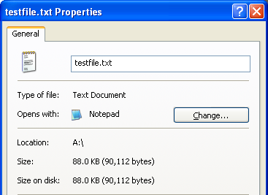
- Click Start, My Computer. Double-click 3 ½ Floppy (A:). The file should be visible, as shown to the left on this page.

- In the 3 ½ Floppy (A:) windows, right-click testfile.txt and click Properties. Notice that the Size and Size on disk values are the same, as shown to the right on this page–the compression is not working! Why is that?

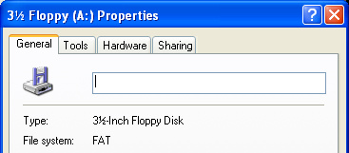
- To see why, click Start, My Computer. Right-click 3 ½ Floppy (A:) and click Properties. Notice that the File system: is FAT. FAT is the older, simpler file system that was replaced by NTFS, and it does not allow you to use NTFS compression. Floppy disks still use the older FAT system, but most hard disks now use the NTFS file system.

