Starting Your Computer
- Start your computer with the appropriate L removable hard drive in it. Log in with the account information your instructor provided to you. In Fall 2005, the User name is CNIT235 with a password of windowsxp

Starting VMWare Workstation
- Double-click the VMWare Workstation icon on the desktop.
- When the VMWare Workstation window opens, click the CNIT 100 tab and then click Start this virtual machine.
- When the virtual machine starts, click the Waldo icon. This is an Administrator account, and it should have no password. If it asks for a password, try P@ssw0rd

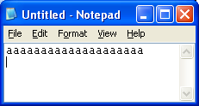
Creating a Test File
- Right-click an empty area of the desktop and select New, Folder. Name the folder NTFS.
- Click Start, All Programs, Accessories, Notepad. In the Notepad window, type a few letters, so your screen looks like the example to the right on this page.
- Close Notepad.

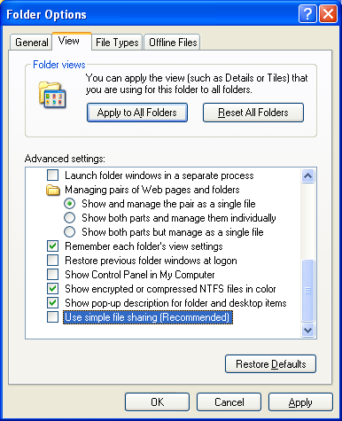
Turning Off Simple File Sharing
- Simple File Sharing conceals the NTFS file permissions, and we want to see them, so we need to turn it off. In the NTFS window, click Tools, Folder Options.
- In the Folder Options box, click the View tab. Scroll to the bottom of the Advanced settings: list and remove the check box next to Use simple file sharing (Recommended) as shown to the right on this page. Click OK.

Protecting the Test File with NTFS Permissions
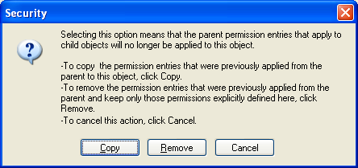
- Right-click testfile and click Properties.
- In the testfile.txt Properties box, click the Security tab. Click the Advanced button.
- In the Advanced Security Settings for testfile.txt box, clear the Inherit from parent the permission entries that apply to child objects… check box.
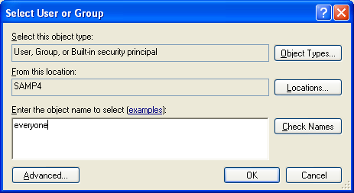
- When a Security box opens, as shown to the upper right on this page, click the Remove button.
- In the Advanced Security Settings for testfile.txt box, click OK.
- In the Security box, click Yes.
- In the testfile.txt Properties box, click the Add button.
- In the Select User or Group box, enter everyone as shown to the right on this page, and click OK.
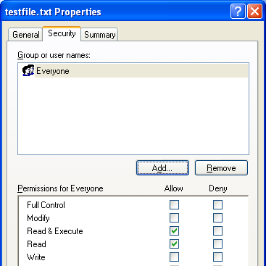

- The testfile.txt Properties box should now look like the figure to the right on this page. This means that Everyone can Read & Execute and Read the file, but they are not allowed to Modify or Write to the file. Click the OK button.

Using a File that is Protected by NTFS Permissions
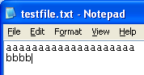
- Double-click testfile. The file opens in Notepad. Type in some more text, as shown to the right on this page.
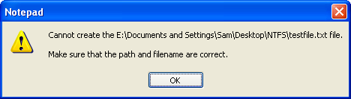
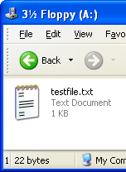
- Click File, Save to save the file. You get a message like the one shown to the right on this page – this message does not explain what the problem is, but it cannot create the file. The reason it cannot create the file is that the NTFS permissions prevent it.
- Click OK. In the Save As box, click Cancel. Close Notepad. In the Notepad box, asking if you want to save changes, click No.

Copying the File to a Floppy Disk
- Insert a floppy disk. Right-click testfile, point to Send to, and click 3 ½ Floppy (A:).
- Click Start, My Computer. Double-click 3 ½ Floppy (A:). The file should be visible, as shown to the right on this page.
- In the 3 ½ Floppy (A:) window, double-click testfile.txt to open it in Notepad.
- Type in some more text, as shown to the right on this page.
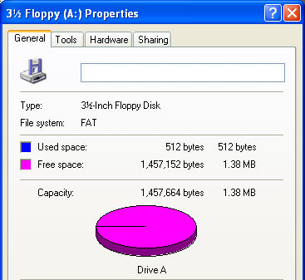
- Click File, Save to save the file. The file saves normally. Close Notepad.
- Why didn’t the NTFS permissions stop you from changing the file? To find out, in the 3 ½ Floppy (A:) window, right-click testfile.txt and click Properties. The Security tab is gone! The NTFS permissions were lost.
- To see why, click Start, My Computer. Right-click 3 ½ Floppy (A:) and click Properties. Notice that the File system: is FAT. FAT is the older, simpler file system that was replaced by NTFS, and it does not allow you to protect your file with NTFS permissions. Floppy disks continue to use the older FAT system, but most hard disks now use the NTFS file system.

