Downloading and Installing NVU
- Use your virtual PC.
- Open Internet Explorer and go to nvu.com
- At the top of the page, click the Downloads link.
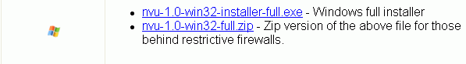
- In the next screen, scroll down to find the Windows full installer as shown to the right on this page. Click the blue nvu-1.0-win32-installer-full.exe link
- In the File Download – Security Warning box, click Run.
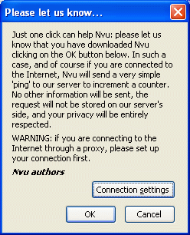
- In the Internet Explorer – Security Warning box, click Run.
- An installer opens. Click through the installer, accepting all the default selections.
- When you see the Please let us know… box shown to the right on this page, click OK.
- Close the Nvu tips box.
Using NVU
- Enter some text in the large white area, as shown below. You can format text using the toolbar buttons. It works pretty much the same way as Microsoft Word.
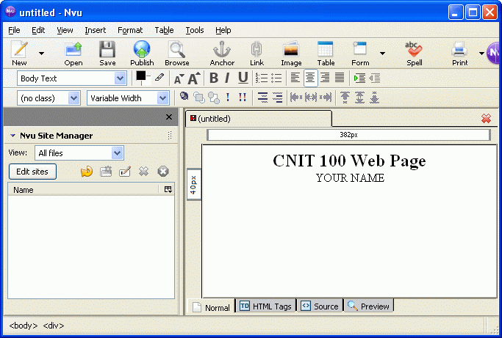
Saving a Web Page
- Click the Save button in the top left. In the Page Title box, enter CNIT 100 Web Page.
- In the Save Page As dialog box, give the page a name of nvupage.html and save it in the My Documents folder.
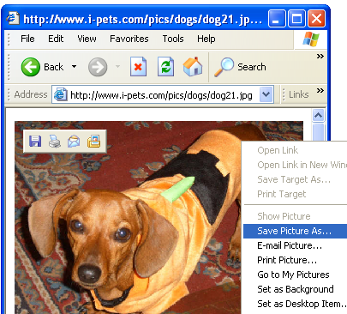
Saving an Image File
- Open a new browser window and go to Google.com. Do a search for anything you like, such as dogs, and find a picture you like.
- You need to save this picture on your hard disk, and you need to make sure you know its exact file name, including the file extension.
- Right-click on the picture you like best and select Save Picture As…, as shown to the right on this page.

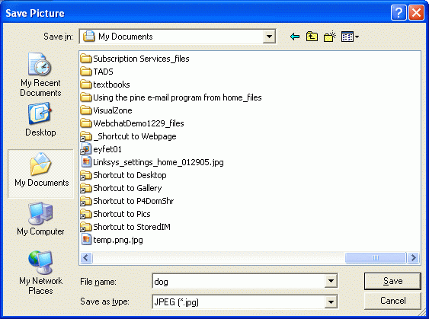
- The Save Picture dialog box opens, as shown to the right on this page. In the left section of the Save Picture dialog box, click the My Documents folder. Click Save to save your image.

Adding an Image to the Web Page
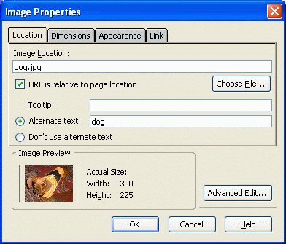
- Click the Image button in the top center of the Nvu window.
- In the Image Properties box, click Choose File. Find your image and double-click on it.
- In the Image Properties box, in the Alternate text: box, type a short description of the image. Click OK.
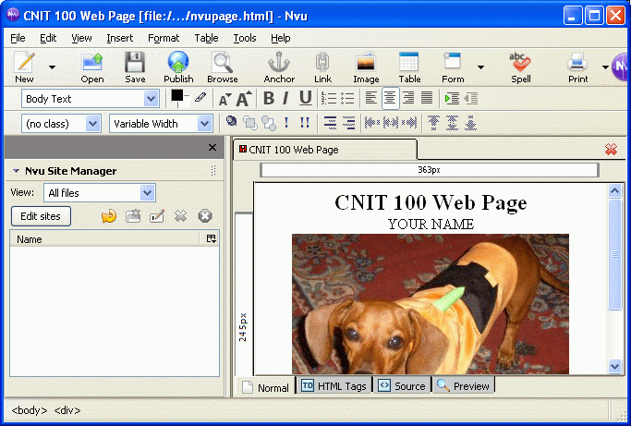
- The image should appear on your Web page, as shown below on this page. Click the Save button.

Publishing the Web Page on the CCSF Server
- This Web page consists of two files in your my Documents folder: notepadpage.html and dog.jpg. But no one can see the files on your computer – to make them available to other people, you have to move the files up to a Web server.
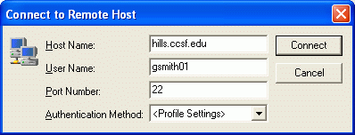
- Click Start, All Programs, SSH Secure Shell, Secure File Transfer Client. If SSH is not on the All Programs menu, it needs to be installed on your computer. Ask your instructor to do it.
- When the Secure File Transfer window opens, press the Enter key.
- In the Connect to Remote Host window, enter a Host Name of hills.ccsf.edu and a User Name of your HP-UNIX ID. Your HP-UNIX ID is the same ID you use to get your CCST email, or to log in to the computers in the ACRC in Batmale room 301. Press the Enter key.
- One or two more boxes appear. Press Enter to close them. When you see the Enter Password box, enter your birthday in the format jul0369
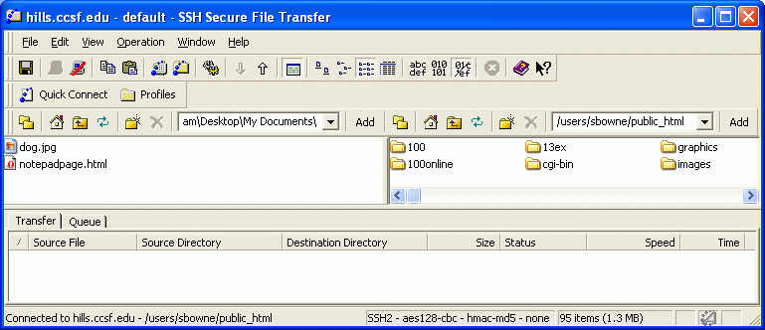
- Double-click the public_html folder in the right pane to open it, and navigate to My Documents folder in the left pane. You should see the two files notepafpage.html and dog.jpg in the left pane, as shown below on this page.

- Drag the two files from the left pane to the right pane and drop them. This copies your files to the server.
- Open a browser and type in this URL to see your page:
hills.ccsf.edu/~gsmith01/notepadpage.html
Replace gsmith01 with your HP-UNIX ID.

Last modified 4-26-06

