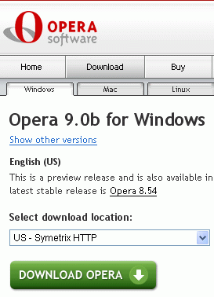
Downloading and Installing Opera 9.0
- Use your virtual PC.
- Open Internet Explorer and go to opera.com
- Click the Download Opera 9 Beta link.
- In the next screen, select a Download location in the US, as shown to the right on this page, and click the green DOWNLOAD OPERA button.
- In the File Download – Security Warning box, click Run.
- In the Internet Explorer – Security Warning box, click Run.
- An installer box opens. When the large heading Opera 9.0 Beta appears, click Start setup.
- Accept the agreement and click through the installer, accepting all the default selections.
- Opera should open.
Using Trash
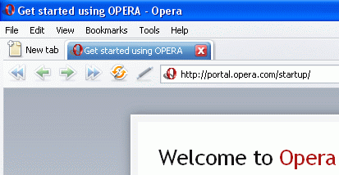
- At the top of the screen there is a blue tab showing the currently open page: Get started using OPERA. Click the X button on the tab.
- The page closes, leaving a blank window. Click the Trash icon in the upper right corner of the Opera window. In the drop-down menu, click Get started using OPERA. The page re-opens.
- Notice that there is now a second tab, named Blank Page. That’s a bit silly, and could be considered a bug in the beta version. Close the Blank Page tab by clicking on the X.
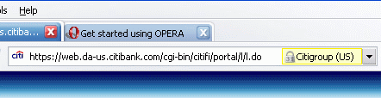
Using Security Bar
- Type in the address citibank.com and press the Enter key. In the Citibank page, click the sign on link in the upper right.
- This is a secure page, because the URL begins with https. Opera shows you it’s secure by displaying a yellow padlock to the right of the URL. But it also shows the name of the owner of the security certificate, so you know who you are communicating with.
Using Thumbnail Preview
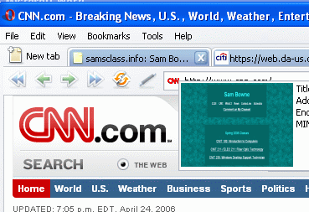
- In the upper left of the window, click the New Tab button. Type in any URL you like, such as samsclass.info and press the Enter key to open the page.
- Click the New Tab button again, and enter another URL such as cnn.com
- Point to one of the tabs and hover there, but don’t click. A tiny version of the Web page appears, as shown to the right on this page. This is useful to find the page you want when many tabs are open.
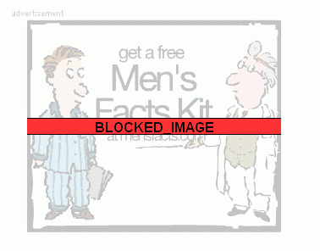
Using Content Blocker
- Suppose there is stuff I don’t want to see on a Web page that is otherwise useful. You can block it!
- Look on the CNN page and find an annoying ad (there should be plenty of ads!). To block it, point to an empty part of the CNN page, such as the right hand margin, and right-click. In the context menu, click Block content….
- A message appears in a yellow bar near the top of the screen saying Click on content you want to block. The text on the page turns gray – you cannot block the gray part. But the ads and images are clear. To block an ad, just left-click on it once. You should see a red BLOCKED IMAGE bar across it, as shown above.
- In the yellow bar, click the gray Done button. CNN reappears, without the ad.
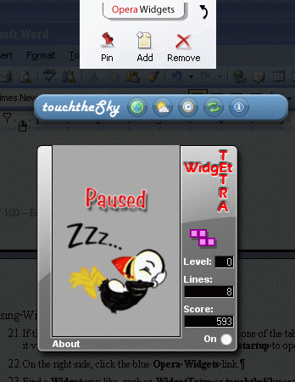
Using Widgets
- If the Get Started Using Opera page is still open on one of the tabs, click that tab to make it visible. If not, type in the URL portal.opera.com/startup to open it.
- On the right side, click the blue Opera Widgets link.
- Find a Widget you like, such as WidgetTetra or touchtheSky and download it.
- When the Widgets are active, all the other windows are dimmed to a dark gray. Put the Widget anywhere you want to on the gray desktop.
- To add more widgets, click the Add button. When you are done with them, click the Opera Widgets button at the top center of the screen.
- You are now back on your normal desktop. To see the widgets again, click the Opera Widgets button at the top center of the screen.

Last modified 4-24-06

