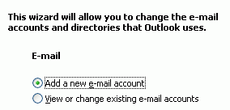
WARNING TO STUDENTS USING PUBLIC MACHINES IN THE ICL-1 LAB OR OTHER COMPUTER LABS: If you have important mail in your pine Inbox it will be lost when you do this homework. Use the WebIMAP page hills.ccsf.edu/mail to forward your important messages to another account before doing this project.

1. Start Microsoft Outlook with Start, Programs, Microsoft Office, Microsoft Office Outlook. Select Tools, E-mail Accounts from the menu bar. When the E-mail Accounts window opens as shown to the upper right on this page, click Add a new e-mail account and then click Next.

2. In the next window, select POP3 and then click Next.

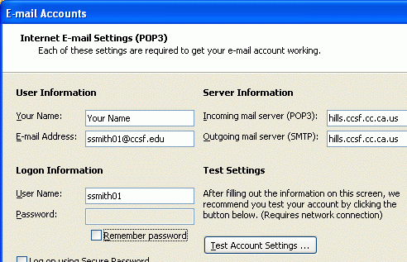
3. In the next window, fill in your name, e-mail address, and HP-UNIX user ID on the left side. Leave the password blank and uncheck the Remember Password box. On the right side, enter hills.ccsf.cc.ca.us for both the Incoming and Outgoing server names.

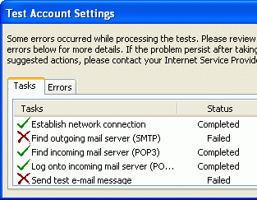
Click the Test Account Settings button. When a box pops up asking for your password, enter your birthday in the format

jan1578

If you are on campus, all the tests should succeed. If you are working from home, the send tests will fail as shown to the right on this page. You cannot send mail with the CCSF system from off campus.

Close the Test Account Settings window.

In the Email Accounts window, click Next. In the next window, click Finish.

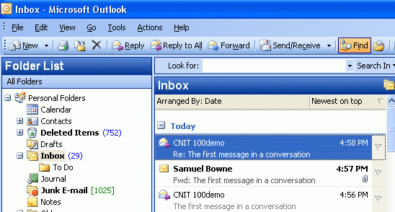
4. In the main Outlook window, click Send/Receive. You should see your email messages appear as shown to the right on this page.

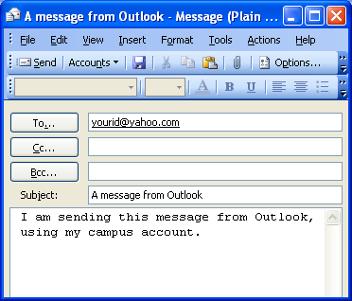
5. To send an email, click the New button in the top left of the window. Then fill in the address and message as shown to the right on this page. To send it, click the Send button. Then click the Send/Receive button in the main Outlook window.

Last modified 2-8-06

