Starting Your Computer
- Start your computer with the appropriate L removable hard drive in it. Log in with the account information your instructor provided to you. In Spring 2006, the User name is CNIT235 with a password of windowsxp

Starting VMWare Workstation
- Double-click the VMWare Workstation icon on the desktop.
- When the VMWare Workstation window opens, click the CNIT 100 tab and then click Start this virtual machine.
- When the virtual machine starts, click the Waldo icon. This is an Administrator account, and it should have no password. If it asks for a password, try P@ssw0rd


Testing Your Computer with PC Pitstop

Open Internet Explorer, click in the Address bar near the top of the window, and type in

www.pcpitstop.com

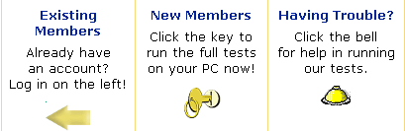
Then press the Enter key open the PC Pitstop page, as shown to the right on this page

Click on Full Tests in the upper left part of the window. The PC Pitstop Full Tests page opens, showing three boxes with gold icons in them as shown to the right on this page.

Click the key under the words New Members
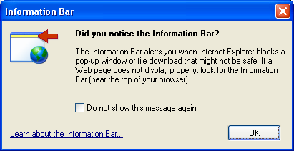

If an Information Bar box opens, as shown to the right on this page, click OK.

Click the yellow bar at the top of the browser window, and click Install ActiveX Control… as shown below on this page.
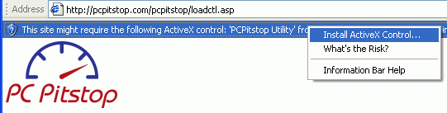
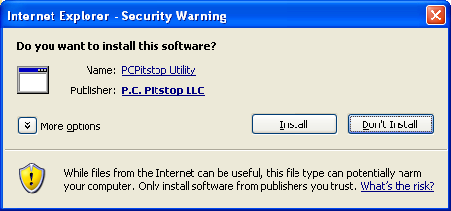

When the Internet Explorer – Security Warning box opens, as shown to the right on this page, click Install.

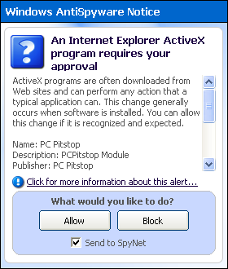
If a Windows AntiSpyware Notice box opens, as shown to the right on this page, click Allow.

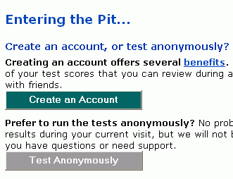

When you see the Entering the Pit… screen, as shown to the right on this page, click Test Anonymously.

In the next screen, click Let’s go!

When a PC Pitstop Utility box opens, as shown below, click OK.

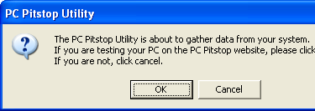

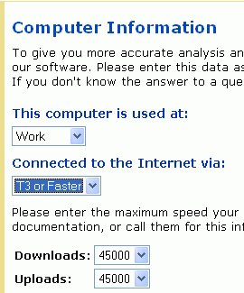
Wait while the PC Pitstop software runs – it takes a few minutes, and the screen will show large test patterns during the video card test.

When a Computer Information box opens, as shown to the right on this page, select Work and T3 or Faster. The Downloads and Uploads should both automatically set to 45000, the speed of a T3 connection. After answering the questions, and click the Go button.

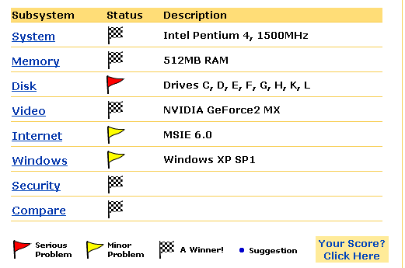
When a Test Results Summary window opens, scroll down and find the summary of your computer system with colored flags, as shown to the right on this page.

If you have any red or yellow flags, click on them to find out what problems there are with your computer, and how to fix them.

Last Updated: 3-27-06

