Using Calculator
- Click Start, All Programs, Accessories, Calculator. Calculator opens. Look at it just to see what it is, and close it. This is a little program included in Windows. Where is this program stored on the hard disk?
- In fact, the program is stored in C:\Windows\System32 and it is a single file named calc.exe. To see it, do these steps:
Finding Calculator with My Computer
- Click Start, My Computer. Double-click drive C:. Click Show the contents of this folder.
- Double-click Windows. Click Show the contents of this folder.
- Double-click System32. The folders appear at the top in this window. Scroll down past all the folders and find the files, which are in alphabetical order. Notice how hard it is to find things in this folder, which contains thousands of files. Find the calc.exe file, as shown below on this page.
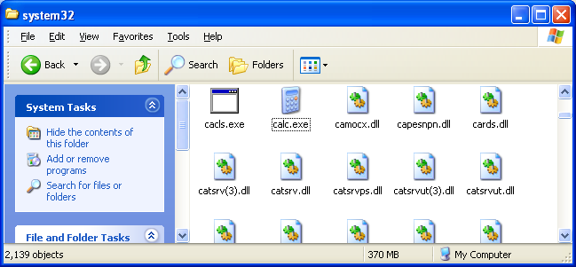

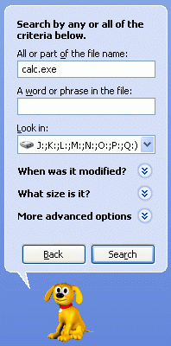

- Double-click the calc.exe file. This is another, far less convenient, way to open Calculator. Close the Calculator window.
Finding Calculator with Search
- Click Start, Search.
- In the Search Results window, click All files and folders.
- In the All or part of the file name: box, enter calc.exe as shown to the right on this page. Click Search.

- After a few minutes, the file is found, as shown below on this page. Search shows you the folder the file is in, and other information: its size, type, and the date the file was last modified.
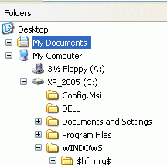
Finding Calculator with Windows Explorer
- Right-click the Start button and left-click Explore. A window opens showing a folder tree in the left pane – this is Windows Explorer.
- In the left pane, click + and – signs to expand and contract the folders. Arrange the folders so you can see the C:\WINDOWS folder, as shown to the right on this page.
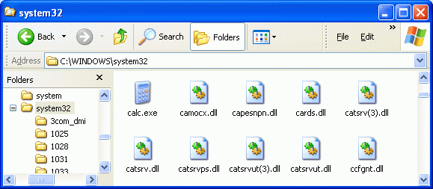
- Scroll down in the left pane until you can see the System32 folder and click it to select it. Then scroll down in the right pane and find calc.exe as shown below in this page.

Finding a Lost Homework File
- Open Microsoft Word. Type your name into the file and click File, Save to save it. Accept the default filename and location and save the file. Close Word.
- Suppose you did this, and forgot where you saved the file. Let’s see a few ways to find the file.

Using My Recent Documents
- Click Start. Point to My Recent Documents. You will see a list of recently-used files, as shown below on this page. Your Name.doc should appear on this list. Click the Your Name.doc file to open it.
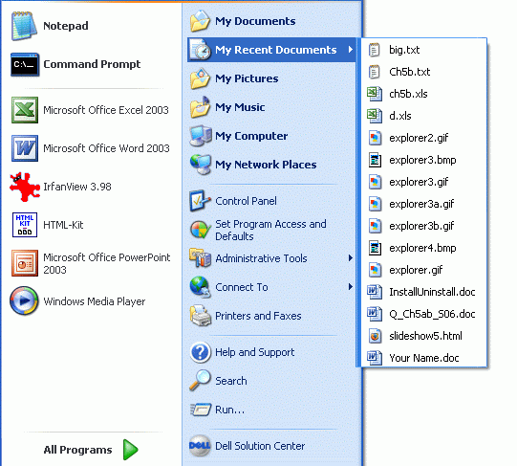

Using Advanced Search
- Suppose your file does not appear on the My Recent Documents list, because too many other files were used since you last opened that file. Let’s imagine that you have even forgotten the file name. You can still find the file with an Advanced Search.
- Click Start, Search. In the Search Results window, click All files and folders.
- In the All or part of the file name: box, enter *.doc. This will find all Microsoft Word documents, regardless of the file name.
- Click When was it modified? Click the Within the last week radio button. Click Search.
- A list of all the Word documents created during the last week appears. Your file should be among them.

