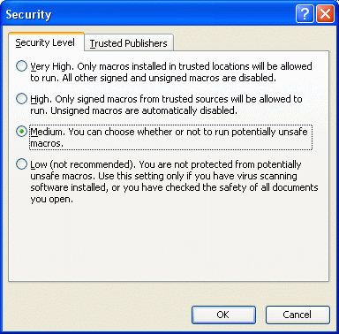
Lowering the Macro Security Setting
- Open Microsoft PowerPoint.
- Click Tools, Macro, Security.
- A Security box opens, as shown to the right on this page. Click the Medium button, and click the OK button. This step is necessary to allow PowerPoint macros to run.
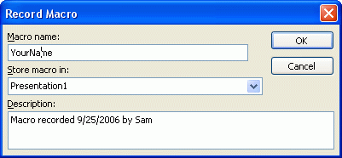
- Close PowerPoint. Start PowerPoint again. This ensures that the security setting takes effect.
Recording a Macro
- Click Tools, Macro, Record New Macro.
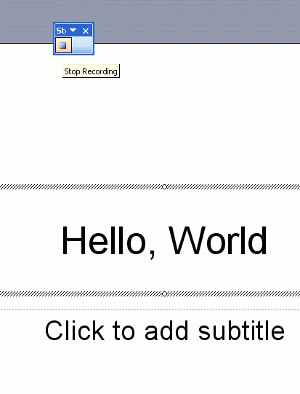
- A Record Macro box opens, as shown to the right on this page. In the Macro name box, enter your first name (do not use any spaces). Then click OK.
- Click in the Click to add Title box and type in Hello, World!. Then click the Stop Recording button, as shown to the right on this page.
Stop Recording
Viewing a Macro
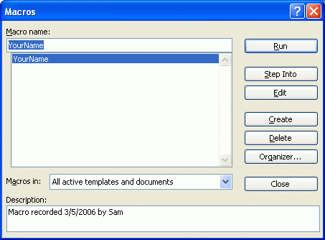
- Click Tools, Macro, Macros.
- A Macros box opens. Click on your name and click the Edit button.
- A Presentation1 – NewMacros window opens as shown below on this page. There are several lines of text in this window starting with a Sub statement and ending with an End Sub statement. This is a Visual Basic Program. The Sub and End Sub statements indicate the start and end of this program, also called a Subroutine or a Macro.
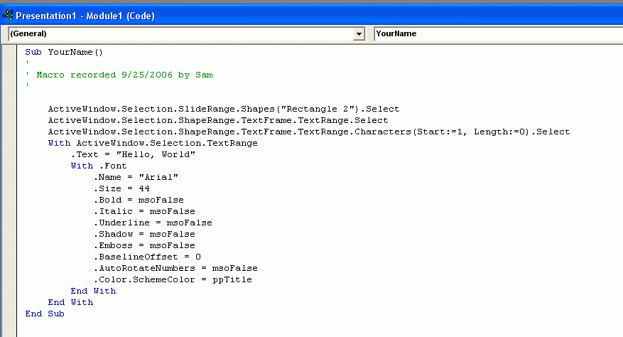
- Notice the lines of green text starting with apostrophes. These are Comments – they have no effect on the operation of the program. They are just there to help the programmer stay organized.
- The ActiveWindow.Selection commands select which object the text goes into, and the .Text command types the text.
- The text properties like “Arial” and .Size = 44 should be obvious – they determine what font the text uses.

Running a Macro
- Click the red X at the upper right of the Microsoft Visual Basic – Presentation1 window. The Visual Basic Program vanishes and your PowerPoint document appears again.
- Click Tools, Macro, Macros. In the Macros box, click on your name, and click the Run button.

- The macro runs, typing in another Hello, World! into your PowerPoint presentation, as shown below on this page.
Editing a Macro
- Click Tools, Macro, Macros.
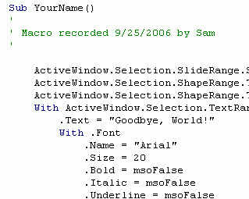
- A Macros box opens. Click on your name and click the Edit button.
- A Presentation1 – NewMacros window opens. Find the line that has “Hello, World!” in it, and change that text to something else, like “Goodbye, World!” as shown to the right on this page. Be careful not to erase the quotation mark. Change something else about the text, such as the size.
Running the Modified Macro
- Click the red X at the upper right of the Microsoft Visual Basic – Document1 window. The Visual Basic Program vanishes and your PowerPoint document appears again.
- Click Tools, Macro, Macros. In the Macros box, click on your name, and click the Run button.
- The macro runs, typing in the new text, as shown below on this page.

Creating Your Own Modified Macro
- Edit the macro again, to type your name into the box, as shown below on this page.


- Save the PowerPoint document on a floppy disk with any name you choose. Give the floppy to the Results Presenter.

Last modified 9-25-06

