Starting Your Computer
- Start your computer with the appropriate L removable hard drive in it. Log in with the account information your instructor provided to you. In Fall 2005, the User name is CNIT235 with a password of windowsxp

Starting VMWare Workstation
- Double-click the VMWare Workstation icon on the desktop.
- When the VMWare Workstation window opens, click the CNIT 100 tab and then click Start this virtual machine.
- When the virtual machine starts, click the Waldo icon. This is an Administrator account, and it should have no password. If it asks for a password, try P@ssw0rd
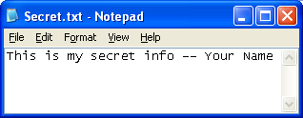
Making a Deleted File
- Click Start, All Programs, Accessories, Notepad. In the Notepad window, type in a short message including your name, as shown to the right on t his page. Save the file on a floppy disk with the name Secret.txt.
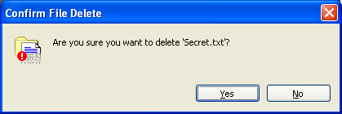
- Click Start, My Computer, 3 ½ Floppy (A:). Click the Secret.txt file once to select it. Press and hold the Shift key. Press the Delete key. Read the Confirm File Delete box that appears—it should say Are you sure you want to delete ‘Secret.txt’?, like the box shown to the right on this page. Click Yes. This deletes the file completely, so that it is not in the Recycle bin, and Windows does not provide any way to ever get the file back.

Downloading and Installing Recover My Files
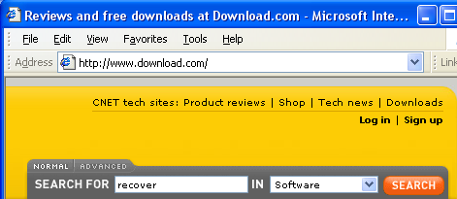
- Open Internet Explorer and go to downloads.com
- In the SEARCH FOR box, enter recover and click the SEARCH button.

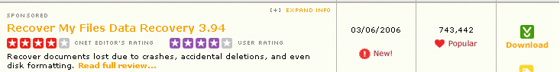
- Find Recover My Files Data Recovery as shown below, and click the green Download button on the right side.

- In the File Download – Security Warning box, click Run.
- In the Internet Explorer – Security Warning box, click Run.
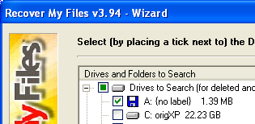
- When you see the Welcome to the Recover My Files Setup Wizard, close all other programs and click Next.
- Accept the agreement and click Next.
- Click Next through the remaining screens, and click Install to install the software.
- At the Product Activation screen, click Later.
- When you see the Completing the Recover My Files Setup Wizard, click Finish.
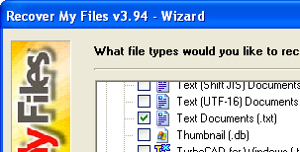
- In the Recover My Files box, check I accept the terms of this agreement and click OK.
Recovering Deleted Files
- In the Recover My Files v3.94 – Wizard, click Fast File Search. Click Next.
- In the next screen, put a check mark by drive A: as shown to the right on this page.
- The next screen is where you choose which file types to recover. Uncheck all the items, and check Text Documents (*.txt) as shown to the right on this page. Click Start.
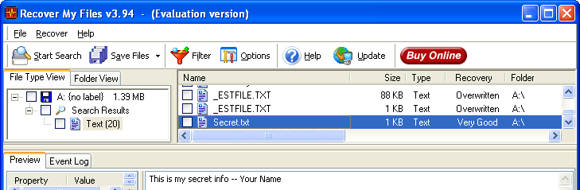
- When the search finishes, you should be able to find Secret.txt and click it. You will see the file contents in the preview pane at the bottom.

Downloading and Installing AbsoluteShield File Shredder
- Deleting files is not enough to stop people from getting them back. For that you need to shred them.
- Open Internet Explorer and go to downloads.com
- In the SEARCH FOR box, enter shredder and click the SEARCH button.
- Find AbsoluteShield File Shredder, and click the green Download button on the right side.
- In the File Download – Security Warning box, click Run.
- In the Internet Explorer – Security Warning box, click Run.
- When you see the Welcome to the AbsoluteShield File Shredder Setup Wizard, close all other programs and click Next.
- Accept the agreement and click Next.
- Click Next through the remaining screens, and click Install to install the software.
- At the Click Finish to exit Setup screen, click Finish.
- If a Microsoft AntiSpyware box pops up, allow the change.
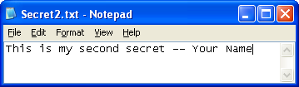
Making a Shredded File
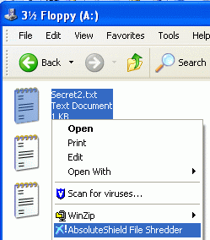
- Click Start, All Programs, Accessories, Notepad. In the Notepad window, type in a short message including your name, as shown to the right on this page. Save the file on a floppy disk with the name Secret2.txt. Close Notepad.

- Click Start, My Computer, 3 ½ Floppy (A:). Right-click the Secret2.txt file and click AbsoluteShield File Shredder as shown to the right on this page.

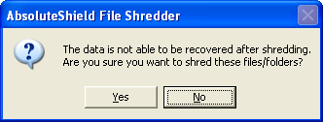
- In the AbsoluteShield File Shredder box shown to the right on this page, click Yes. When you see the message 1 file is shredded, the file is gone.

Recovering Deleted Files
- To prove that the shredded file is really gone, run the Recovery program again.
- In the Recover My Files v3.94 – Wizard, click Start Search. In the next screen, click Fast File Search. Click Next.
- In the next screen, put a check mark by drive A: as shown to the right on this page.
- The next screen is where you choose which file types to recover. Uncheck all the items, and check Text Documents (*.txt) as shown to the right on this page. Click Start.
- In the Warning box, click Yes.
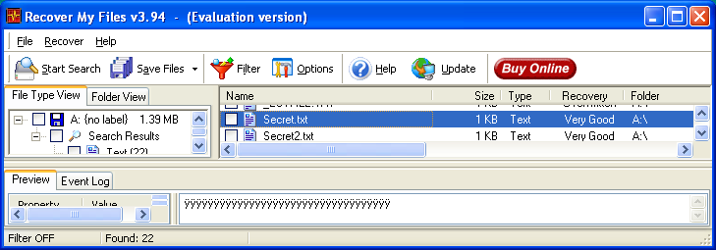
- When the search finishes, hunt through all the files. Secret2.txt is on the list, but if you click it you will see that the contents have been destroyed, as shown below—the lower pane has nothing readable in it. The contents of the file are completely gone.

