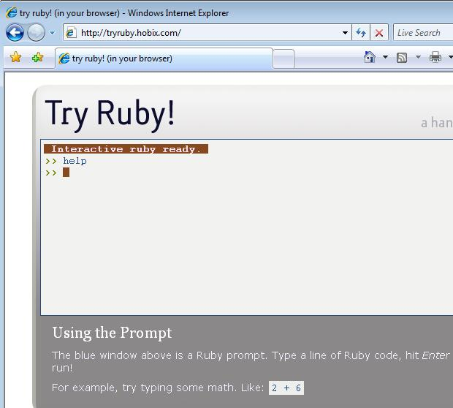
Programming in Ruby
- Open a browser and go to tryruby.hobix.com
- In the top part of the screen, under the words Interactive ruby ready, type
help
and press the Enter key.
- Follow the instructions shown in the gray area near the bottom of the window. The next thing to do is to type in
2 + 6
and press the Enter key.
- Just continue to follow the instructions. Write down 3 things that are interesting to show the class later. You don’t have to do the whole thing, unless you want to, but get at least to the second summary.

Last modified 9-25-06

