Creating an SVG Image
- Do not use the virtual machine, and don’t use Internet Explorer.
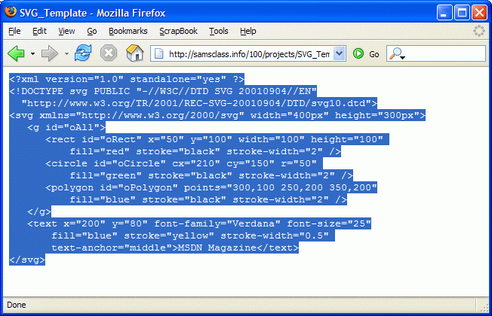
- Open Forefox and go to samsclass.info/100/projects/SVG_Template.html
- Highlight all the text, as shown to the right on this page, right-click, and click Copy.
- Click Start, All Programs, Accessories, Notepad. Right-click in the Notepad window and click Paste.
- In the Notepad window, click File, Save As….

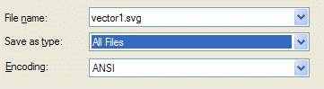
- Save the file on a floppy disk. Give it any name you choose, with a file extension of .svg – to do that, you need to set the Save as type: to All Files, as shown to the right on this page.

Associating the SVG File Type with Firefox
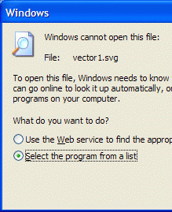
- Click Start, My Computer. Open the Floppy Disk. Double-click the vector1.svg file.
- A Windows box opens as shown to the left on this page, saying that Windows cannot open this file. Click Select the program from a list as shown to the right on this page, and click OK.
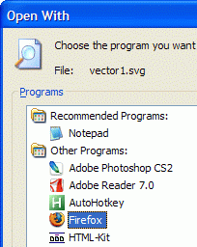
- In the Open With box, click Firefox, as shown to the right on this page. Click OK.
Understanding How Vector Graphics Work
- Firefox opens showing the vector graphic, as shown below on this page. Compare the Notepad file to the vector graphic, and find the four statements shown below. The rect statement draws the rectangle, the circle statement draws the circle, the polygon statement draws the triangle, and the text statement draws the letters.
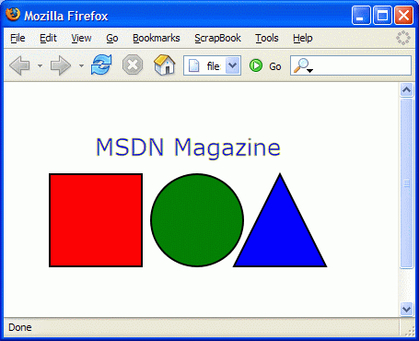
<rect id="oRect" x="50" y="100" width="100" height="100"
fill="red" stroke="black" stroke-width="2" />
<circle id="oCircle" cx="210" cy="150" r="50"
fill="green" stroke="black" stroke-width="2" />
<polygon id="oPolygon" points="300,100 250,200 350,200"
fill="blue" stroke="black" stroke-width="2" />
<text x="200" y="80" font-family="Verdana" font-size="25"
fill="blue" stroke="yellow" stroke-width="0.5"
text-anchor="middle">MSDN Magazine</text>

Modifying the Vector Graphic: Making the Rectangle Taller
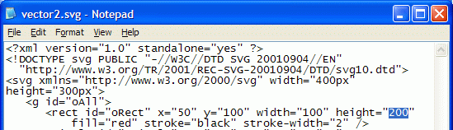
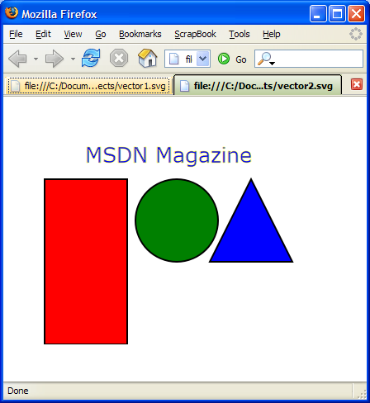
- In the rect statement, change the height value to 200, as shown to the right on this page. Click File, Save As… and save the file with the name vector2.svg.

- In the 3 ½ Floppy window, Double-click the vector2.svg to open it. The rectangle is now taller, as shown to the right on this page.

Modifying the Vector Graphic: Moving the Circle
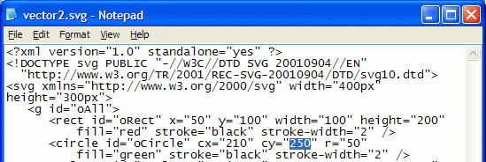
- In the circle statement, change the cy value to 250, as shown to the right on this page. Click File, Save As… and save the file with the name vector3.svg.
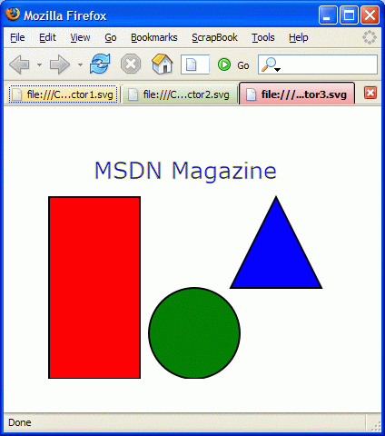
- In the 3 ½ Floppy window, Double-click the vector32.svg to open it. The circle has moved down, as shown to the right on this page.

Try to Make These
- See if you can make these figures:
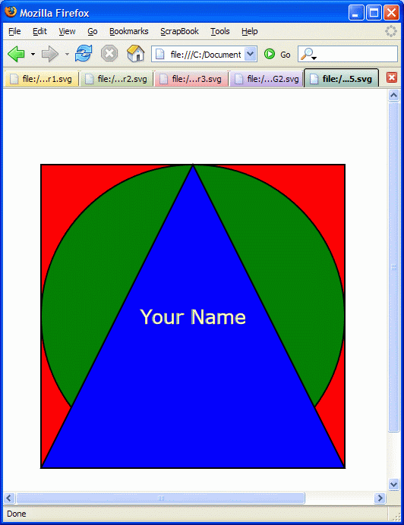
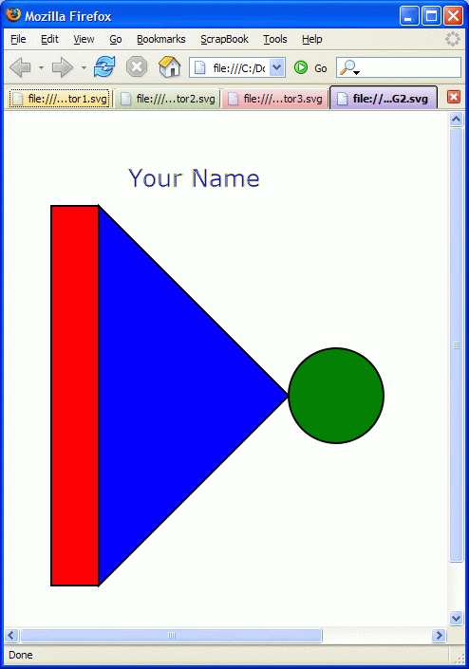

Based on http://msdn.microsoft.com/msdnmag/issues/03/07/ScalableVectorGraphics/ Last modified 5-11-06

