Do This on Two Machines at Once
- Two group members should do this at the same time, so you can make Skype phone calls from one machine to another in the classroom.
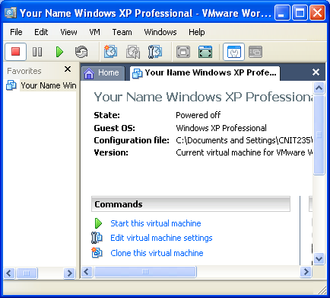
Starting VMWare Workstation
- We will use a program called VMWare Workstation, which simulates a computer on top of the existing Windows XP operating system. That way you can practice installation and other activities without changing (and possibly damaging) the existing operating system.
- Double-click the VMWare Workstation icon on the desktop.
- A VMWare Workstation window opens as shown to the right on this page. Click the blue Start this virtual machine link.
- A couple of VMWare message boxes will open, telling you details about how VMWare works that don’t matter right now. Just click the default selection to get past them.
- When your virtual PC starts, you will see a window with a virtual desktop in it, and a virtual Start button. Whenever you need to install software, do it in the virtual PC. That way you won’t mess up the host PC.

Requirements
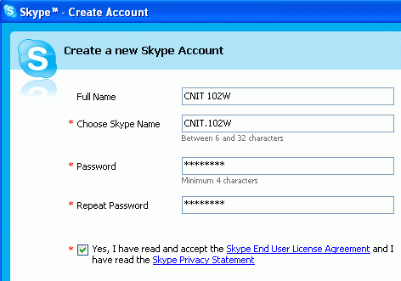
- You will need a headset with a microphone for each machine.

Installing Skype
- Open a browser and go to skype.com (I did it with Internet Explorer. With other browsers the steps may be slightly different.)
- Click the Download Now button. On the next screen, click the Download button. On the next screen, click the Download button.
- In the File Download – Security Warning box, click Run.
- In the Internet Explorer – Security Warning box, click Run.
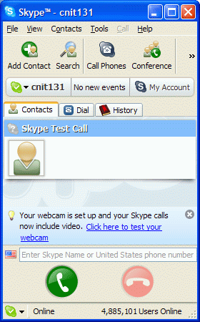
- A blue box appears with a header of Hello! Thank you for downloading Skype. Check the Yes, I accept the EULA box and click Install.

Creating a Skype Account
- A Create a new Skype Account box opens, as shown above and to the right on this page. Make up a Skype Name and password, and click the Yes, I have read and I accept the Skype end user license agreement box. Click Next.
- In the Help your friends find you window, enter your name, city, and e-mail address and click Sign in.

Testing Your Sound Settings
- A Skype window opens showing that you have only one Contact -- Skype Test Call. Click the Skype Test Call to make it larger, as shown to the right on this page, and click the round green Call button at the bottom of the window.
- You should hear a voice guiding you through a test of your speakers and headphones. Repeat this test until you get your sound system working correctly. You may need help from your instructor.

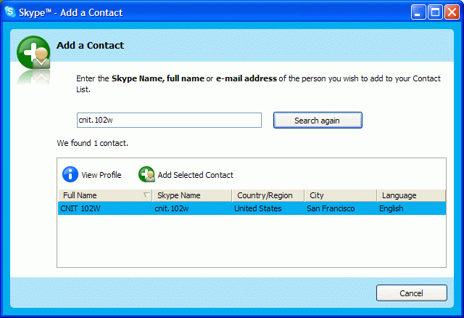
Adding Your Teammate as a Contact
- At the upper left of the Skype window, click the the Add Contact button. In the Add a Contact box, enter your teammate’s Skype name. Click the Search button. When your teammate’s name appears, click on it.
- Click the Add Selected Contact button.
- In the Say Hello! to Teammate’s name box, click OK.

Calling Your Teammate
- In the Skype window, on the Contacts tab, there is now an entry for your teammate. Double-click it.
- You should hear a telephonic ringing sound. Your teammate should answer so you can talk back and forth.

Calling a Normal Telephone
- In the Skype window, click the Dial tab. Enter any US phone number, including the area code. For example, if you are in Science 214, there is a phone in the room with this phone number: 415-452-5081. If you have a cell phone, try calling it too. Press the Enter key to dial.
- Answer the phone when it rings, or get someone else to answer it.
Last modified 8-30-06

