Calculating Expected Latencies from the AT&T Website
- Open a browser and go to ipnetwork.bgtmo.ip.att.net
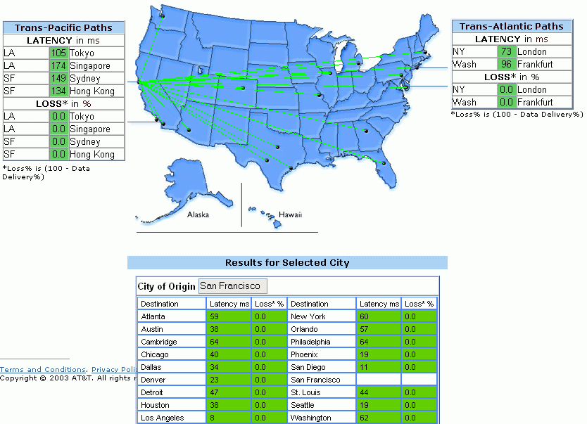
- At the upper left, click Current Performance
- In the Select a city box, select San Francisco.
- You will see a diagram showing LATENCY values for the AT&T worldwide network, as shown to the right on this page.
- In the upper left of the screen, find the current LATENCY for traffic from San Francisco to Hong Kong (in the figure above, it is 134 ms). Write it in the box on the next page in the AT&T Expected Latency column for SF to Hong Kong.
- Use the same technique to find the expected latency for Internet traffic from SF to Sydney.
- The next value we want is SF to Singapore. However, the data in the Trans-Pacific Paths box in the upper left of the AT&T web page only gives us LA to Singapore. That’s from Los Angeles, not San Francisco. So traffic from San Francisco will have to make two trips: San Francisco to Los Angeles, and then LA to Sydney. To get the latency for the San Francisco to Los Angele rip, look at the chart at the bottom of the page. In the example above, San Francisco to Los Angeleis 8 ms, and LA to Singapore is 174 ms, so adding them together, SF to Singapore is 182 ms. Figure out the expected latency from the current data on the AT&T website and write it in the box on the next page.
- The last value we want is SF to Frankfurt. In the upper-right of the page is the Trans-Atlantic Paths data, which gives a latency for Wash to Frankfurt. You will have to add the trip from San Francisco to Washington as shown in the chart at the bottom of the page.

Measuring Actual Latencies with TRACERT
- Now we will send real Internet traffic to those sites and see what the actual latencies are.
Trip AT&T Expected Latency Actual Latency

SF to Hong Kong

SF to Sydney

SF to Singapore

SF to Frankfurt
- Click Start, All Programs, Accessories, Command Prompt.
- In the Command Prompt window, type in the command TRACERT WWW.HKU.HK and press the Enter key. A chart of hops appears as shown below. This is showing you the latency in ms (milliseconds) for each router between you and the HKU website in Hong Kong. To read this diagram, look at the server names in the right column and try to spot server names that make it obvious where those servers are. Then look at the three numbers to the left to see the latency for that router.

E:\Documents and Settings\Sam>TRACERT WWW.HKU.HK

Tracing route to www.hku.hk [147.8.145.50]
over a maximum of 30 hops:

1 1 ms 1 ms 1 ms 192.168.2.1
2 7 ms 20 ms 28 ms 10.21.64.1
3 9 ms 9 ms 9 ms vl4.aggr1.sfrn.ca.rcn.net [209.122.64.161]
4 10 ms 9 ms 9 ms ge4-0.border1.sfrn.ca.rcn.net [208.59.255.6]
5 10 ms 12 ms 12 ms ge-3-0-0.r00.plalca01.us.bb.verio.net [198.32.17
6.14]
6 11 ms 11 ms 11 ms p16-0-1-1.r21.plalca01.us.bb.verio.net [129.250.
3.84]
7 22 ms 10 ms 11 ms p64-0-0-0.r21.mlpsca01.us.bb.verio.net [129.250.
5.49]
8 12 ms 12 ms 112 ms p64-2-2-0.r20.tokyjp01.jp.bb.verio.net [129.250.
2.35]
9 122 ms 165 ms 164 ms p16-3-0-0.r00.newthk01.hk.bb.verio.net [129.250.
2.110]
10 166 ms 164 ms 164 ms p16-3-0-0.r00.newthk01.hk.bb.verio.net [129.250.
2.110]

- In the example on the previous page, you can see these items pretty easily:

sfrn.ca.rcn.net This is in San Francisco, with latencies of 10 ms, 9 ms, and 9 ms

tokyjp01.jp.bb.verio.net This is in Tokyo, Japan, with latencies of 12, 12, and 112 ms

newthk01.hk.bb.verio.net This is in Hong Kong, and had latencies of 122, 165, and 164 ms
- Find the first router in Hong Kong, and write the observed latencies in the box on the previous page.
- Repeat the same process to find the latencies for the other sites in the box above. Here are some Web sites in the cities you need that worked when I tried it:

www.usyd.edu.au Sydney

www.sg Singapore

www.uni-frankfurt.de Frankfurt
Preparing the Results
- Type your results into a Word document so the presenter can project them and explain them to the class.

