Starting Your Computer
- Start your computer with the appropriate L removable hard drive in it. Log in with the account information your instructor provided to you. In Spring 2006, the User name is CNIT235 with a password of windowsxp

Starting VMWare Workstation
- Double-click the VMWare Workstation icon on the desktop.
- When the VMWare Workstation window opens, click the CNIT 100 tab and then click Start this virtual machine.
- When the virtual machine starts, click the Waldo icon. This is an Administrator account, and it should have no password. If it asks for a password, try P@ssw0rd

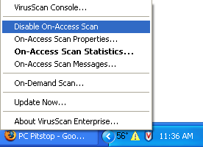
Disabling McAfee Antivirus
- While doing this project, we must disable the McAfee resident virus scanner. Look on the lower right corner of the desktop near the clock for a little blue shield with a red V on it. Right-click that shield and select Disble On-Access Scan as shown to the right on this page.

- The shield icon now shows a red circle-and-slash on it, showing that it is disabled, as shown to the right.
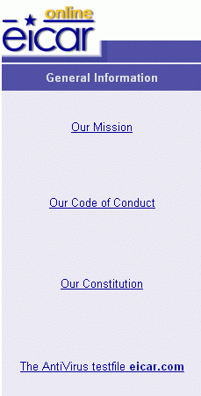

Saving the eicar.com test virus in the My Documents folder

Open Internet Explorer, click in the Address bar near the top of the window, and type in

eicar.com

The eicar page opens, as shown to the right on this page. In the left bar, click The AntiVirus testfile eicar.com.

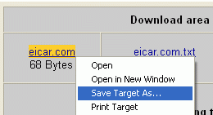
In the next screen, scroll down to the bottom and find the Download area using the standard protocol http. Right-click eicar.com and select Save Target As… as shown below on this page. Save the file in the My Documents folder.

Testing Your Computer with Trend Housecall

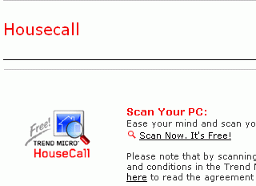
Open Internet Explorer, click in the Address bar near the top of the window, and type in

housecall.trendmicro.com

Then press the Enter key open the Housecall page, as shown to the right on this page. Click Scan Now. It’s Free!

In the next screen, click Scan Now. It’s Free! Again.

In the next screen, check Yes, I accept the Terms of Use and click the Launching HousecCall >> button.

In the next screen, in the “Browser plug-in” section, click the Launching HousecCall >> button.

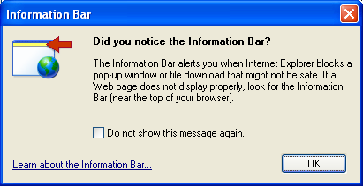
If an Information Bar box opens, as shown to the right on this page, click OK.

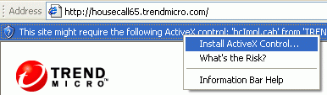

Click the yellow bar at the top of the browser window, and click Install ActiveX Control… as shown to the right on this page.
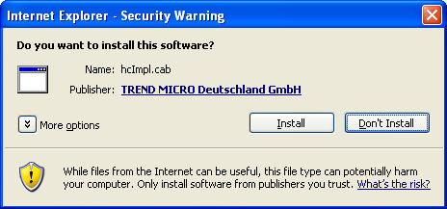

When the Internet Explorer – Security Warning box opens, as shown to the right on this page, click Install.
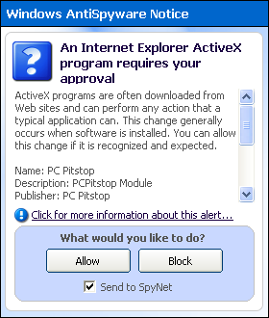

If a Windows AntiSpyware Notice box opens, as shown to the right on this page, click Allow.

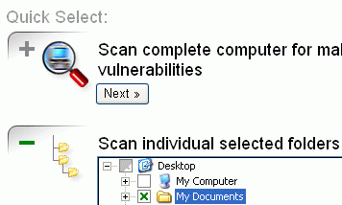

When you see the Quick Select screen shown to the right on this page, click the Select >> button under the header Scan individual selected folders. Click the + sign next to Desktop to expand the tree, click the box next to My Documents to put a green X in it, as shown to the right on this page. Click the Next button.

When the scan is finished, you should see the EICAR signature found, as shown below. If you don’t, repeat the process and try using the Java-based Housecall kernel.
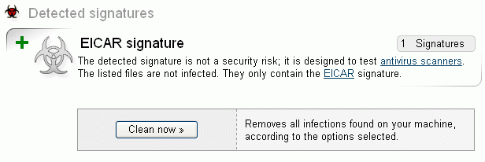

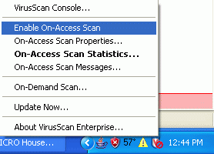
Restarting McAfee Antivirus
- Right-click the shield icon and select Disble On-Access Scan as shown to the right on this page.
- The shield icon should no longer show a red circle-and-slash on it.

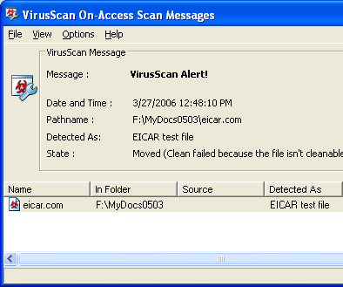

Deleting the eicar.com file
- Click Start, My Documents. Find the eicar.com file and right-click it.
- A VirusScan On-Access Messages box opens as shown to the right on this page. Click the Close Window button.
- Look in the My Documents window – the eicar file is gone! It was moved to C:\Quarantine and renamed to protect your system. That’s why resident antivirus scanners are better than online scanners – they protect you from getting infected. Online scanners just find infections after they are already on your computer.

Updated 3-27-06

