Starting VMWare Workstation
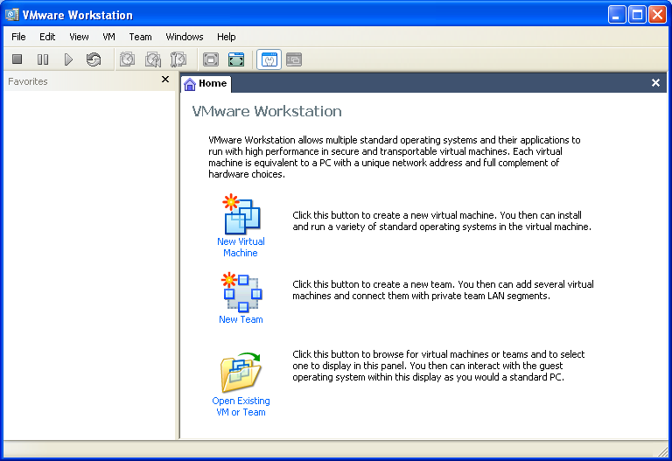
- Double-click the VMWare Workstation icon on the desktop.
- A VMWare Workstation window opens as shown to the right on this page. If necessary, click the Home tab. Click the Open Existing VM or Team icon.
- In the Open box, click My Documents. Double-click the My Virtual Machines folder. Double-click the Ubuntu folder. Double-click the Ubuntu file.
- In the left pane of the Ubuntu – Vmware Workstation window, click Start this virtual machine. If you see a message beginning The location of this virtual machine’s configuration file has changed…, click OK. If you see a message about VMware Tools, click OK.
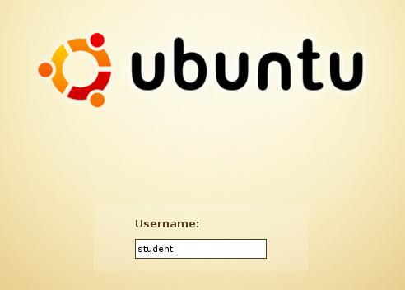
- You will see a black screen with some text on it saying GRUB LOADER and other things, and then a pretty orange ubuntu logo.
Logging in to Ubuntu
- When you see the ubuntu login screen shown to the right on this page, enter the Username student and press the Enter key.
- The next screen asks for a password. Enter password and press the Enter key.
- Hold down the Ctrl and Alt keys, and press the Enter key. That should make the Ubuntu desktop fill the whole screen, which will make it easier to use.
Browsing the Web
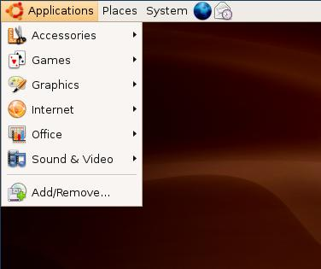
The Ubuntu Desktop
The word Applications at the top left of the desktop works like the Start button in Windows. Click it to see a menu of available programs, as shown to the right on this page.

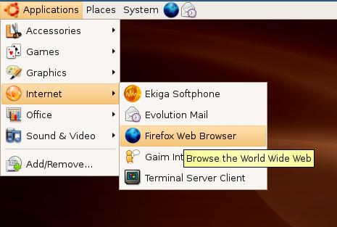
Browsing the Web with Ubuntu
Click Applications, Internet, Firefox Web Browser, as shown to the right on this page.

Firefox opens, showing you a page titled ubuntu. This is a Web browser, like Internet Explorer. Click in the address box, erase the current URL, and enter yahoo.com. Press the Enter key to open Yahoo.
Word Processing

Word Processing with OpenOffice.org Word Processor
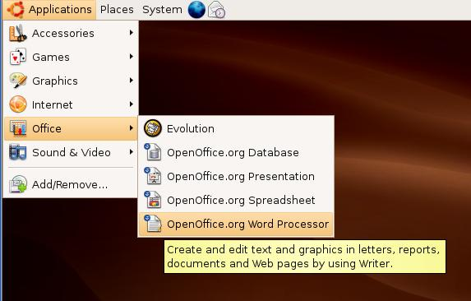
The word Applications at the top left of the desktop works like the Start button in Windows.
Click Applications, Office, OpenOffice.org2 Word Processor, as shown to the right on this page.
An Open Office 2 logo appears and vanishes, and it looks like nothing is happening.
Writer opens, as shown below. You can use it like Microsoft Word, with some differences.
Making Presentations
OpenOffice.org Presentation
The word Applications at the top left of the desktop works like the Start button in Windows.
Click Applications, Office, OpenOffice.org2 Presentation, as shown to the right on this page.
An Open Office 2 logo appears and vanishes, and it looks like nothing is happening.
Writer opens, as shown below. You can use it like Microsoft Word, with some differences.
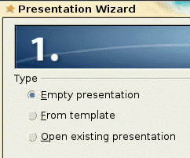

In the Presentation Wizard box 1, accept the default selection of Empty presentation and click Next.

In the Presentation Wizard box 2, select any background and click Next.

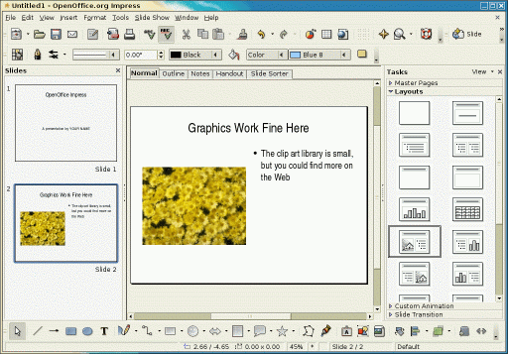
In the Presentation Wizard box 3, select any options you like and click Create.

Impress opens. It’s a lot like PowerPoint. You can choose a slide design from the right pane, and if you want to change the background color, click Master Pages in the right pane to see some choices.

Linux Games
The Ubuntu Desktop
The word Applications at the top left of the desktop works like the Start button in Windows. Click it to see a menu of available programs, as shown to the right on this page.

Click Applications, Games, as shown to the right on this page.

Try some of the games, and find a couple to show the class.

Graphics
The Ubuntu Desktop
The word Applications at the top left of the desktop works like the Start button in Windows. Click it to see a menu of available programs, as shown to the right on this page.
Click Applications, Graphics, Gimp.
Click File, New, OK.
Click a drawing tool in the The GIMP box, as shown to the left in the figure below.
Choose a Brush in the bottom portion of the Layers, Channels, … window, as shown in the center in the figure below.
Draw in the Untitled-1.0 … window, as shown to the right in the figure below.
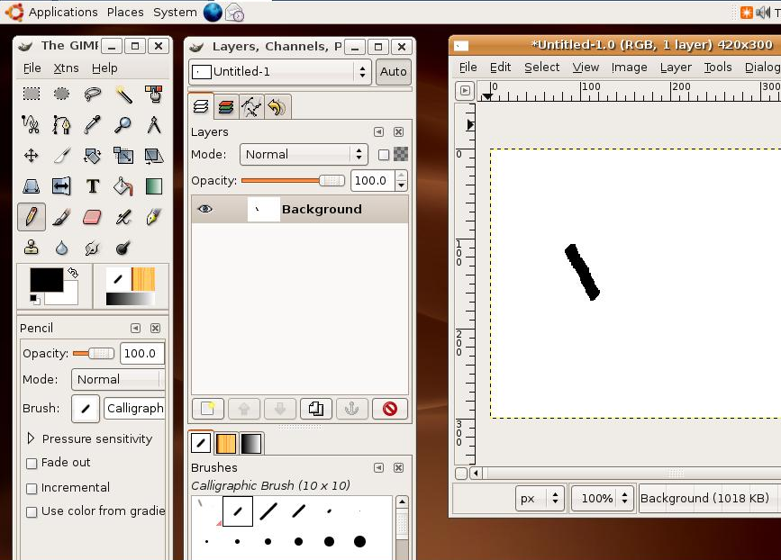
.

- Firefox opens, showing you a page titled ubuntu. This is a Web browser, like Internet Explorer. Click in the address box, erase the current URL, and enter yahoo.com. Press the Enter key to open Yahoo.
Instant Messaging
The Ubuntu Desktop
The word Applications at the top left of the desktop works like the Start button in Windows. Click it to see a menu of available programs, as shown to the right on this page.

Browsing the Web with Ubuntu
Click Applications, Internet, Firefox Web Browser, as shown to the right on this page.

- Firefox opens, showing you a page titled ubuntu. This is a Web browser, like Internet Explorer. Click in the address box, erase the current URL, and enter yahoo.com. Press the Enter key to open Yahoo.
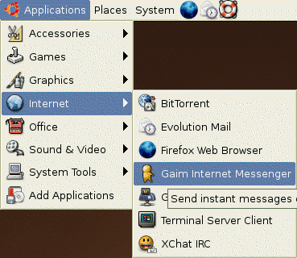
Instant Messaging with Ubuntu
Click Applications, Internet, Gaim Internet Messenger as shown to the right on this page.

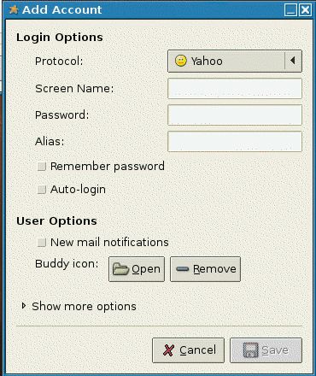
Gaim opens three windows Start with the Add Account window, as shown to the right on this page. In the Protocol list, select Yahoo. Type in your Yahoo name and password and click Save.
Then enter your password again in the login window and click Sign on.
In the Buddy List window, click Buddies, New Instant Message. Type in the Yahoo ID of the Windows User. Send an instant message to the Windows user.

