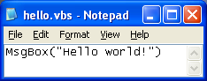
Creating a VBScript Program
- Click Start, All Programs, Accessories, Notepad.
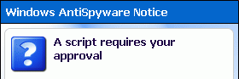
- Type in the text shown to the right on this page. Save the file on the desktop with the name hello.vbs – be sure to get the filename extension correct.
Running a VBScript Program
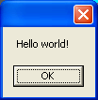
- Minimize all windows, if necessary, and find the hello.vbs icon on the desktop. Double-click that icon to run the VBScript program.
- If a Windows AntiSpyware Notice pops up, saying A script requires your approval, click Allow.
- A window opens containing the text Hello world! as shown to the right on this page. This is the output of the VBScript program. Click OK to close the window.
Creating a VBScript Program With Two Commands
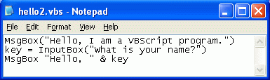
- Click Start, All Programs, Accessories, Notepad.
- Type in the three lines as shown to the right on this page. Save the file on the desktop with the name hello2.vbs.
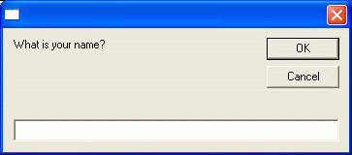
- Double-click the hello2.vbs icon on the desktop. If a Windows AntiSpyware Notice pops up, saying A script requires your approval, click Allow.
- A window opens containing the text Hello, I am a VBScript program. Click OK to close the window.
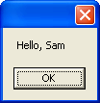
- When a box appears asking What is your name? as shown to the right on this page, type in your name and click OK.
- You should see a box saying Hello to you by name, as shown to the right on this page.
Understanding VBScript Programs
- VBScript programs contain commands. So far you have used only two commands: MsgBox and InputBox. Here’s how they work:
- MsgBox(“text”) Pops up a box with text in it, where text can be anything you want.
- x = InputBox(“text”) Pops up a box with text in it, and a place for the user to type in some text. The text is stored in the variable named x, where x can be any name you want.
Creating Your Own VBScript Program
- Make your own VBScript program. It should do these things:
- Pop up a box saying Welcome to my VBScript program.
- Ask the user for their name.
- Pop up a box Hello name, I am happy to meet you!, with the name from the previous box appearing instead of name,
- Pop up a box saying This program was written by YOUR NAME with your own name instead of YOUR NAME.
- Save your batch file on a floppy disk and give that disk to the Results Presenter. Explain how it works to the Results Presenter.

Based on this tutorial: http://www.pcsupportadvisor.com/Windows_scripting_host_page2.htm
Last modified 3-6-06

