Recording a Video
- Do not use the virtual machine. Use one of these hard drives: L5, L10, L15, L20.
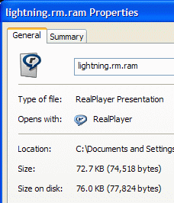
- Use a little round Logitech webcam and a microphone on a stand, provided by your instructor. Plug the webcam into the USB port on the lower front panel of your computer. Plug the microphone into the pink port there.
- There are two plugs – one for the speakers, and one for the microphone. They should plug into corresponding ports on the front of your computer.
- Double-click the Logitech icon on the desktop. Click Quick Capture. You should see live video from the webcam.
- Record a video. Save it. It saves in the My Documents folder, in the My Pictures folder, in a folder with the name Logitech on it. Open that folder and find your video.
- Right-click your video file and select Properties. In the Properties sheet, find the Size: as shown to the right on this page. My example file has a size of 74.518 bytes. Find the size of your file and write it down.
Creating Your RSS Feed File
- Open a browser and go to samsclass.info/100/projects/RSS_Template.html
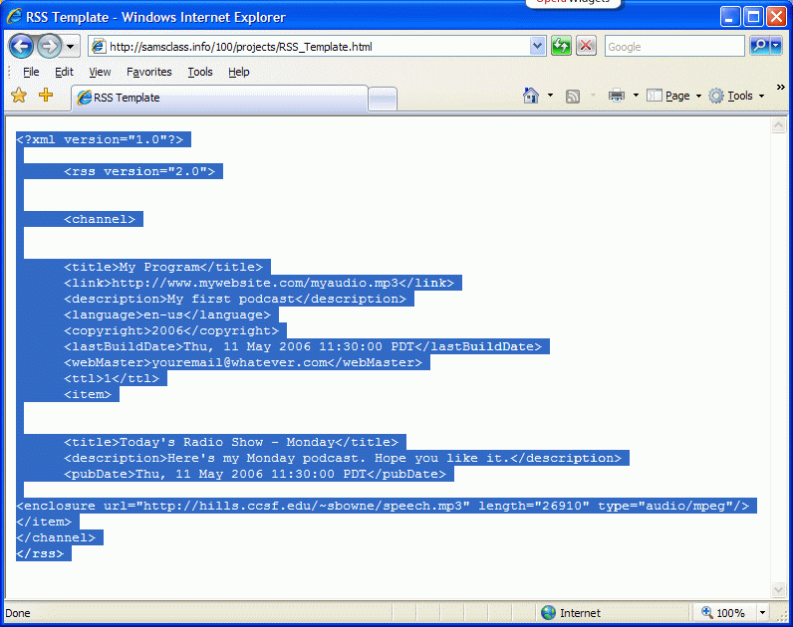
- Highlight all the text, as shown to the right on this page, right-click, and click Copy.
- Click Start, All Programs, Accessories, Notepad. Right-click in the Notepad window and click Paste.

- You can modify the title of the program, website address, dates, and so on in this file to make it yours. But the only part you really have to correct is the line starting <enclosure near the end. There are three changes you need to make here:
- Change sbowne to your own HP-UNIX ID
- Change speech.mp3 to the correct file name
- Change 26910 to the correct file size
- Save the file in the My Music folder with a filename of podcast.rss.
Putting your RSS Feed on the Hills Server
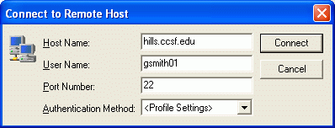
- Click Start, All Programs, SSH Secure Shell, Secure File Transfer Client.
- When the Secure File Transfer window opens, press the Enter key.
- In the Connect to Remote Host window, enter a Host Name of hills.ccsf.edu and a User Name of your HP-UNIX ID. Your HP-UNIX ID is the same ID you use to get your CCST email, or to log in to the computers in the ACRC in Batmale room 301. Press the Enter key.
- One or two more boxes appear. Press Enter to close them. When you see the Enter Password box, enter your birthday in the format jul0369
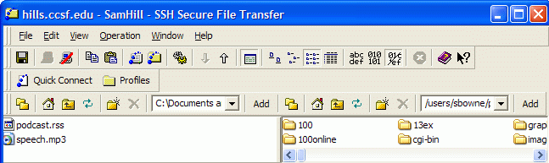
- Double-click the public_html folder in the right pane to open it, and navigate to the My Music folder in the left pane. You should see the two files podcast.rss and speech.mp3 in the left pane, as shown below on this page.

- Drag the two files from the left pane to the right pane and drop them. This copies your files to the server.

Viewing a Podcast in Internet Explorer 7
- Go to the a machine with the newest version of Internet Explorer on it (the demonstration machine in S215 has it) and open your feed by entering this URL:
hills.ccsf.edu/~gsmith01/podcast.rss
Replace gsmith01 with your HP-UNIX ID. Your podcast should open as shown below. When I tried it, clicking on the blue link did not work, but right-clicking on it, saving it on the desktop, and playing it from there did. Try to play your sound file.
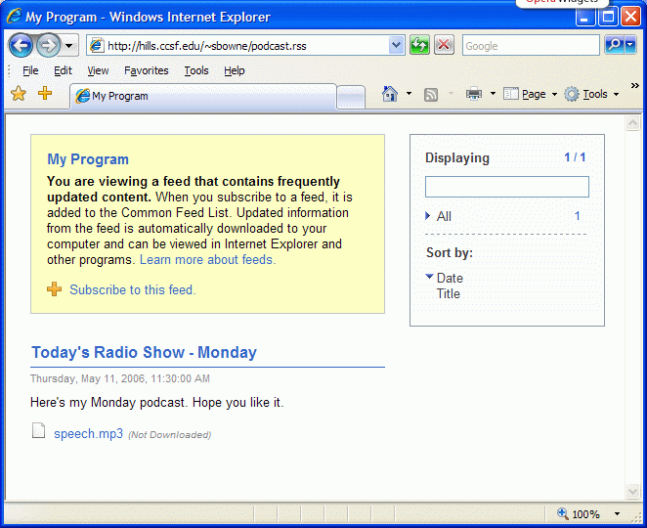
- If your video podcast won’t play, try opening mine at samsclass.info/100/projects/podcast2.rss
- If mine works, but yours doesn’t, check your RSS code with the RSS Validator at: rss.scripting.com
Based on http://radio.about.com/od/podcastin1/a/aa030805a.htm
Last modified 5-11-06

