Creating an Important File to Back Up
- Open Microsoft Word. Type in your name, or any other text. Save the document in the My Documents folder with the name Important Info.
Making a Big File
- One problem with some online file storage services is that the upload and download speeds are slow. To test that, let’s make a big file.
- Press the PrtScn button on the upper right of the keyboard. This copies the contents of the video memory to the clipboard – nothing visible happens on the screen.
- Click Start, All Programs, Accessories, Paint. Click Edit, Paste. A copy of the desktop is pasted into the Paint window.
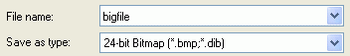
- Click File, Save As…. Save the file in the My Documents folder with the name bigfile. Make sure it is saved with a Save as type: of 24-bit Bitmap as shown to the right on this page.
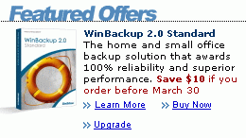
- Click Start, My Documents. Right-click bigfile and click Properties. Check the size of the file—its exact size depends on the resolution of your monitor, but it should be at least 1 megabyte.
Downloading and Installing WinBackup
- Open Internet Explorer and go to www.liutilities.com
- In the WinBackup 2.0 Standard section, as shown to the right on this page, click Learn More.
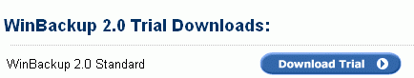
- In the left pane of the next screen, click Free Trial Version.
- On the WinBackup 2.0 Standard line, click the Download Trial button, as shown to the right on this page.
- In the Trial Download Form, enter a fake name and a working email address. Click the Download Trial Version Now! Button.
- In the next screen, click Download WinBackup 2.0 Std Trial Version Now.
- In the File Download – Security Warning box, click Run. Wait for the download (about one minute).
- In the Internet Explorer – Security Warning box, click Run.
- In the Welcome to the WinBackup Installation Wizard box, click Next.
- Accept the agreement and click Next.
- Accept the default destination location and click Next.
- At the Ready to Install the Application screen, click Next.
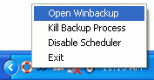
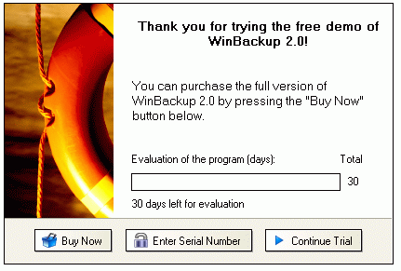
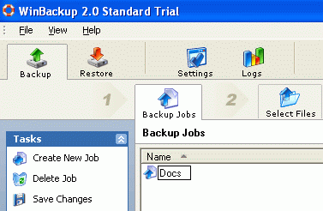
- In the WinBackup has been successfully installed box, click Finish.
- If some Windows AntiSpyware Notice boxes pop up, click Allow.
Creating a Backup Job
- WinBackup is running, and appears as a little red-and-white life preserver icon in the Notification Area next to the clock in the lower right corner of the desktop. Right-click the icon and select Open Winbackup, as shown at the top right on this page.
- A box appears wayingThank you for trying the free demo of WinBackup 2.0, as shown to the right on this page. Click Continue Trial.

- A WinBackup Standard Trial window opens. In the left pane, click Create a New Job. Type in the name Docs for the job. In the second row of icons, click Select Files.

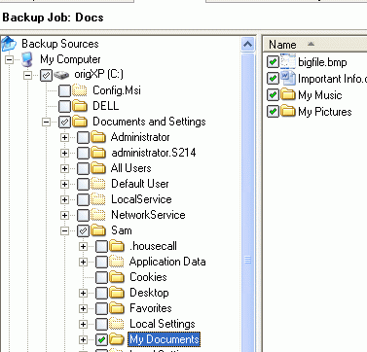

- In the left pane of the window, expand My Computer and expand the C: drive. Then expand the Documents and Settings folder, and your user name (probably Waldo). Check My Documents. You should see bigfile and Important Info in the right pane, as shown to the right on this page.
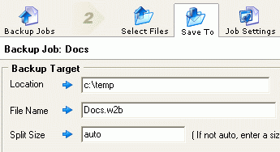
- Click the Save To icon. Enter a Location: of C:\Temp and accept the default file name and split size, as shown to the right on this page.

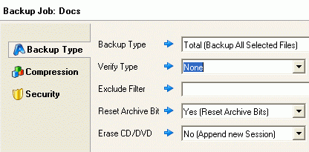
- Click the Job Settings icon. In the Backup Type section, accept all the default settings, as shown to the right on this page.
- In the left portion of the Job Settings pane, click Compression. Accept the default setting of Normal (Medium Compression).

- In the left portion of the Job Settings pane, click Security. Set the Security Level to Low (Password Protection). Enter a password in the next two boxes, as shown below.
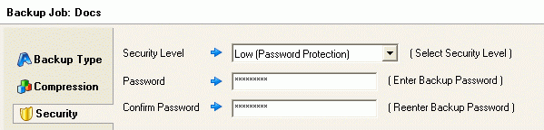

- Click the Schedule icon. In the Run this Job box, select Daily. Set the Start Time to be the current time as shown in the lower right corner of your computer screen plus 2 minutes, as shown below. Then click the Run Backup icon.
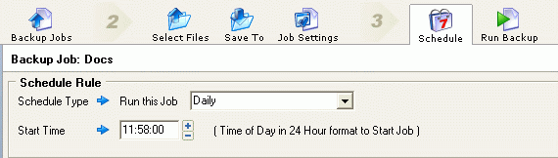

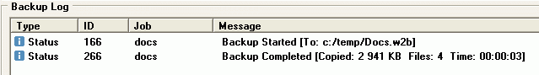
- In the Backup Actions section, click Run Backup. The backup job should run, and a Backup Log should appear, as shown below on this page.

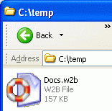
Observing the Backup File
- Click Start, My Computer. Double-click the C: drive. Double-click the Temp folder. You should see the Docs.w2b backup file in this folder, as shown to the right on this page. This file is compressed and password-protected, and it contains all the files from the My Documents folder.

