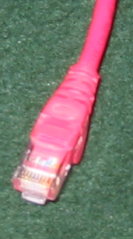
This project requires two wireless adapters and an installation CD.

Logging in as Administrator
- Select two nearby machines in the room. Ask your instructor to log into them both with an administrative account. You cannot install the wireless adapters without administrative privileges, and they don’t work in the virtual machine.

Testing the Machines
- Open Internet Explorer and verify that you can connect to the Internet with both the machines. If you cannot, call the instructor over to fix the problem before proceeding any further.

Disconnecting the Network Cables
- Look at the back of the computers and find the Ethernet cable(s), as shown to the right on this page. There should be a blue Ethernet cable, which is the Internet connection, and there may be a red Ethernet cable as well. Disconnect all the Ethernet cables from each machine. Make a note of where they were so you can put them back later.
- Open Internet Explorer and verify that you cannot connect to the Internet anymore. Do this on both machines.

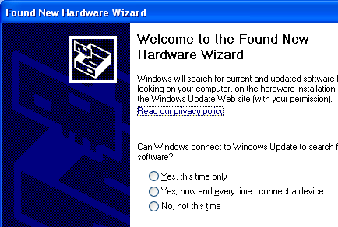
Installing the Wireless Adapter
- Insert the CD-ROM the instructor has provided. If a blue 802.116 Wireless Lan box appears, click the EXIT button to close it.
- Plug the USB wireless adapter into the computer. The USB ports are under the small panel at the bottom front of the system unit.
- An alert box should pop up hear the clock saying Found New Hardware. The Found New Hardware Wizard should open as shown to the right on this page.
- In the Welcome to the Found New Hardware Wizard screen, click No, not at this time and click Next.
- In the next screen, click Install from a list or specific location and click Next.
- In the Please choose your search and installation options screen, accept the default selection of Search removable media and click Next.
- The CD-ROM light comes on as the wizard searches for drivers on it.
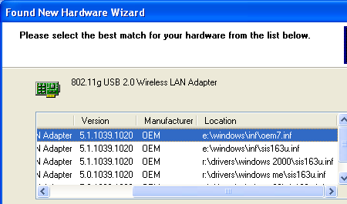
- In the Please select the best match for your hardware from the list below screen, scroll to the right so you can see the Location column, as shown to the right on this page. Find the driver in the Windows XP folder (not shown in the figure to the right) and click it to select it. Then click Next.
- A Hardware Installation box pops up. Click Continue Anyway.
- If a Windows Antispyware Notice pops up, click Ignore.
- In the Completing the Found New Hardware Wizard screen, click Finish.

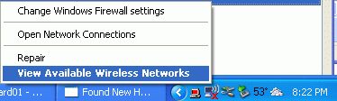
Connecting to the Wireless Network
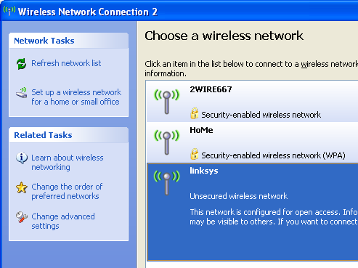
- In the Notification Area at the bottom right of your desktop, there should be a little icon showing a computer with radio waves coming out of it. Right-click that icon and select View Available Wireless Networks, as shown to the right on this page.
- A box opens up showing the available networks, as shown to the right on this page. There should be a linksys network available. If it’s not there, something must be wrong with the group doing the LAN with Router project – go over there and find out what’s going on.
- Click the linksys item once to select it, and click the Connect button.
- A Wireless Network Connection box opens warning you that the network is unsecured. Click Connect Anyway.
- After you are connected, you should be able to open Internet Explorer and get on the Internet.
- Repeat the whole process for a the second computer, so it is connected to the Internet via wireless.

Returning the Computers to Normal
- Remove the wireless adapters from the machines. Give them back to your instructor. Plug the Ethernet cables back into the machines. After a minute or so, the machines should be back on the Internet. If they cannot connect, restart them.

Last modified 4-3-06

