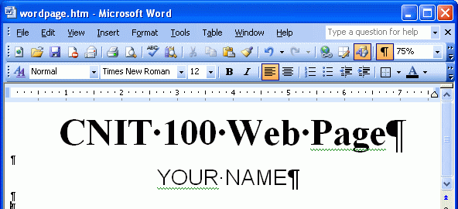
Do not use the virtual computers for this project.
Making a Web Page with Word
- Start Microsoft Word.
- Click Start, All Programs, Accessories, Word.
- Type in the text you see to the right on this page.
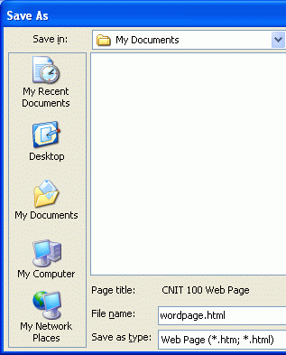
- Click File, Save as Web Page.
- In the Save as box, select a Save as type: of Web Page, as shown to the right on this page.
- Save the file with the name wordpage.html in the My Documents folder.

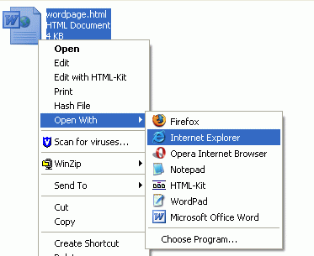
Viewing your Web Page Locally
- Click Start, My Documents. Find the wordpage.html icon and right-click it. Point to Open With, and click Internet Explorer, as shown to the right on this page.

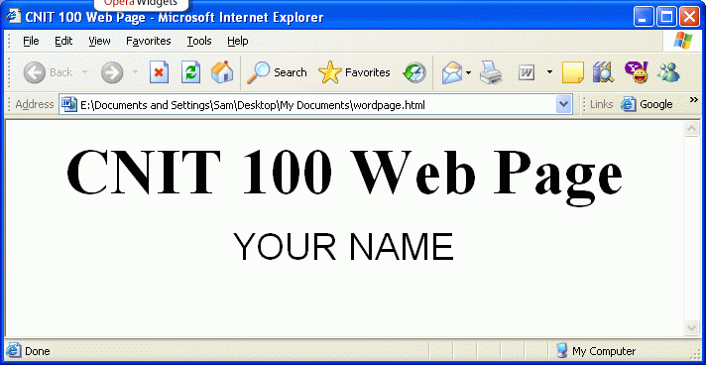
- It will open in Internet Explorer, as shown to the right on this page.

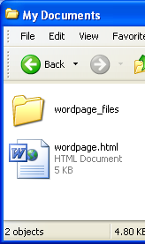
Adding an Image to the Web Page
- In the Word window, click Insert, Picture, Clip Art. Search for any sort of image, such as kitten. Click on one of the pictures to insert it. Click File, Save to save your Web page. Close Word.
Viewing the Saved Web Page
- Open the My Documents folder. You will see two items, as shown to the right on this page: wordpage.html and a folder named wordpage_files. That folder contains the image, and some other files Word created. This is the main disadvantage of using Word to make Web pages—it creates a complex set of files and folders when they are not really necessary. Also, the HTML inside the Word page is positively scary, as you’ll see later.
Publishing the Web Page on the CCSF Server
- This Web page consists of several files in your my Documents folder. But no one can see the files on your computer – to make them available to other people, you have to move the files up to a Web server.
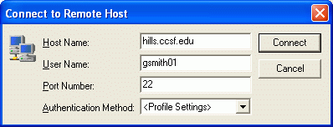
- Click Start, All Programs, SSH Secure Shell, Secure File Transfer Client. When the Secure File Transfer window opens, press the Enter key.
- In the Connect to Remote Host window, enter a Host Name of hills.ccsf.edu and a User Name of your HP-UNIX ID. Your HP-UNIX ID is the same ID you use to get your CCST email, or to log in to the computers in the ACRC in Batmale room 301. Press the Enter key.
- One or two more boxes appear. Press Enter to close them. When you see the Enter Password box, enter your birthday in the format jul0369

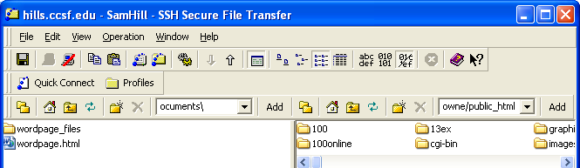
- Double-click the public_html folder in the right pane to open it, and navigate to My Documents folder in the left pane. You should see wordpage.html and wordage_files in the left pane, as shown below on this page.

- Drag the two items from the left pane to the right pane and drop them. This copies your files to the server.
- Open a browser and type in this URL to see your page:
hills.ccsf.edu/~gsmith01/wordpage.html
Replace gsmith01 with your HP-UNIX ID. Your page should be visible, as shown below on this page.
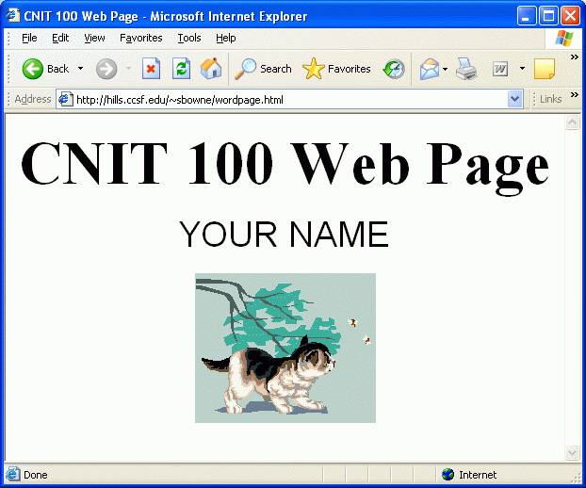
Viewing the Source Code of a Web Page Created by Word
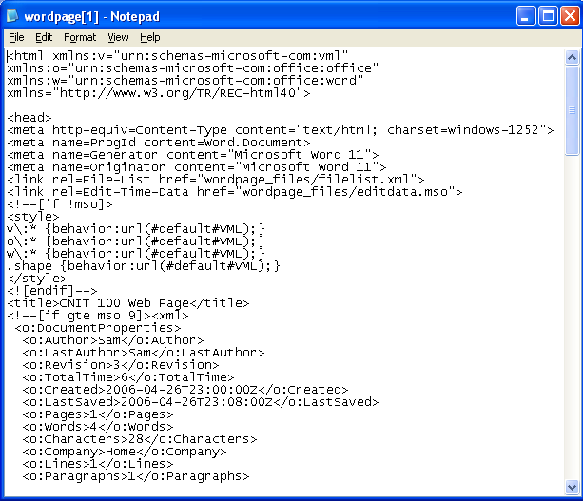
- In the browser window, click View, Source. The source code opens – this is HTML, but it is extremely advanced and complicated HTML. You don’t need all this complicated stuff to make such a simple page!

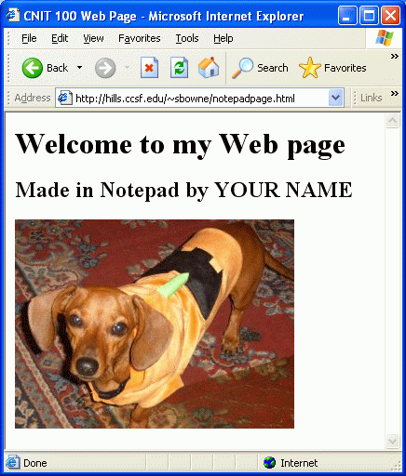
Viewing the Source Code of a Web Page Created in Notepad
- Open another browser window and open this Web page:
http://hills.ccsf.edu/~sbowne/notepadpage.html
- As you can see, this page has the same elements as the one you made – two lines of formatted text and an image. Click View, Source. As you can see below, it is far simpler.
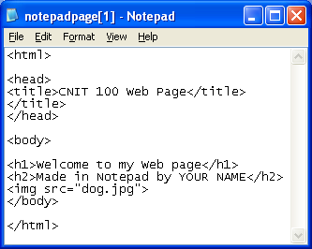

Last modified 4-26-06

