Do This on Two Machines at Once
- Two group members should do this at the same time, so you can send instant messages from one machine to another in the classroom.
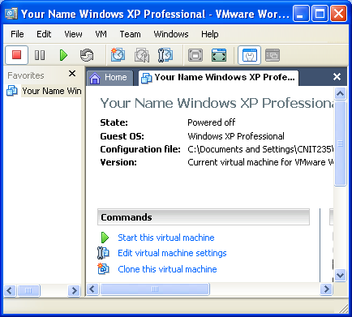
Starting VMWare Workstation
- We will use a program called VMWare Workstation, which simulates a computer on top of the existing Windows XP operating system. That way you can practice installation and other activities without changing (and possibly damaging) the existing operating system.
- Double-click the VMWare Workstation icon on the desktop.
- A VMWare Workstation window opens as shown to the right on this page. Click the blue Start this virtual machine link.
- A couple of VMWare message boxes will open, telling you details about how VMWare works that don’t matter right now. Just click the default selection to get past them.
- When your virtual PC starts, you will see a window with a virtual desktop in it, and a virtual Start button. Whenever you need to install software, do it in the virtual PC. That way you won’t mess up the host PC.

Installing Yahoo Messenger
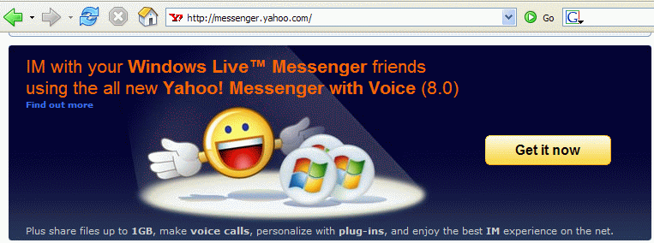
- Open a browser go to messenger.yahoo.com

- Click the Get it now button

- Install the software, following the prompts on the screen.

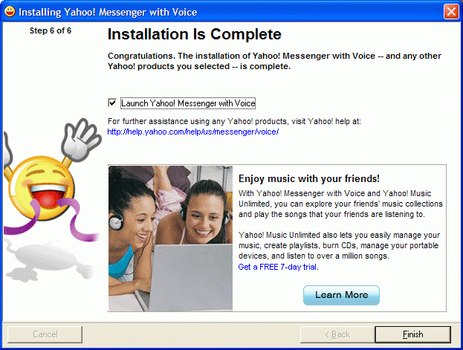
- When you see the Installation is Complete message, click Finish.
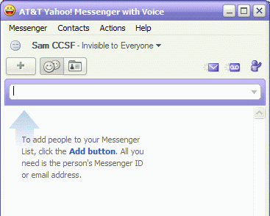
- An AT&T Yahoo! Messenger with Voice box appears. Enter your Yahoo ID and Password and click Sign in.

- When a Welcome to Yahoo! Messenger box appears, drag it to the side.

- You should see an AT&T Yahoo! Messenger with Voice box as shown to the right on this page. Enter the Yahoo ID of the other member of your group so the two of you can send messages back and forth.
Installing a Webcam
- If you can, get a webcam working on one of the machines so you can send a live image of the classroom to the other machine. Your instructor may have additional instructions to help you get the webcam going.

