Team Members:

Manager: _________________________________________

Google Researcher: _________________________________________

Altavista Researcher: _________________________________________

Ask Researcher:: _________________________________________

Results Presenter: _________________________________________

Topic: Search Engines and Search Operators

Manager: Assemble your team. If any member is absent, cross the name out on the list above and reorganize the team as necessary. You may have to have one member do two jobs, and/or take over a job yourself. You may give out a total of two bonus points to members of your team who do outstanding work, either +2 to one person, or +1 to two people. You cannot give bonus points to yourself.

Here are the tasks for each person:

Google Researcher , Altavista Researcher , and AskResearcher:

Follow your handout, and give your results to the Presenter.

Results Presenter: Make sure to do these things in your presentation:

- Explain to the class what a search operator is
- Write a Search String on the Whiteboard and explain it
- Demonstrate two of the searches with the projector

Team Members:

Manager: _________________________________________

Book Researcher: _________________________________________

Web Researcher: _________________________________________

Report Writer: _________________________________________

Results Presenter: _________________________________________

Topic: URLs and File Types

Manager: Assemble your team. If any member is absent, cross the name out on the list above and reorganize the team as necessary. You may have to have one member do two jobs, and/or take over a job yourself. You may give out a total of two bonus points to members of your team who do outstanding work, either +2 to one person, or +1 to two people. You cannot give bonus points to yourself.

Book Researcher: There are five parts in an URL:
- Web protocol standard
- Web server name
- Folder name
- Document name, and
- Filename Extension.
Find two examples of each of these in the book and make sure you understand them. Make a note of the page numbers and work with the Results Presenter so he can show them to the class and explain what they mean. Hint: for a second protocol, try looking for FTP.

Web Researcher: There are five parts in an URL:
- Web protocol standard
- Web server name
- Folder name
- Document name, and
- Filename Extension.
However, not all URLS have all five items.

1. Finding a good example URL on the Web: Use Internet Explorer and find a Web page with all five items present. This URL should start with http: to indicate that it’s on the Web. Identify all the parts of the URL and save the complete URL into a Word document saved on a floppy disk.

2. Saving a Web Page to the Desktop: Then save the Web page on your computer’s desktop with the File, Save As… command in Internet Explorer. Use a Save as type: of Webpage, complete (*.htm, *.html). Find the page’s icon on your desktop and double-click it to open it in Internet Explorer. Look at the URL – it should start with file:/// to indicate that it’s a file on your computer. Identify all the parts of the URL and save the complete URL into a Word document saved on a floppy disk.

Report Writer: Make sure you have notes of the page numbers and explanations of the URL sections the Book Researcher found. Prepare a Word Document saved on a Floppy Disk with the URLs the Web Researcher found. Don’t write URLs down with a pen, use copy-and-paste to move them to the Word document, so the Presenter can just click on them to open them.

Results Presenter: Don’t try to type URLs onto the demonstration computer. Instead, bring the floppy disk to the projector and open the Word document to show your results.

Your presentation should cover these items:

- Project the pages from the textbook using the CD in the back of the textbook, and show the examples of the URLs.
- Project the Web page you found on the Web and explain its URL
- Show the URL of the Web page you saved to the desktop and explain how its URL is different from the previous one.

Team Members:

Manager: _________________________________________

Book Researcher: _________________________________________

Web Designer: _________________________________________

Report Writer: _________________________________________

Results Presenter: _________________________________________

Topic: Making Web Pages

Task: Here are the tasks for each person:

Manager: Assemble your team. If any member is absent, cross the name out on the list above and reorganize the team as necessary. You may have to have one member do two jobs, and/or take over a job yourself. You may give out a total of two bonus points to members of your team who do outstanding work, either +2 to one person, or +1 to two people. You cannot give bonus points to yourself.

Book Researcher: Look in the textbook on page 28 and study the example Web page you see there. Figure out how to use HTML tags to create these effects:

Make text big

Make text centered

Put an image on a page

Make a link to another Web page
Then go help the Web Designer make the page with your information.

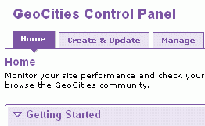
Web Designer: You will need an image for your Web page. Go to Google, find an image and save it on a floppy disk. Give it a simple name like car.jpg or cat.jpg. The image must be a .gif or .jpg file.

Open a browser and go to yahoo.com. Click the Geocities link and sign in with your Yahoo ID and password.

Under the GeoCities Control Panel header, click the Create & Update tab, as shown to the right on this page.
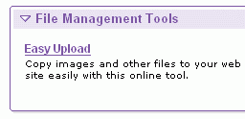
Near the bottom of the screen, in the File Management Tools section, click Easy Upload.

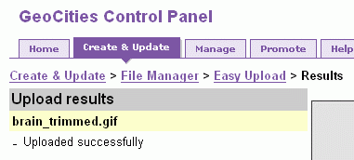
In the next screen, click a Browse button. Find your floppy disk and your image and double-click it. Then click the Upload Files button.

When you see the Upload results screen as shown to the right, showing that your file uploaded successfully, click the Create & Update link.

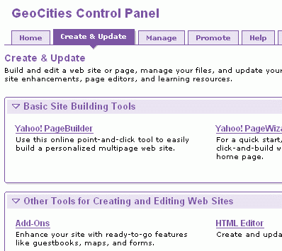
In the Other Tools for Creating and editing Web Sites section, click HTML Editor.

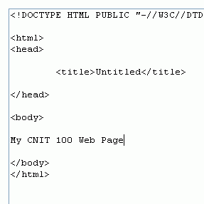
Now you should see a window with HTML in it, as shown to the right on this page. Type in text and HTML tags between the <body> and </body> tags:

Make a Web page with these items:

- Large, centered text
- Your image
- A link to another page
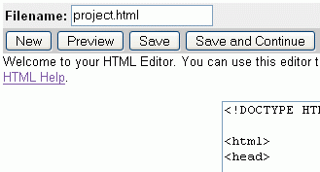
When you are done writing the code, type a filename ending in .html into the Filename box at the upper left of the window, and click the Save button.

In the next screen, find your file and click the View link.

Report Writer: Make a neat report showing the URL of the page created and all the HTML tags you used.

Results Presenter: Project the page so the class can see it, and select View, Source to show the class the HTML your group wrote. Explain what tags you used, and what they do.

Team Members:

Manager: _________________________________________

Computer Operator: _________________________________________

Computer Operator: _________________________________________

Web Researcher:: _________________________________________

Results Presenter: _________________________________________

Topic: Opera Web Browser

Here are the tasks for each person:

Manager: Assemble your team. If any member is absent, cross the name out on the list above and reorganize the team as necessary. You may have to have one member do two jobs, and/or take over a job yourself. You may give out a total of two bonus points to members of your team who do outstanding work, either +2 to one person, or +1 to two people. You cannot give bonus points to yourself.

Computer Operators: Follow the handout. You both do the same thing.

Web Researcher: Find these things:
- How many people are using Opera compared with Internet Explorer?
- Find a review of Opera that compares it with Internet Explorer. Find at least one advantage of Opera and one disadvantage of Opera.

Results Presenter: Demonstrate the Opera features the Computer Operators used. Explain the things the Web Researcher found.
Team Members:

Manager: _________________________________________

Computer Operator: _________________________________________

Computer Operator: _________________________________________

Web Researcher:: _________________________________________

Results Presenter: _________________________________________

Topic: Firefox Web Browser

Here are the tasks for each person:

Manager: Assemble your team. If any member is absent, cross the name out on the list above and reorganize the team as necessary. You may have to have one member do two jobs, and/or take over a job yourself. You may give out a total of two bonus points to members of your team who do outstanding work, either +2 to one person, or +1 to two people. You cannot give bonus points to yourself.

Computer Operators: Follow the handout. You both do the same thing.

Web Researcher: Find these things:
- How many people are using Firefox compared with Internet Explorer?
- Find a review of Firefox that compares it with Internet Explorer. Find at least one advantage of Firefox and one disadvantage of Firefox.

Results Presenter: Demonstrate the Firefox features the Computer Operators used. Explain the things the Web Researcher found.
Team Members:

Manager: _________________________________________

Computer Operator: _________________________________________

Computer Operator: _________________________________________

Web Researcher:: _________________________________________

Results Presenter: _________________________________________

Topic: Avant Web Browser

Here are the tasks for each person:

Manager: Assemble your team. If any member is absent, cross the name out on the list above and reorganize the team as necessary. You may have to have one member do two jobs, and/or take over a job yourself. You may give out a total of two bonus points to members of your team who do outstanding work, either +2 to one person, or +1 to two people. You cannot give bonus points to yourself.

Computer Operators: Follow the handout. You both do the same thing.

Web Researcher: Find these things:
- How many people are using Avant compared with Internet Explorer? If you can’t find that, can you find out how many people have downloaded Avant?
- Find a review of Avant that compares it with Internet Explorer. Find at least one advantage of Avant and one disadvantage of Avant.

Results Presenter: Demonstrate the Avant features the Computer Operators used. Explain the things the Web Researcher found.
Team Members:

Manager: _________________________________________

Book Researcher: _________________________________________

Web Designer: _________________________________________

Results Presenter: _________________________________________

Topic: Making a Web Pages With an image

Task: Here are the tasks for each person:

Manager: Assemble your team. If any member is absent, cross the name out on the list above and reorganize the team as necessary. You may have to have one member do two jobs, and/or take over a job yourself. You may give out a total of two bonus points to members of your team who do outstanding work, either +2 to one person, or +1 to two people. You cannot give bonus points to yourself.

Book Researcher: Look in the textbook on page 28 and study the example Web page you see there. Figure out how to use HTML tags to create these effects:

Make text big

Make text centered

Put an image on a page

Make a link to another Web page
Then go help the Web Designer make the page with your information.

Web Designer: You will need an image for your Web page. Go to Google, find an image and save it on a floppy disk. Give it a simple name like car.jpg or cat.jpg. The image must be a .gif or .jpg file.

Open a browser and go to yahoo.com. Click the Geocities link and sign in with your Yahoo ID and password.

Under the GeoCities Control Panel header, click the Create & Update tab, as shown to the right on this page.
Near the bottom of the screen, in the File Management Tools section, click Easy Upload.

In the next screen, click a Browse button. Find your floppy disk and your image and double-click it. Then click the Upload Files button.

When you see the Upload results screen as shown to the right, showing that your file uploaded successfully, click the Create & Update link.

In the Other Tools for Creating and editing Web Sites section, click HTML Editor.

Now you should see a window with HTML in it, as shown to the right on this page. Type in text and HTML tags between the <body> and </body> tags:

Make a Web page with these items:

- Large, centered text
- Your image
- A link to another page
When you are done writing the code, type a filename ending in .html into the Filename box at the upper left of the window, and click the Save button.

In the next screen, find your file and click the View link.

Results Presenter: Project the page so the class can see it, and select View, Source to show the class the HTML your group wrote. Explain what tags you used, and what they do.

