Manager: _________________________________________

Pine user: _________________________________________

Pine user: _________________________________________

Yahoo user: _________________________________________

Report Writer: _________________________________________

Results Presenter: _________________________________________

Topic: Using “pine” – text-only email

Task: Using the UNIX email program “pine” to send and receive email, and comparing it to Web-based email:

Here are the tasks for each person:

Manager: Assemble your team. If any member is absent, cross the name out on the list above and reorganize the team as necessary. You may have to have one member do two jobs, and/or take over a job yourself. You may give out a total of two bonus points to members of your team who do outstanding work, either +2 to one person, or +1 to two people. You cannot give bonus points to yourself.

Pine users: Follow the Pine handout.

Yahoo user: Follow the Yahoo User handout.

Report Writer: Make sure you understand what happened, and why the images did not appear in pine. Write down a clear explanation of it

Results Presenter: Before your presentation:

- Ask the pine user to start SSH and pine on the demonstration computer at the front of the classroom, so the pine email is visible.
- Ask the Yahoo user to log into their Yahoo email on the demonstration computer at the front of the classroom.
- Demonstrate the copies of the messages sent to Yahoo and to pine, and explain why they are different. Refer to the written explanation you got from the Report Writer.
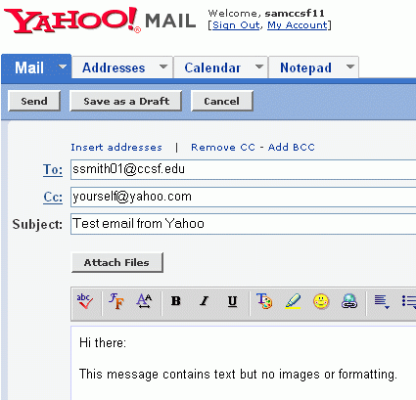
Yahoo user: Log in to your yahoo email and compose a message to the pine user as shown to the right on this page. Don’t use the literal address ssmith01@ccsf.edu – use the pine user’s account name instead. Send a copy to yourself.

Open your copy of the message and compare it to the message the pine user receives. They should look the same.

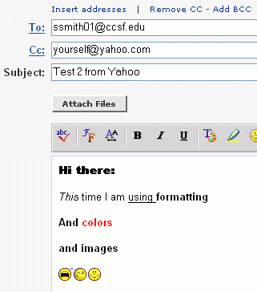
Yahoo user (continued): Log in to your yahoo email and compose another message to the pine user as shown to the right on this page. This time use the formatting buttons to add text formats and images to the message. Send the message.

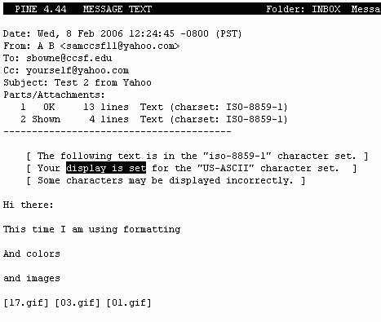

When the pine user opens this message, the formatting and images are absent. The message just contains codes as shown to the right on this page.

Manager: _________________________________________

GMail User: _________________________________________

Yahoo Mail User: _________________________________________

New Gmail User: _________________________________________

Results Presenter: _________________________________________

Topic: GMail

Task: To learn how GMail differs from other email services:

Manager: Assemble your team. If any member is absent, cross the name out on the list above and reorganize the team as necessary. You may have to have one member do two jobs, and/or take over a job yourself. You may give out a total of two bonus points to members of your team who do outstanding work, either +2 to one person, or +1 to two people. You cannot give bonus points to yourself.

GMail User: Follow the Using GMail handout.

Yahoo Mail User: First watch the GMail User get started, and watch the GMail Tour along with the GMail User. The GMail User and the New GMail User will send you a lot of messages. Reply to them all until they both have a series of 5 or 6 messages and replies.

New GMail User: Follow the New GMail User handout.

Results Presenter: Ask the Yahoo Mail user to open their mail on the demonstration computer, and show the class how a series of messages and replies looks in Yahoo. Then open the GMail account and show how the same conversation looks in GMail’s Conversation View. Explain how it works. If anyone in the class wants a GMail account, tell them to see the GMail User and the New Gmail User to find out how.

Manager: _________________________________________

WebIMAP User: _________________________________________

Yahoo User: _________________________________________

Report Writer: _________________________________________

Results Presenter: _________________________________________

Topic: Using WebIMAP

Task: Here are the tasks for each person:

Manager: Assemble your team. If any member is absent, cross the name out on the list above and reorganize the team as necessary. You may have to have one member do two jobs, and/or take over a job yourself. You may give out a total of two bonus points to members of your team who do outstanding work, either +2 to one person, or +1 to two people. You cannot give bonus points to yourself.

WebIMAP User: Follow the WebIMAP handout.

Yahoo User: Log in to your Yahoo account and reply to the messages you get from the IMAP user. Show the Report Writer the exact steps you use to reply to a message.

Report Writer: Write down the exact steps the IMAP user has to go through to read and reply to an email message. Count how many clicks are needed. Then do the same for Yahoo. Make a neat report showing the steps.

Results Presenter: Ask the IMAP user to log in on the demonstration computer so you can show the class the IMAP screen. Write the steps required to reply to an email on the whiteboard for the two types of email. Which system seems better to you? Make a recommendation and tell the class your reasoning.

Manager: _________________________________________

Outlook User: _________________________________________

Yahoo User: _________________________________________

Report Writer: _________________________________________

Results Presenter: _________________________________________

Topic: Using Outlook for POP3 Email

Task: Here are the tasks for each person:

Manager: Assemble your team. If any member is absent, cross the name out on the list above and reorganize the team as necessary. You may have to have one member do two jobs, and/or take over a job yourself. You may give out a total of two bonus points to members of your team who do outstanding work, either +2 to one person, or +1 to two people. You cannot give bonus points to yourself.

Outlook User: Follow the Outlook handout.

Yahoo User: Log in to your Yahoo account and reply to the messages you get from the Outlook User.

Report Writer: Write down the exact steps the Outlook User has to go through to read and reply to an email message. Count how many clicks are needed. Then do the same for the Yahoo User. Make a neat report showing the steps.

Results Presenter: Demonstrate Outlook mail using the demonstration machine. Don’t use the virtual PC – the main system has Outlook installed.

Compare Yahoo Mail and Outlook. Which system seems better to you? Make a recommendation and tell the class your reasoning.

Manager: _________________________________________

Hushmail User: _________________________________________

Hushmail User: _________________________________________

Web Researcher: _________________________________________

Results Presenter: _________________________________________

Topic: Hushmail

Task: Here are the tasks for each person:

Manager: Assemble your team. If any member is absent, cross the name out on the list above and reorganize the team as necessary. You may have to have one member do two jobs, and/or take over a job yourself. You may give out a total of two bonus points to members of your team who do outstanding work, either +2 to one person, or +1 to two people. You cannot give bonus points to yourself.

Hushmail Users: Follow the Hushmail handout.

Web Researcher: Find answers to these questions on the Web, and save them on a floppy in a Word document so the Presenter can use it.

- How many bits long is the encryption key used by Hushmail?

- How long should an encryption key be to make data secure?

- What is a digital signature?

Results Presenter: Ask a Hushmail user to log in so you can demonstrate the software to the class. Then explain the three questions and answers above.

Manager: _________________________________________

IE User: _________________________________________

IE User: _________________________________________

Firefox User: _________________________________________

Web Researcher: _________________________________________

Results Presenter: _________________________________________

Topic: Email and Cookies

Task: Here are the tasks for each person:

Manager: Assemble your team. If any member is absent, cross the name out on the list above and reorganize the team as necessary. You may have to have one member do two jobs, and/or take over a job yourself. You may give out a total of two bonus points to members of your team who do outstanding work, either +2 to one person, or +1 to two people. You cannot give bonus points to yourself.

IE Users: Follow the Email and Cookies: Internet Explorer handout.

Firefox User: Follow the Email and Cookies: Firefox handout.

Web Researcher: Find brief answers to these questions on the Web, and save them on a floppy in a Word document so the Presenter can use it.

- What is a session cookie?

- What is a persistent cookie?

- Why do Web sites like Yahoo use cookies?

Results Presenter: Choose either Firefox or Internet Explorer for your demonstration. Show these steps:

- Log in to Yahoo, checking the Remember my ID on this computer box.
- Shut down the computer and restart it.
- Open the browser and show the class that it’s still logged in.
- Delete the cookies and show the class that you are not logged in anymore.

Then present the things the Web Researcher found.

