Team Members:

Manager: _________________________________________

Book Researcher: _________________________________________

Web Researcher: _________________________________________

Web Researcher: _________________________________________

Report Writer: _________________________________________

Results Presenter: _________________________________________

Topic: Types of Memory (Ch 2b)

Task: Learn about the four types of memory and explain them to the class.

There are four types of memory: RAM, ROM, CMOS, and Virtual Memory.

Here are the tasks for each person:

Book Researcher: Find a description of the four types of memory in the book. What is special about each one, and makes it different from the others? Give your results to the Report Writer.

Web Researchers: Find a description of the four types of memory on the Web. What is special about each one, and makes it different from the others? Give your results to the Report Writer.

Report Writer: Write each of the four terms, with a brief explanation of each one.

Results Presenter: Write the four terms on the whiteboard. Use the report from the Report Writer and explain the terms to the class.

Team Members:

Manager: _________________________________________

Book Researcher: _________________________________________

Web Researcher: _________________________________________

Report Writer: _________________________________________

Results Presenter: _________________________________________

Topic: ASCII (Ch 2a)

Task: Learn how to perform ASCII conversion and explain it to the class.

Here are the tasks for each person:

Book Researcher: Find the chart that shows how to convert text to ASCII the textbook. For example, A is 01000001. Use the chart to do the two conversions in the box below. Give your results to the Report Writer.
What is HELLO in ASCII?

What does the ASCII code 01000011010011100100100101010100 translate to in text? Hint – break it into groups of 8 bits first!

Report Writer: Make a Word document on a floppy with the results the others found, ready for the Presenter.

Results Presenter: Present the results to the class. Demonstrate the ASCII Converter web page.

Web Researcher: Open a browser and go to this Web page, which is shown below:

http://nickciske.com/tools/binary.php

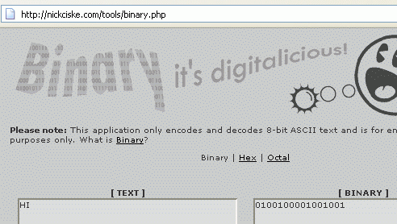

You can now convert TEXT to BINARY using the gray ENCODE and DECODE buttons. Use this page to answer the two questions in the box below. Give your results to the Report Writer.

What is HELLO in ASCII?

What does the ASCII code 01000011010011100100100101010100 translate to in text? Hint – break it into groups of 8 bits first!
Team Members:

Manager: _________________________________________

Book Researcher: _________________________________________

Web Researcher: _________________________________________

Report Writer: _________________________________________

Results Presenter: _________________________________________

Topic: UNICODE (Ch 2a)

Task: Learn how to perform UNICODE conversion and explain it to the class.

Here are the tasks for each person:

Book Researcher: Find these things in the book:

- What is UNICODE and how is it different from ASCII?

- When is UNICODE used?

Report Writer: Make a Word document on a floppy with the results the others found, ready for the Presenter.

Results Presenter: Present the results to the class. Demonstrate the UNICIDE Converter web page used by the Web Researcher.

Web Researcher: Open a browser and go to this Web page, which is shown below:

http://weber.ucsd.edu/~dkjordan/resources/unicodemaker.html

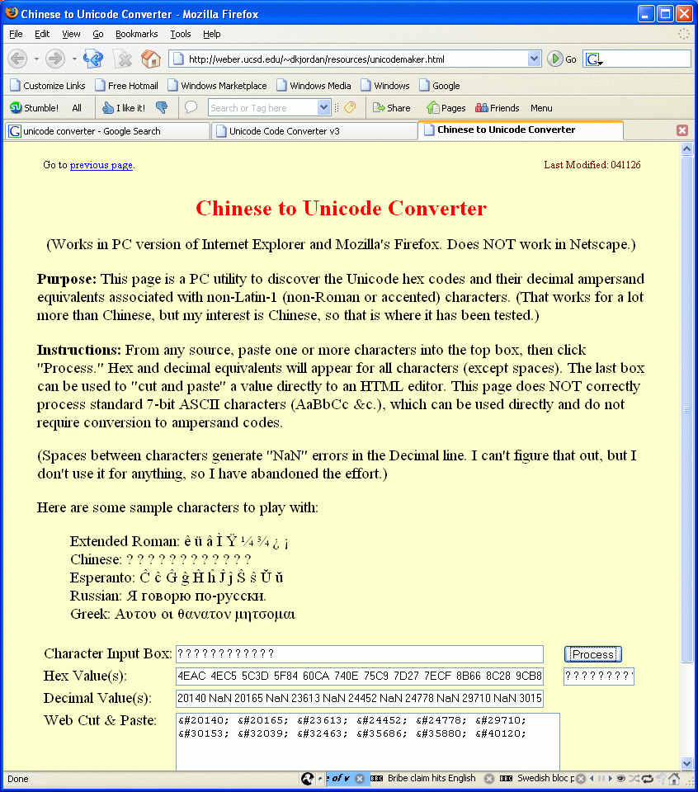

Use this page to convert the five examples shown into UNICODE. Demonstrate the process to the Report Writer.

What is HELLO in ASCII?

What does the ASCII code 01000011010011100100100101010100 translate to in text? Hint – break it into groups of 8 bits first!
Team Members:

Manager: _________________________________________

Book Researcher: _________________________________________

Web Researcher: _________________________________________

Report Writer: _________________________________________

Results Presenter: _________________________________________

Topic: Hard Disks (Ch 2c)

Task: Learn about hard disks.

Here are the tasks for each person:

Book Researcher: Find a description of a hard disk in the book. Compare it to hard disk you got from your instructor. Find the platters, the read/write head, and the controller. Give your results to the Report Writer.

Web Researcher: Find two different hard disks for sale on the Web. Which one is better? Find two specific differences between them. Give your results to the Report Writer.

Report Writer: Make a Word document on a floppy with the results the others found, ready for the Presenter.

Results Presenter: Pass the sample hard drive around the class, and explain its components. Show the class the Web pages you found selling hard disks and explain how they compare.

Team Members:

Manager: _________________________________________

Book Researcher: _________________________________________

Calculator User: _________________________________________

Report Writer: _________________________________________

Results Presenter: _________________________________________

Topic: Binary (Ch 2a)

Task: Learn how to convert numbers between base ten and binary.

Here are the tasks for each person:
In binary, the rightmost digit is the number of 1s
The second digit from the right is the number of 2s
The third digit from the right is the number of 4s
The fourth digit from the right is the number of 8s
The fifth digit from the right is the number of 16s

Book Researcher: Read the explanation of binary math in the book at the start of chapter 2a, and box to the right. Then look at the two examples below and try to understand them.

11 in Binary means 1x2 + 1x1 = 2 + 1 = 3

1000 in Binary means 1x8 + 0x4 + 0x2 + 0x1 = 8 + 0 + 0 + 0 = 8

What is 7 in binary?

What is 13 in binary?

What is the binary number 1111 in decimal?
Answer the four questions in the box to the right, figuring out the answers without a calculator. If you have difficulty, ask your group members for help.

Calculator User: On a computer, click Start, All Programs, Accessories, Calculator. In the Calculator window, click View, Scientific. You should see a window like the figure below. You can click the digits 0 through 9 to enter values, and use the little buttons at the upper left labeled Dec to see the value in Decimal and Bin to see the value in Binary.
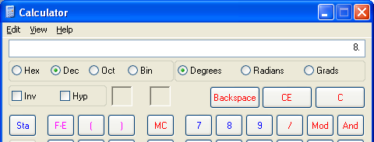

What is 7 in binary?

What is 13 in binary?

What is the binary number 1111 in decimal?
Answer the questions in the box to the right using the Calculator. See if the Book Researcher got the same answers.

Report Writer: Write the three questions and answers, with an explanation of how to figure them out without a calculator.

Results Presenter: Write the three questions on the whiteboard. Use the report from the Report Writer and explain the conversions to the class.

Team Members:

Manager: _________________________________________

Book Researcher: _________________________________________

Web Researcher: _________________________________________

Report Writer: _________________________________________

Results Presenter: _________________________________________

Topic: Solid State Storage (Ch 2c)

Task: Learn about Solid State Storage Devices:

Here are the tasks for each person:

Book Researcher: Look up information about Solid State Storage devices in the book. Find one USB solid state storage device, and one that requires a card reader. Get specific brand names and give them to the Web Researcher and to the Report Writer.

Web Researchers: Find the two items the Book Researcher tells you about on the Web. How much do they cost? Which one is better? Give your results to the Report Writer.

Report Writer: Make a Word document on a floppy with the results the others found, ready for the Presenter.

Results Presenter: Write down the results the researchers found. Explain to the class what you were looking for, and what you found. Explain which device is better, and why.

