Using Pine

1. HP-UNIX User ID and Passwords
User ID  (name like ssmith01) | ______________________________
First Password  (birthday like jan1276) | ______________________________
New Password  (anything you want, at least 6 characters, must include letters and numbers) | ______________________________

Fill in the three items in the box to the right.

2. Start the SSH Secure Shell Client

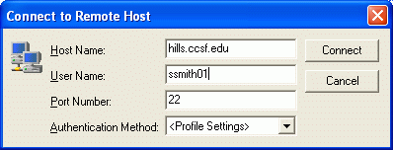
Click Start, All Programs, SSH Secure Shell, Secure Shell Client. The SSH Secure Shell window opens as shown in the figure to the right on this page.

3. Connect to Remote Host

Click the Quick Connect button in the SSH Secure Shell window. A Connect to Remote Host window appears as shown in the figure to the right on this page. Enter a Host Name of hills.ccsf.edu and put your User ID in the User Name box (don’t use ssmith01—use your own ID instead). Then click the Connect button.

4. Host Identification

If a Host Identification window opens as shown to the right, press Enter to close it.

5. Enter Your Password

An Enter Password box opens. Type in your birthday (like this jan1475) and press Enter.

6. You are Now Connected

You should see a hills.ccsf.edu window as shown to the right on this page.

At the
TERM = (vt100)
line, press Enter.

A $ should appear, showing that you are connected to the HP-UNIX system, and it is ready for you to enter a UNIX command. You may see some letters before the $, like bash-2.04$. That’s OK.

7. Start the pine E-mail program

At the UNIX $ prompt, type

pine

and press the Enter key. The pine MAIN MENU opens as shown to the right on this page.

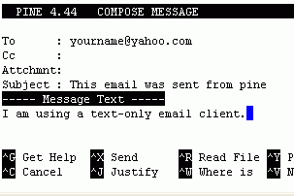
8. Sending Mail with Pine
From the Pine MAIN MENU, hit C to compose an email message.
In the header To: field, enter the Yahoo email address of the group member who will be using Yahoo.
Put in any subject and text you wish, but don’t leave them blank. To move from one field to another, use the Tab or Enter keys. The mouse does not work in pine!
To send the email, hold down the Ctrl key and press X. Then press Y.

9. Reading Mail With Pine
a. From the Pine MAIN MENU, hit I to see the message index. The email senders and subjects appear as shown below. Use the keyboard up-arrow and down-arrow keys to move the -> arrow to point to the message you want to read and press the Enter key to read it.
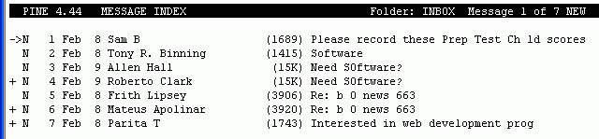

When you are done reading a message, press M to return to the main menu.

Last updated 2-8-06

