Team Members:

Manager: ___________________________________

Google Researcher: ___________________________________

Altavista Researcher: ___________________________________

Report Writer: ___________________________________

Results Presenter: ___________________________________

Topic: Search Engines and Search Operators

Task: Using various search engines, figure out what query you need to enter to find each of these specific things:

- A review comparing various models of cell phones written within the last 3 months

- A list of final exam dates for this semester (Spring 2006) in the ccsf.edu domain

- Another item of your choice, which must state just what you want, and limit the search in some manner, such as to a specific domain or date range
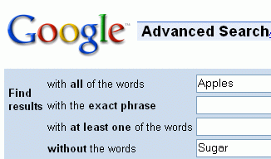
Here are the tasks for each person:


Google Researcher: Find queries that find each of the above items. You can use the Advanced Search link to build the queries.

For example, suppose you are looking for pages with Apples but without Sugar. Start at Google.com and click the Advanced Search link (on the right side of the screen). Enter the items as shown to the right on this page and click the Google Search button.

Now you get the results, and the query box shows the query you need to do that search:

Apples –sugar

Google uses the minus sign as a Search Operator to remove a word from the search.

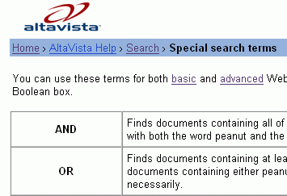
AltaVista Researcher: Find queries that find each of the above items. Try to do it without using the Advanced Search screen. Instead, try to figure out the query strings using AltaVista Help. To get the Help page, start at

altavista.com

Click on the tiny blue word Help in the lower right. In the next screen, click on Search. In the next page, in the AltaVista Features section, click on Special Search Terms. You should see the altavista help page shown to the right on this page. Use this information to plan your queries, and return to altavista.com to test them. Make sure they find what you are looking for.

Report Writer: Make a neat report showing the best search strings found for each search engine.

Results Presenter: Make sure to do these things in your presentation:

- Explain to the class what you were looking for
- Write a Search String on the Whiteboard and explain it
- Demonstrate the searches with the projector

Team Members:

Manager: ___________________________________

Book Researcher: ___________________________________

Web Researcher: ___________________________________

Report Writer: ___________________________________

Results Presenter: ___________________________________

Topic: URLs and File Types

Task: As a group, select one type of storage device and one type of processing device (CPU) to research. Here are the tasks for each person:

Book Researcher: There are five parts in an URL:
- Web protocol standard
- Web server name
- Folder name
- Document name, and
- Filename Extension.
Find two examples of each of these in the book and make sure you understand them. Make a note of the page numbers and work with the Results Presenter so he can show them to the class and explain what they mean. Hint: for a second protocol, try looking for FTP.

Web Researcher: There are five parts in an URL:
- Web protocol standard
- Web server name
- Folder name
- Document name, and
- Filename Extension.
However, not all URLS have all five items.

1. Finding a good example URL on the Web: Use Internet Explorer and find a Web page with all five items present. Identify all the parts of the URL and make sure the Report Writer has that URL correctly copied into a Word document saved on a floppy disk.

2. Saving a Web Page to the Desktop: Then save the Web page on your computer’s desktop with the File, Save As… command in Internet Explorer. Find the page’s icon on your desktop and double-click it to open it in Internet Explorer. Look at the URL – how does it compare to the URL you saw earlier? Make sure the Report Writer has the URL correctly copied into a Word document saved on a floppy disk, and is ready to explain the differences.

3. Saving a Web Page on a Floppy Disk: Save the same Web page on a floppy disk with the File, Save As… command. Open My Computer and the floppy disk, and double-click the page to open it in Internet Explorer. Look at the URL – how does it compare to the URL you saw earlier? Make sure the Report Writer has the URL correctly copied into a Word document saved on a floppy disk, and is ready to explain the differences.

Report Writer: Make sure you have notes of the page numbers and explanations of the URL sections the Book Researcher found. Prepare a Word Document saved on a Floppy Disk with the URLs the Web Researcher found. Don’t write URLs down with a pen, use copy-and-paste to move them to the Word document, so the Presenter can just click on them to open them.

Results Presenter: Don’t try to type URLs onto the demonstration computer. Instead, bring the floppy disk to the projector and open the Word document to show your results.

Your presentation should cover these items:

- Project the pages from the textbook using the CD in the back of the textbook, and show the examples of the URLs.
- Project the Web page you found on the Web and explain its URL
- Show the URL of the Web page you saved to the desktop and explain its URL
- Open the Web page you saved on your floppy and explain its URL

Team Members:

Manager: ___________________________________

Book Researcher: ___________________________________

Web Designer: ___________________________________

Report Writer: ___________________________________

Results Presenter: ___________________________________

Topic: Making Web Pages

Task: Here are the tasks for each person:

Book Researcher: Look in the textbook on page 30 and study the example Web page you see there. Figure out how to use HTML tags to create these effects:

Make text big

Make text centered

Put an image on a page

Make a link to another Web page
Then go help the Web Designer make the page with your information.

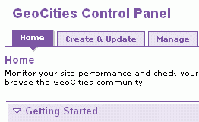
Web Designer: You will need an image for your Web page. Go to Google, find an image and save it on a floppy disk. Give it a simple name like car.jpg or cat.jpg. The image must be a .gif or .jpg file.

Open a browser and go to yahoo.com. Click the Geocities link and sign in with your Yahoo ID and password.

Under the GeoCities Control Panel header, click the Create & Update tab, as shown to the right on this page.
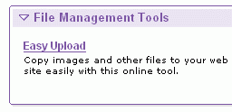
Near the bottom of the screen, in the File Management Tools section, click Easy Upload.

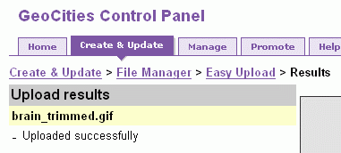
In the next screen, click a Browse button. Find your floppy disk and your image and double-click it. Then click the Upload Files button.

When you see the Upload results screen as shown to the right, showing that your file uploaded successfully, click the Create & Update link.

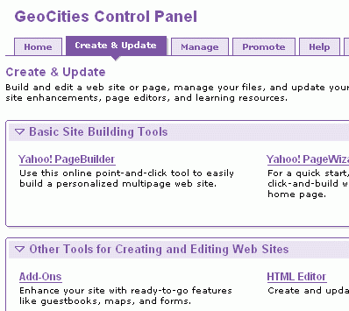
In the Other Tools for Creating and editing Web Sites section, click HTML Editor.

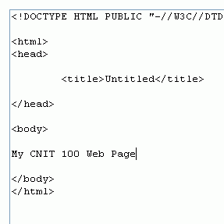
Now you should see a window with HTML in it, as shown to the right on this page. Type in text and HTML tags between the <body> and </body> tags:

Make a Web page with these items:

- Large, centered text
- Your image
- A link to another page
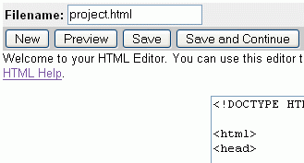
When you are done writing the code, type a filename ending in .html into the Filename box at the upper left of the window, and click the Save button.

In the next screen, find your file and click the View link.

Report Writer: Make a neat report showing the URL of the page created and all the HTML tags you used.

Results Presenter: Project the page so the class can see it, and select View, Source to show the class the HTML your group wrote. Explain what tags you used, and what they do.

