Team Members:

Manager: ___________________________________

Pine user: ___________________________________

Yahoo user: ___________________________________

Report Writer: ___________________________________

Results Presenter: ___________________________________

Topic: Using “pine” – text-only email

Task: Using the UNIX email program “pine” to send and receive email, and comparing it to Web-based email:

Here are the tasks for each person:

Pine user: Log into the pine email program as explained in the Pine handout. Send an email to the Yahoo user’s email account, and leave pine open so you can read mail you receive.

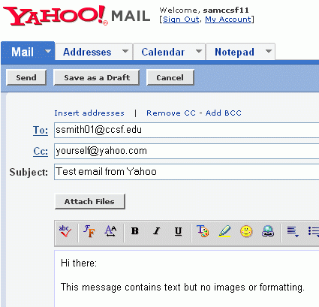
Yahoo user: Log in to your yahoo email and compose a message to the pine user as shown to the right on this page. Don’t use the literal address ssmith01@ccsf.edu – use the pine user’s account name instead. Send a copy to yourself.

Open your copy of the message and compare it to the message the pine user receives. They should look the same.
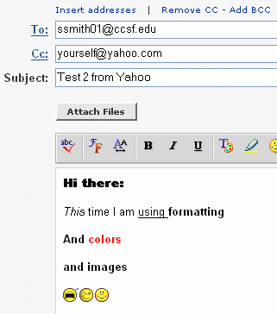
Yahoo user (continued): Log in to your yahoo email and compose another message to the pine user as shown to the right on this page. This time use the formatting buttons to add text formats and images to the message. Send the message.

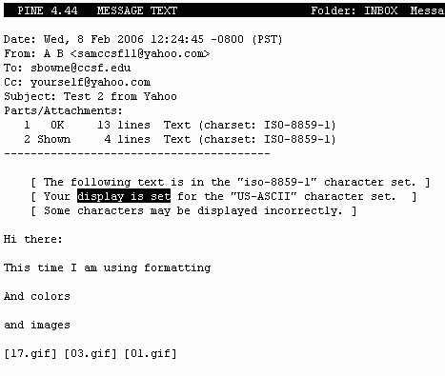

When the pine user opens this message, the formatting and images are absent. The message just contains codes as shown to the right on this page.

Report Writer: Make sure you understand what happened, and why the images did not appear in pine. Write down a clear explanation of it

Results Presenter: Before your presentation:

- Ask the pine user to start SSH and pine on the demonstration computer at the front of the classroom, so the pine email is visible.
- Ask the Yahoo user to log into their Yahoo email on the demonstration computer at the front of the classroom.
- Demonstrate the copies of the messages sent to Yahoo and to pine, and explain why they are different. Refer to the written explanation you got from the Report Writer.

Team Members:

Manager: ___________________________________

GMail User: ___________________________________

Yahoo Mail User: ___________________________________

New Gmail User: ___________________________________

Results Presenter: ___________________________________

Topic: GMail

Task: To learn how GMail differs from other email services:

GMail User: Log in to GMail, invite the New Gmail User, view the GMail Tour, and create a series of messages. The steps are in the Using GMail handout.

Yahoo Mail User: First watch the GMail User get started, and watch the GMail Tour along with the GMail User. When the GMail user sends you a message, reply to it. The Gmail User will reply to your reply, and you should reply again. When the series of messages and replies are done, your Yahoo Mail screen should look like the figure below. Each message you receive shows up separately, and the messages you sent do not appear in the Inbox at all.
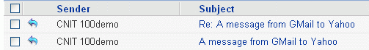

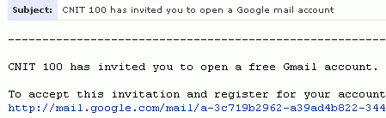
New GMail User: GMail is not available to everyone – only to people who are invited to join by people who are already using GMail. Give the Gmail User your Yahoo email address so that you can be invited to GMail. Then read your Yahoo mail and open the message that contains your invitation, as shown to the right on this page. Follow the instructions in that message to get your own GMail account.

Results Presenter: Ask the Yahoo Mail user to open their mail on the demonstration computer, and show the class how a series of messages and replies looks in Yahoo. Then open the GMail account and show how the same conversation looks in GMail. Explain how it works. If anyone in the class wants a GMail account, tell them to see the GMail User and the New Gmail User to find out how.
Team Members:

Manager: ___________________________________

IMAP User: ___________________________________

Yahoo User: ___________________________________

Report Writer: ___________________________________

Results Presenter: ___________________________________
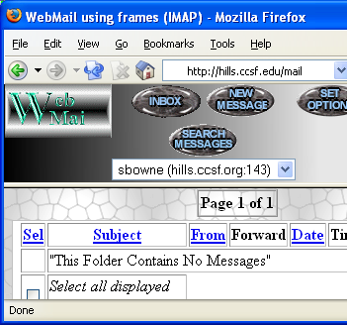

Topic: Using IMAP

Task: Here are the tasks for each person:

IMAP User: Start a browser and go to hills.ccsf.edu/mail

Enter your HP-UNIX ID and password. Your HP-UNIX ID is the same ID you use in the Batmale 301 computer lab, something like

ssmith01

The password is your birthday in this format:

jan1578

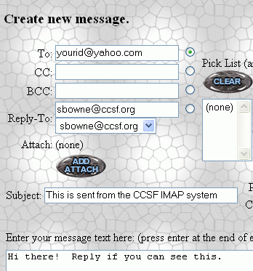
The first time you log in, you will see a configuration page – just accept the defaults and go on to the WebMail page shown to the upper right on this page.

Click the New Message button and compose a message to the Yahoo User as shown to the right on this page. Click the Send Message button to send it.

When the Yahoo User replies to your message, reply to the reply. Show the Report Writer the exact steps you use to reply to a message.

Yahoo User: Log in to your Yahoo account and reply to the messages you get from the IMAP user. Show the Report Writer the exact steps you use to reply to a message.

Report Writer: Write down the exact steps the IMAP user has to go through to read and reply to an email message. Count how many clicks are needed. Then do the same for Yahoo. Make a neat report showing the steps.

Results Presenter: Ask the IMAP user to log in on the demonstration computer so you can show the class the IMAP screen. Write the steps required to reply to an email on the whiteboard for the two types of email. Which system seems better to you? Make a recommendation and tell the class your reasoning.

Team Members:

Manager: ___________________________________

Outlook User: ___________________________________

Yahoo User: ___________________________________

Report Writer: ___________________________________

Results Presenter: ___________________________________

Topic: Using Outlook for POP3 Email

Task: Here are the tasks for each person:

Outlook User: Configure Outlook on one of the lab computers to get your CCSF email. The instructions to do that are in the Outlook handout. Then send a message to the Yahoo User. When the Yahoo User replies, reply to that reply. Show the Report Writer the exact steps you do to reply to a message.

Yahoo User: Log in to your Yahoo account and reply to the messages you get from the Outlook User. Show the Report Writer the exact steps you use to reply to a message.

Report Writer: Write down the exact steps the Outlook User has to go through to read and reply to an email message. Count how many clicks are needed. Then do the same for the Yahoo User. Make a neat report showing the steps.

Results Presenter: Ask the IMAP user to log in on the demonstration computer so you can show the class the IMAP screen. Write the steps required to reply to an email on the whiteboard for the two types of email. Which system seems better to you? Make a recommendation and tell the class your reasoning.

