Two students should do this together, on two nearby machines, so they can see each other’s work.

Entering the Teamspace Demo

- Open Internet Explorer and go to teamspace.com. Click the Online Demo! button.

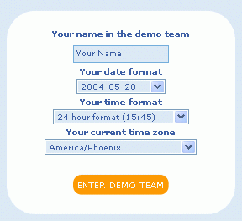
- In the next screen, enter your first name and click Enter Demo Team.
- The next screen says Welcome to the DEMO-team at the top. Click Continue.


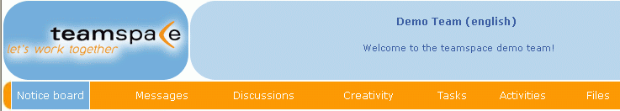
- Teamspace has several sections, as shown on the yellow bar near the top, labeled Notice board, Messages, Discussions, Creativity, Tasks, etc.

Using the Notice Board
- Scroll down in the Notice Board section and find the Notice I put there last night. It has Intro to Computers prominently in it.
- Find the New notice link in the upper left and click it. Add a Notice of your own. Find the Notice the other student in your group put there and read it.
Sending Messages
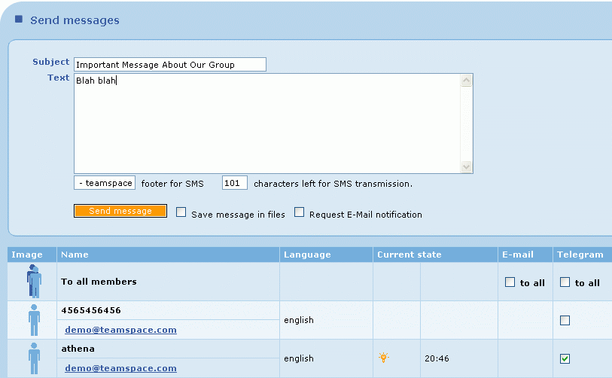
- Click Messages in the top yellow bar. Scroll down and find the other member of your group, and put a check mark in the Telegram section of their line. Then type a message into the box at the top and click Send message. Go look at their screen to see what a Telegram looks like.

Other Tasks
- If time permits, try using the Discussion feature to post a new thread of connected messages, and the Files section to upload a file.
- Explain to the Report Writer what you have done, and what you think of this software. Do you think people could use this to work together on a project?

