
Open a browser and Google Azureus

Click on the Azureus : Java BitTorrent Client link

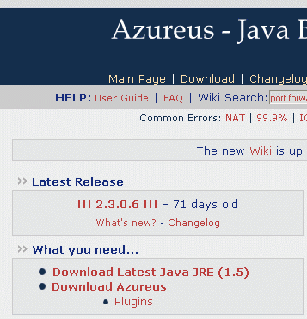

You need to download two things: Java JRE and Azureus.

Click on Download Java JRE

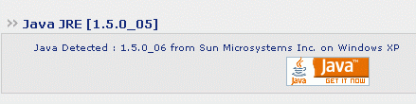

In the next screen, click on the orange java icon

In the next window, click the Download Now button.


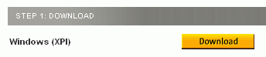
In the next screen, click the Download button next to Windows XP.

Install the software, following the prompts on the screen.

Then close your browser and restart it. Use Google again to find the Azureus download page. Click Download Azureus.

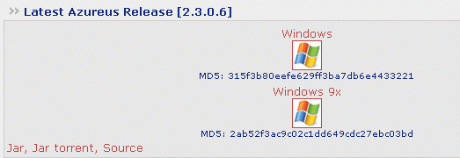
When you see the latest Azureus Release screen, click the Windows icon.

When you see the screen that asks you to Please select a mirror, click the Download link for any mirror in the USA.


Download the file, save it on your desktop, and run it. Follow the on-screen prompts to install the software.

After it is installed, click Start, All Programs, Azureus, Azureus to run it. Update it and restart it as prompted to.
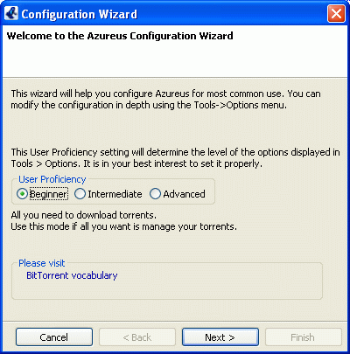
You will see the Configuration Wizard as shown to the right. Just click Next and accept all the default settings.

To find some torrents to download, open a browser and go to legaltorrents.com.

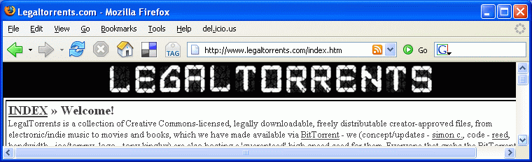

Find something you want to see, right-click it, and select Copy Shortcut.

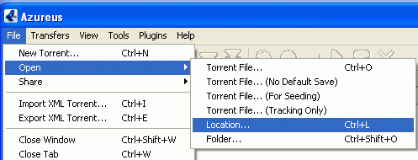
In the Azareus window, click File, Open, Location.


In the Open Location dialog box, paste the link into the URL box and click OK.

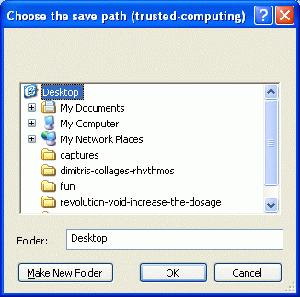
In the Choose the save path box, select Desktop and click OK.

That’s all. The file should download to the desktop. For more help, use the Help menu in Azareus.

Remember: Downloading copyrighted songs, movies, etc. is a crime! Make sure you are getting legal torrents.

