Goals of This Chapter

List the advantages of networked computing relative to standalone computing

Distinguish between client/server and peer-to-peer networks

List elements common to all client/server networks

Describe several specific uses for a network

Identify some of the certifications available to networking professionals

Identify the kinds of skills and specializations that will help you excel as a networking professional
Why Use Networks?

Network

Group of computers and devices

Connected by transmission media

Stand-alone computer

Not connected to other computers

Uses local software and data

Advantages of networks over standalone computers

Device sharing by multiple users

Saves money and time

Central network management
Types of Networks

Models vary according to:

Computer positioning

Control levels over shared resources

Communication and resource sharing schemes

Network models

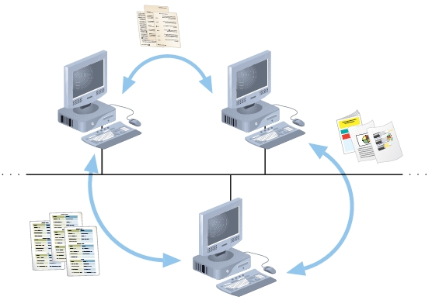
Peer-to-Peer

Client/server

Peer-to-Peer Network

Typical in a home with several computers

Direct computer communication

Equal authority

Individual resource sharing

May share resources

May prevent access to resources

Each computer can send data to every other computer on the network

Advantages

Simple configuration

Inexpensive to set up

Disadvantages

Not flexible
Peer-to-Peer Network

Not necessarily secure

Not practical for large installations

Resource sharing method

Modify file sharing controls

A user responsibility

Not centrally controlled

Potential variations and security issues

Environments

Small home or office

Large networks using the Internet

Gnutella, Freenet, original Napster

BitTorrent software

Obama’s Helicopter Secrets Revealed

Because of misconfigured peer-to-peer file sharing

Link Ch 1a on the course Web page

samsclass.info

Click on CNIT 106

Client/Server Networks

Central computer (server)

Facilitates communication and resource sharing

Clients (other computers)

Personal computers

Known as workstations

Central resource sharing controlled by server

Data sharing, data storage space, devices

No direct sharing of client resources

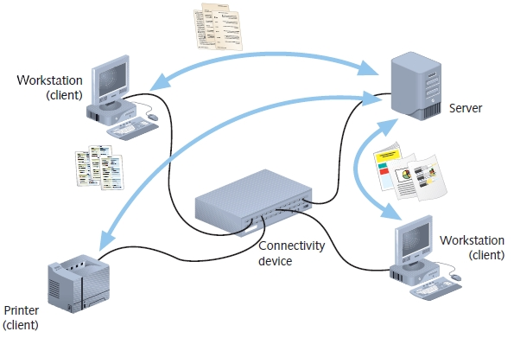
Computer roles

Server

Clients

Run local applications

Store data locally

Use server shared applications, data, devices

Use server as intermediary

Communication

Switches or routers

Server requirement

Network operating system
Client/Server Network

Manages client data, resources

Ensures authorized user access

Controls user file access

Restricts user network access

Dictates computer communication rules

Supplies application to clients

Server examples

UNIX, Linux, Microsoft Server 2003 and 2008, MAC OS X Server

Server features relative to clients

More memory, processing, storage capacity

Equipped with special hardware

Provides network management functions

Disadvantages relative to peer-to-peer networks

Complex in design and maintenance

Advantages relative to peer-to-peer networks

User credential assigned from one place

Multiple shared resource access centrally controlled

Central problem monitoring, diagnostics, correction capabilities

User response time optimization capabilities

Efficient processing on large networks

Scalability

Popular in medium- and large-scale organizations

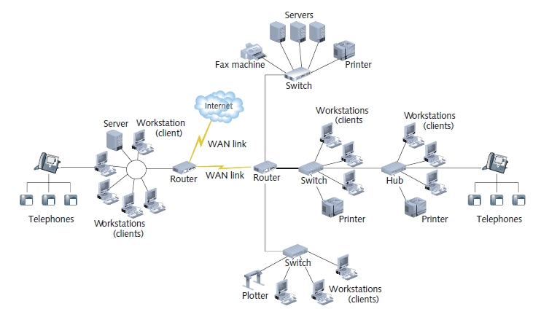
LANs, MANs, and WANs

LAN (local area network)

Network confined to a relatively small space

1980s -- LANs became popular as peer-to-peer based

Today -- Larger and more complex client/server network

MAN (metropolitan area network)

Network extends beyond building boundaries

Larger than LAN

Connects clients and servers from multiple buildings

WAN (wide area network)


Connects two or more geographically distinct LANs or MANs

Comparison to LANs

Use slightly different transmission methods and media

Use greater variety of technologies

Network connection

Separate offices in same organization

Separate offices in different organizations

Warriors of the Net Video

Links Ch 1b, 1c
Elements Common to Client/Server Networks

Client

Network computer requesting resources or services from another network computer

Client workstation human user

Client software installed on workstation

Server

Network computer managing shared resources

Runs network operating system

Workstation

Personal computer

May or may not be connected to network

NIC (network interface card)

Device inside computer

Connects computer to network media

Allows communication with other computers

NOS (network operating system)

Server software

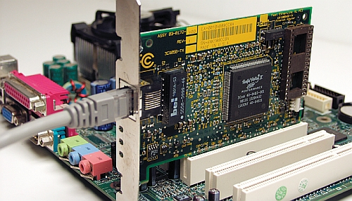
Enables server to manage data, users, groups, security, applications, and other networking functions

Ethernet NIC

Host

A computer that enables other computers to share resources

Node

Client, server, or other device

Communicates over a network

Identified by unique number (network address)

Connectivity device

Allows multiple networks or multiple parts of one network to connect and exchange data

Such as a switch or router

Segment

Group of nodes

Use same communications channel for traffic

Backbone

Connects segments and significant shared devices

“A network of networks”

Topology

Computer network physical layout

Ring, bus, star or hybrid formation

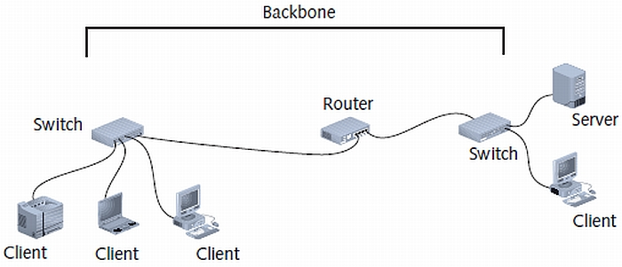
A LAN Backbone

Protocol

Standard method or format for communication between networked devices

Data packets

Distinct data units exchanged between nodes

Addressing

Scheme for assigning unique identifying number to every node

Transmission media

Means through which data is transmitted and received

Common Network Topologies
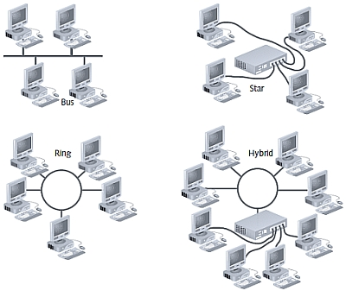

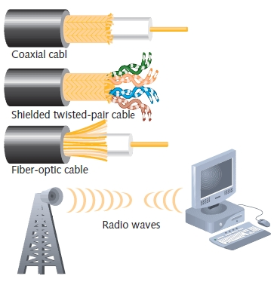

Transmission Media

How Networks Are Used

Network services

Functions provided by a network

Most visible

E-mail

Other vital services

Printer sharing, file sharing, Internet access and Web site delivery, remote access capabilities, the provision of voice (telephone) and video services, network management

File and Print Services

File services

Capability of server to share data files, applications and disk storage space

File server

Provides file services

File services provide foundation of networking

Print services

Share printers across network

Saves time and money

Access Services

Allow remote user network connection

Allow network users to connect to machines outside the network

Remote user

Computer user on different network or in different geographical location from LAN’s server

Network operating systems include built-in access services

Access Services

Provide LAN connectivity when WAN connection is not cost-effective

External staff used to diagnose problems

Allow external users to use network resources and devices

Same as if logged on to office workstation

Communications Services

Convergence

Multiple types of communications services on the same network

Phone calls, fax, text messages, video…

Unified communications

Centralized management of network-based communications

E-mail

Oldest and most frequently used

Mail server

Computer responsible for mail services

Coordinates storage and transfer of e-mail

Additional tasks of mail servers

Intercept spam

Handle objectionable content

Route messages according to rules

Provide Web-based client

Notify administrators or users if certain events occur

Schedule e-mail transmission, retrieval, storage, maintenance functions

Communicate with mail servers on other networks

Mail server runs specialized mail server software

Internet Services

Supplying Web pages

Servers work together to bring Web pages to user’s desktop

Web server

Computer installed with appropriate software to supply Web pages to many different clients upon demand

Other Internet services

File transfer capabilities, Internet addressing schemes, security filters, means for directly logging on to other Internet computers

Management Services

Small network management

Single network administrator

Network operating system’s internal functions

Today’s larger network management

Centrally administered network management tasks

Other important services

Traffic monitoring and control

Load balancing

Hardware diagnosis and failure alert

Asset management

License tracking

Security auditing

Address management

Backup and restoration of data
Becoming a Networking Professional

Job market

Many job postings for computer professionals

Expertise levels required vary

To prepare for entering job market

Master general networking technologies

Select areas of interest

Study those specialties

Hone communication and teamwork skills

Stay abreast of emerging technologies

Mastering the Technical Challenges

Networking positions utilizing logical and analytical thinking

Obtain skill sets desired

Positions in high demand

Consider a general knowledge of all

Specialize in a few

Determine appropriate personal learning methods

Obtain hands-on experience

Developing Your “Soft Skills”

Soft skills

Not easily measurable

Important to networking projects

Customer relations

Oral and written communications

Dependability

Teamwork

Leadership abilities

Pursuing Certification

Certification process

Master material

Pertaining to particular hardware system, operating system, programming language, software application

Proving mastery

Pass exams

Professional organizations

CompTIA

Vendors

Microsoft , Cisco

Benefits

Better salary

Greater opportunities

Professional respect

Access to better support

Drawback

Number of people obtaining and pursuing them

Cheating and fraud (strangely not mentioned in the book)

Finding a Job in Networking

Job research methods

Search the Web

Read the newspaper

Visit a career center

Network

Attend career fairs

Enlist a recruiter

Joining Professional Associations

Provide varying benefits

Connect with people having similar interests

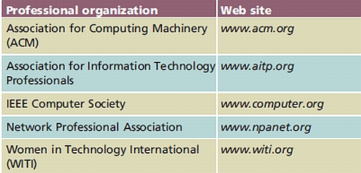
New learning opportunities

Specialized information access

Tangible assets (free goods)

Publications

Technical workshops and conferences

Free software, prerelease software

Expensive hardware lab access

Last modified 1-20-07 0:12

