Objectives

Identify organizations that set standards for networking

Describe the purpose of the OSI model and each of its layers

Explain specific functions belonging to each OSI model layer

Objectives (cont’d.)

Understand how two network nodes communicate through the OSI model

Discuss the structure and purpose of data packets and frames

Describe the two types of addressing covered by the OSI model
Networking Standards Organizations

Standard

Documented agreement

Technical specifications/precise criteria

Stipulates design or performance of particular product or service

Standards are essential in the networking world

Wide variety of hardware and software

Ensures network design compatibility

Standards define minimum acceptable performance

Not ideal performance

Many different organizations oversee computer industry standards

Organizations may overlap responsibilities

Example: ANSI and IEEE set wireless standards

Network professional’s responsibility

Be familiar with groups setting networking standards

Understand critical aspects of standards required by own networks

ANSI

ANSI (American National Standards Institute)

1000+ representatives from industry and government

Determines standards for electronics industry and other fields

Requests voluntarily compliance with standards

Obtaining ANSI approval requires rigorous testing

ANSI standards documents available online

EIA and TIA

EIA (Electronic Industries Alliance)

Trade organization

Representatives from United States electronics manufacturing firms

Sets standards for its members

Helps write ANSI standards

Lobbies for favorable computer and electronics industries legislation

TIA (Telecommunications Industry Association)

Formed in 1988

EIA subgroup merged with former United States Telecommunications Suppliers Association (USTSA)

Focus of TIA

Standards for information technology, wireless, satellite, fiber optics, and telephone equipment

TIA/EIA 568-B Series

Guidelines for installing network cable in commercial buildings

IEEE

IEEE (Institute of Electrical and Electronics Engineers)

International engineering professionals society

Goal of IEEE

Promote development and education in electrical engineering and computer science fields

Hosts symposia, conferences, and chapter meetings

Maintains a standards board

IEEE technical papers and standards

Highly respected

IEEE Student Chapter at CCSF

Last semester, the chapter arranged a tour of a data center

I'll let you know what's coming up this semester

ISO

ISO (International Organization for Standardization)

Headquartered in Geneva, Switzerland

Collection of standards organizations

Representing 57 countries

Goal of ISO

Establish international technological standards to facilitate global exchange of information and barrier free trade

Widespread authority

ITU

ITU (International Telecommunication Union)

Specialized United Nations agency

Regulates international telecommunications

Provides developing countries with technical expertise and equipment

Founded in 1865

Joined United Nations in 1947

Members from 191 countries

Focus of ITU

Global telecommunications issues

Worldwide Internet services implementation

ISOC

ISOC (Internet Society)

Founded in 1992

Professional membership society

Establishes technical Internet standards

Current ISOC concerns

Rapid Internet growth

Keeping Internet accessible

Information security

Stable Internet addressing services

Open standards

ISOC oversees groups with specific missions

IAB (Internet Architecture Board)

Technical advisory group

Overseeing Internet’s design and management

IETF (Internet Engineering Task Force)

Sets Internet system communication standards

Particularly protocol operation and interaction

Anyone may submit standard proposal

Elaborate review, testing, and approval processes

IANA and ICANN

IP (Internet Protocol) address

Address identifying computers in TCP/IP based (Internet) networks

Reliance on centralized management authorities

IP address management history

Initially: IANA (Internet Assigned Numbers Authority)

1997: Three RIRs (Regional Internet Registries)

ARIN (American Registry for Internet Numbers)

APNIC (Asia Pacific Network Information Centre)

RIPE (Réseaux IP Européens)

IP address management history (cont’d.)

Late 1990s: ICANN (Internet Corporation for Assigned Names and Numbers)

Private nonprofit corporation

Remains responsible for IP addressing and domain name management

IANA performs system administration

Users and business obtain IP addresses from ISP (Internet service provider)

ICANN's Stormy History

2002: ICANN was sued by one of their own board members to force them to disclose financial documents

2003: ICANN sued Verisign to make them shut down their "Site Finder" service, which captured all mistyped URLs and showed them Verisign ads

2004 Verisign sued ICANN saying they had overstepped their authority

2008 Ten worst spam offenders notified by ICANN

Links Ch 2a, 2b, 2c
The OSI Model

Model for understanding and developing network computer-to-computer communications

Developed by ISO (1980s)

Divides network communications into seven layers

Physical, Data Link, Network, Transport, Session, Presentation, Application

Protocol interaction

Layer directly above and below

Application layer protocols

Interact with software

Physical layer protocols

Act on cables and connectors

The OSI Model (cont’d.)

Theoretical representation describing network communication between two nodes

Hardware and software independent

Every network communication process represented

PDUs (protocol data units)

Discrete amount of data

Application layer function

Flow through layers 6, 5, 4, 3, 2, and 1

Generalized model and sometime imperfect

Mnemonics for the OSI Model

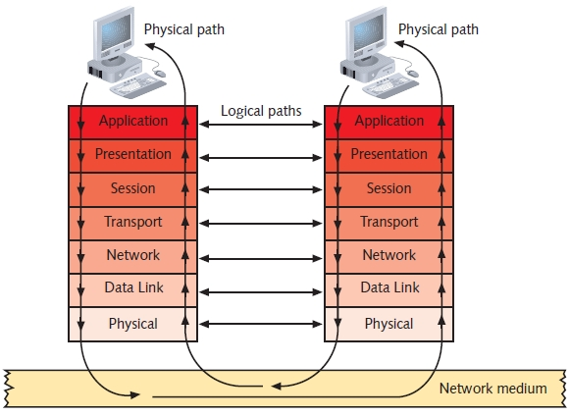
Bottom Up

Please

Do

Not

Throw

Sausage

Pizza

Away

Top Down

All

People

Seem

To

Need

Data

Processing

Application Layer

Top (seventh) OSI model layer

No software applications

Protocol functions

Facilitates communication

Between software applications and lower-layer network services

Network interprets application request

Application interprets data sent from network

Presentation Layer

Protocol functions

Accept Application layer data

Formats data to make it understandable to different applications and hosts

Examples

Text encoding methods ASCII and ANSI

Compression methods like JPEG and MP3

Data encryption and decryption

Session Layer

Protocol functions

Coordinate and maintain communications between two nodes

Session

Connection for ongoing data exchange between two parties

Example: between Web browser client and Web server

Functions

Establishing and keeping alive communications link

For session duration

Determining if communications ended

Determining where to restart transmission

Terminating communications

Transport Layer

Protocol functions

Accept data from Session layer

Provides flow control, segmentation, and error control

Primary Transport Layer Protocols: TCP and UDP

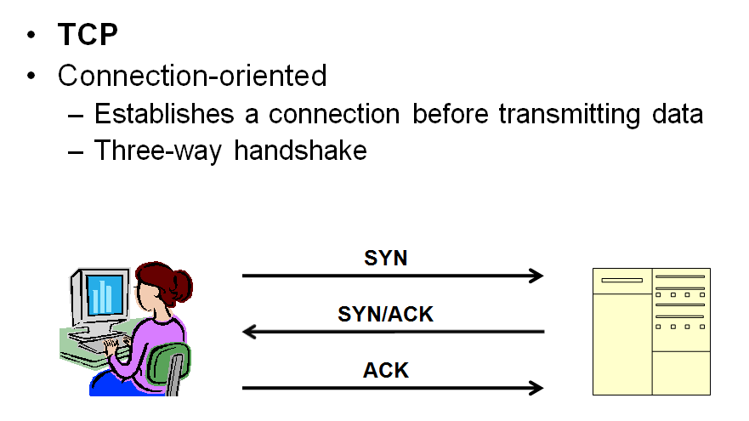
TCP

Require acknowledgements from receiver to ensure data was received correctly

Checksum

Unique character string allowing receiving node to determine if arriving data unit exactly matches data unit sent by source

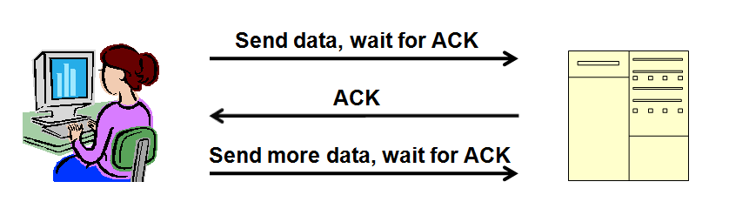
Ensures data integrity

UDP: A connectionless protocol

Do not establish connection with another node before transmitting data—no handshake

Make no effort to ensure data is delivered free of errors

Faster than connection-oriented protocol

Useful when data must be transferred quickly, such as streaming music or video

Segmentation

Breaking large data units received from Session layer into multiple smaller units called segments

Increases data transmission efficiency

MTU (maximum transmission unit)

Largest data unit network will carry

Ethernet default: 1500 bytes

Discovery routine used to determine MTU

Reassembly

Process of reconstructing segmented data units

Sequencing

Method of identifying segments belonging to the same group of subdivided data

Error in Textbook

On page 50, the textbook says that the Network layer translates IP addresses like 147.144.51.121 into MAC addresses like 00-30-48-82-11-BD

That is false. MAC addresses are used at layers 2 and 1 only. Layer 3 works with IP packets which have had the MAC addresses removed from them.

Network Layer

Packet formation

Transport layer segment is encapsulated by a Network layer packet

Network layer adds logical addressing information—IP address

Routing

Determine path from point A on one network to point B on another network

Routing considerations

Delivery priorities, network congestion, quality of service, cost of alternative routes

Common Network layer protocol

IP (Internet Protocol)

Fragmentation

Network layer protocol (IP) subdivides Transport layer segments received into smaller packets

This is usually avoided by adjusting the Maximum Segment Size in the Transport layer, because it makes data transfer inefficient

Link Ch 2e

Data Link Layer

Function of protocols

Divide data received into distinct frames for transmission in Physical layer

Add Physical address to the frame: MAC addresses like 00-30-48-82-11-BD

Frame

Structured package for moving data

Includes raw data (payload), sender’s and receiver’s physical addresses, error checking and control information

Frames may be damaged as they pass through the Physical layer, so the Data Link layer has error-checking

Error checking

Frame check sequence

CRC (cyclic redundancy check)

Possible glut of communication requests

Data Link layer controls flow of information

Allows NIC to process data without error

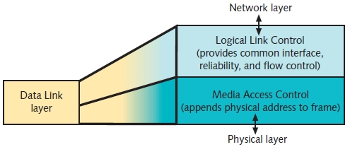
Two Data Link layer sublayers

LLC (Logical Link Control) sublayer

MAC (Media Access Control) sublayer

MAC address components

Block ID

Six-character sequence unique to each vendor

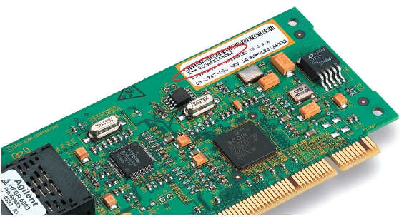
Device ID

Six-character number added at vendor’s factory

MAC addresses frequently depicted in hexadecimal format

MAC Address is printed on NIC

Example of MAC Address

Whole MAC address: 00-30-48-82-11-BD

Block ID

00-30-48

Identifies the vendor

Device ID

82-11-BD

Different for each NIC from the same vendor

If two NICs have the same MAC address, they have problems networking

This can happen with cheaply made refurbished NICs, or with copied virtual machines

Physical Layer

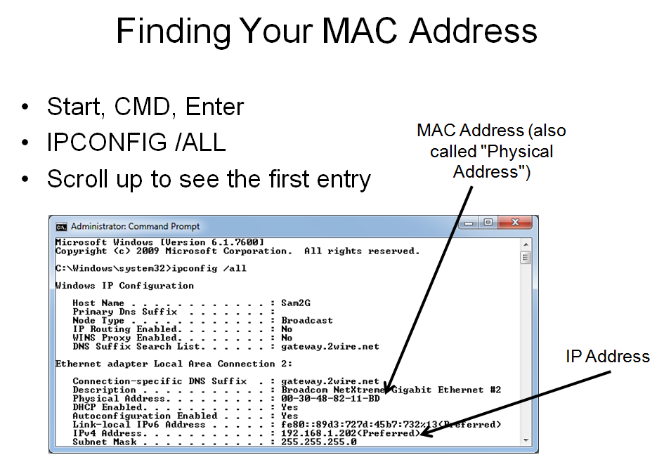
Functions of protocols

Accept frames from Data Link layer

Generate signals as changes in voltage at the NIC

Copper transmission medium

Signals issued as voltage

Fiber-optic cable transmission medium

Signals issued as light pulses

Wireless transmission medium

Signals issued as electromagnetic waves

Physical layer protocols responsibility when receiving data

Detect and accept signals

Pass on to Data Link layer

Set data transmission rate

Monitor data error rates

No error checking

Devices operating at Physical layer

Hubs and repeaters

NICs operate at both Physical layer and Data Link layers
Applying the OSI Model
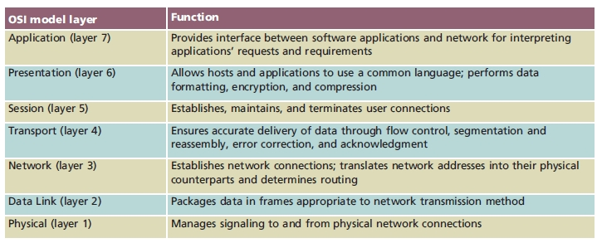

Communication Between Two Systems

Data transformation

Original software application data differs from the bits sent onto the cable by the NIC

Header data added at each layer

Each layer has a different data structure, called a Protocol Data Unit (PDU)

Segments

Generated in Transport layer

Unit of data resulting from subdividing larger PDU from the Session layer

Addressed with TCP Ports (when using TCP)

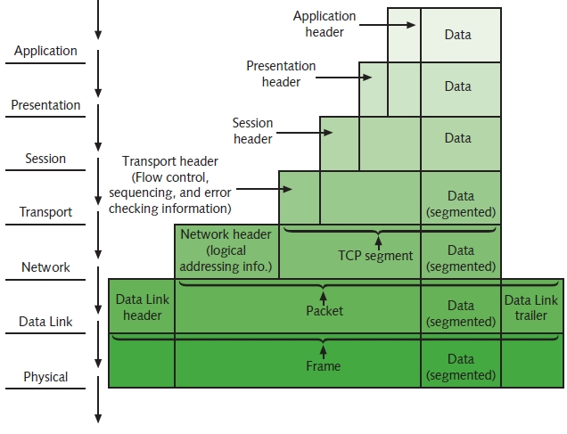

Packets

Generated in Network layer

Data with logical addressing information added to segments

Addressed with IP addresses

Frames

Generated in Data Link layer

Composed of several smaller components or fields

Addressed with MAC addresses

Encapsulation

Occurs in each layer

Process of wrapping one layer’s PDU with protocol information

Allows interpretation by lower layer

Frame Specifications

Frames

Composed of several smaller components or fields

Frame characteristic dependencies

Network type where frames run

Standards frames must follow

Ethernet

Developed by Xerox

Four different types of Ethernet frames

Most popular: IEEE 802.3 standard

Token ring

Developed by IBM

Relies upon direct links between nodes and ring topology

Nearly obsolete

Defined by IEEE 802.5 standard

Ethernet frames and token ring frames differ

Will not interact with each other

Devices cannot support more than one frame type per physical interface or NIC
IEEE Networking Specifications

IEEE’s Project 802

Effort to standardize physical and logical network elements

Frame types and addressing

Connectivity

Networking media

Error-checking algorithms

Encryption

Emerging technologies

802.3: Ethernet

802.11: Wireless
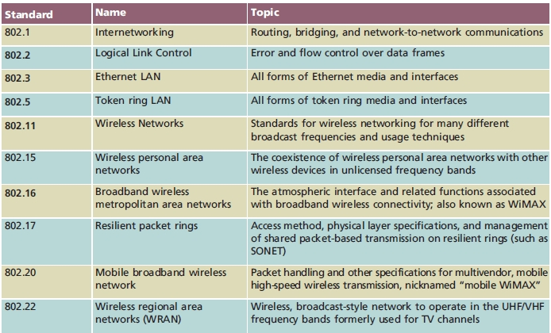

Last modified 8-26-09

